NOx Reduction with Urea and Ammonia: Insights from Reactive Molecular Dynamics Study

Matheus Braga da Silva1, Maria Iaponeide Fernandes Macêdo1, Nilton Rosenbach Jr. 1*, and Adri C. T. van Duin2

1Faculdade de Ciências Exatas e Engenharias, Universidade do Estado do Rio de Janeiro, Av. Manuel Caldeira de Alvarenga, 1203, Rio de Janeiro, RJ, Brazil. [*nilton.rosembach.junior@uerj.br](mailto:*nilton.rosembach.junior@uerj.br)

2Department of Mechanical and Nuclear Engineering, Pennsylvania State University, University Park, Pennsylvania 16802, United States.

Resumo/Abstract

RESUMO – Os óxidos de nitrogênio (NOx) são extremamente prejudiciais ao meio ambiente e à saúde humana, sendo formados principalmente a partir da reação entre o nitrogênio (N2) e o oxigênio (O2) atmosféricos em processos que envolvem combustão. Sistemas de controle primário e secundário para redução das emissões de NOx têm sido implementados e aqueles que se baseiam na tecnologia de Redução Seletiva Catalítica (SCR, *Selective Catalytic Reduction*) são os mais eficientes. A tecnologia SCR utiliza ureia como agente redutor na presença de um catalisador para converter NOx em nitrogênio molecular (N2) e água (H2O). Neste estudo, nós utilizamos o campo de força ReaxFF em simulações de dinâmica molecular para investigar a redução de NOx em fase gasosa a fim de compreender o mecanismo molecular da reação. Os resultados indicam que a espécie NH2 desempenha um papel crucial na redução de NOx com amônia, uma vez que a reação entre NH2 e NO resulta na formação de nitrosamina (NH2NO), que se decompõe em N2 e H2O. Entretanto, nossas simulações revelaram uma via alternativa para a formação de N2 a partir da reação entre HON e NO.

*Palavras-chave: NOx, Redução Seletiva Catalítica (SCR), Dinâmica Molecular Reativa, ReaxFF*

ABSTRACT - Nitrogen oxides (NOx) are extremely harmful to the environment and to human health, being formed mainly from the reaction between atmospheric nitrogen (N2) and oxygen (O2) in processes involving combustion. Primary and secondary control systems to reduce NOx emissions have been implemented and those based on Selective Catalytic Reduction (SCR) technology are the most efficient. The SCR technology uses urea as a reducing agent in the presence of a catalyst to convert NOx into molecular nitrogen (N2) and water (H2O). In this study, we use the ReaxFF force field in molecular dynamics simulations to investigate NOx reduction in the gas phase in order to understand the molecular mechanism of the reaction. The results indicate that the NH2 species plays a crucial role in the reduction of NOx with ammonia, since the reaction between NH2 and NO results in the formation of nitrosamine (NH2NO), which decomposes into N2 and H2O. However, our simulations revealed an alternative pathway for the formation of N2 from the reaction between HON and NO.

*Keywords: NOx, Selective Catalytic Reduction (SCR), Reactive Molecular Dynamics, ReaxFF*

## Introduction

NOx is a shorthand term commonly used to designate two environmentally harmful gases: nitric oxide (NO) and nitrogen dioxide (NO2). These gases have serious impacts on the environment and human health, contributing to the formation of photochemical smog, acid rain, haze, and tropospheric ozone depletion (1).

The majority of NOx emissions result from anthropogenic activities, including both mobile and stationary. NOx is primarily formed in the combustion process through the reaction between atmospheric nitrogen (N2) and oxygen (O2) at high temperatures, independent of the fuel used. As a result, strict regulations have been implemented to control NOx emissions. These measures are necessary to reduce the levels of NOx emissions and mitigate their harmful impacts on human health and the environment (2).

NOx control emissions systems are primary or secondary. Primary NOx emissions control systems are typically designed to reduce NOx emissions directly from the source. This may involve modifying the combustion process to lower peak temperatures, using lower-emitting fuels, or employing exhaust gas recirculation techniques.

Secondary NOx emissions control systems, on the other hand, are installed downstream of the source and are intended to reduce NOx emissions that were not adequately controlled by primary systems. This may involve using Selective Non-Catalytic Reduction (SNCR) or Selective Catalytic Reduction (SCR).

SCR utilizing ammonia (NH3) or urea ((NH2)2CO) is a highly effective technology for reducing NOx emissions from both mobile and stationary sources. Urea is commonly preferred over ammonia because it is safer and easier to handle. SCR technology uses V2O5 as a supported catalyst to reduce NO from stationary sources through the following reaction involving NH3, NO, and O2, which makes the reaction faster. Ammonia is produced by the hydrolysis of urea (3).

4NH3 + 4NO + O2 🡪 4N2 + 6H2O

However, the toxicity of vanadia species and the catalyst poisoning due to SOx oxidation are still obstacles to the application of this technology and have stimulated the development of highly active SCR catalysts capable of operating a low-temperature ranges. Alternative catalysts based on Cu ion-exchanged zeolites (Cu-SSZ-13) have been implemented in the control systems of emissions from mobile sources in many countries (4).

The mechanism for SCR over catalysts is still widely debated in the literature. Even the NOx reduction mechanism at the gas phase is not completely known at the atomic level. All theoretical studies have focused on a mechanism that involves two stages: oxidation and reduction, in which nitrosamine (NH2NO) is a key intermediate. The formation of a long-lived complex such as nitrosamine is a fair agreement with experimental experiments that show a negative temperature dependence for the reaction between highly reactive radicals: NH2 and NO (5).

The mechanism also involves oxidation and reduction stages on the catalyst surface. However, the steps take place in different phases. Kinetic models are more complex for both SNCR and SCR processes, including many reactions and intermediates with two major channels. Nitrosamine channel is prevalente below 1500 K (6).

In this study, we use the reactive molecular dynamics (ReaxFF) method to investigate the reduction of nitrogen oxides (NOx) utilizing ammonia and urea at the gas phase. The results of the study can provide insights into the molecular mechanism underlying the reaction and guide the development of more efficient and effective catalysts for NOx reduction. The ReaxFF method enables us to investigate all possible reactive pathways that lead to the formation of molecular nitrogen (N2) in the absence of a catalyst. Moreover, we aim to validate the accuracy of the reactive force field in describing this chemical system before introducing catalysts.

Atomistic-scale computational methods based on reactive force fields have been demonstrated to accurately describe chemical processes at a low computational cost. Such methods have grown in popularity in recent years and have been successfully used to study a variety of systems and simulation scales beyond those that can be tractable using techniques based on quantum mechanics (QM).

The ReaxFF is a general reactive force field method that describes reactive events through a potential function that incorporates both bond-order-dependent and bond-order-independent contributions to the energy of the system. Bond order (BO) is empirically calculated from interatomic distances and updated at every molecular dynamic (MD) step. Bond-order-independent contributions (van der Waals and Coulomb interactions) also are calculated between every pair of atoms, regardless of bond order, and polarization effects are included by using a geometry-dependent charge calculation scheme. This formalism allows describing events in which chemical bonds can break and form during simulations. The parameters in the ReaxFF energy expressions for bond-order-dependent and bond-order-independent contributions are optimized to fit experimental and QM data describing different processes (bond dissociation, geometry distortion, charges, equation of state, among others) of covalent, ionic, and metallic systems (7). A more detailed description of the ReaxFF method can be found in previous works by van Duin’s group.

## Computational Details

All simulations were carried out in a cubic periodic box with a side length of 60 Å, which contained a mixture with the composition detailed in Table 1.

**Tabela 1.** Composition of the mixtures studied in this work.

|  |  |  |  |
| --- | --- | --- | --- |
| # | Composition | #  Molecules | Density  x 10-2 (gcm-3) |
| 1 | 4NH3:4NO:O2 | 243 | 4.6 |
| 2 | 4NH3:6NO | 270 | 5.2 |
| 3 | 2(NH2)2CO:4NO:O2 | 189 | 5.6 |
| 4 | 2(NH2)2CO:6NO | 216 | 6.2 |
| 5 | 2(NH2)2CO:2NO2:2NO | 162 | 5.6 |
| 6 | 4NH3:2NO2:O2 | 189 | 4.0 |
| 7 | 4NH3:2NO2:2NO | 216 | 4.6 |

After a short 10 ps equilibration at low temperature with switched-off bond parameters to prevent any reaction from occurring, molecular dynamic (MD) simulations were carried out using the canonical (NVT) ensemble with a times step of 0.25 fs, and with trajectories spanning 1 ns. The Berendsen thermostat with a damping constant of 50 fs was utilized to control the temperature of the system at the target value (1250 K) during simulation. The reduction of NO is most effective only within a specific temperature range of 1000 to 1500 K. At temperatures below 1000 K, the reaction proceeds too slowly to be practical, while at temperatures above 1500 K, the reaction yields a net increase in nitric oxide.

A bond-order cutoff of 0.3 was applied to all atom pairs to distinguish the different molecular species present in the system at every molecular dynamic (MD) step, which means that two distinct fragments were identified as separate molecules if all bonds connecting them have bond order below the prescribed cutoff value. The resultant data were used to track the temporal evolution of reagents, intermediates and products throughout the NOx reduction process. Thus, the behavior of the different molecular species involved in the reaction can be used to comprehensively understand the underlying chemical mechanisms.

Several ReaxFF force fields have been developed in previous studies to model systems containing C, H, O, and N. Notable examples include Reaxff force field parametrization used to study shock-induced initiation of crystalline pentaerythritol tetranitrate (PETN) (8), which was subsequently reparameterized to investigate the initial chemical events in nitramine RDX (9), triacetonetriperoxide (TATP) (10), and nitromethane (11). A ReaxFF force field, originally developed for studying carbon cluster formation during thermal decomposition of 1,3,5-triamino-2,4,6-trinitrobenzene (TATB), was reparameterized for hydrazine (N2H4), monomethyl-hydrazine (CH3N2H3), and octahydro-1,3,5,7-tetranitro-1,3,5,6-tetrazocine (HMX) (12). Additionally, Goddard and coworkers developed a ReaxFF force field to investigate tautomerization of glycine (NH2CH2COOH) (13).

In this work, the simulations were conducted using the parameters from a reparameterized nitramine force field used in a previous study on carbon cluster formation during the thermal decomposition of TATB and HMX high explosives. The decision to use this force field was based on the similarities between the systems under investigation, as TATB and HMX have amine (NH2) and nitro (NO2) groups that are also present in the current systems.

## Results and Discussion

Figure 1 depicts the time-dependent behaviour of NO and H2O concentration in the course of reactive molecular dynamics simulations on the mixture comprising NH3, NO, and O2 in a 4:4:1 ratio at the temperature of 1250 K. The concentration of each specie computed at every step of the simulations corresponds to the mean value obtained from three distinct trajectories. As shown in the figure, the reaction completely consumes NO within the first 100 ps, while the concentration of H2O, a product of NOx reduction, gradually increases during that period. All other mixtures studied in this work present a similar kinetic profile.

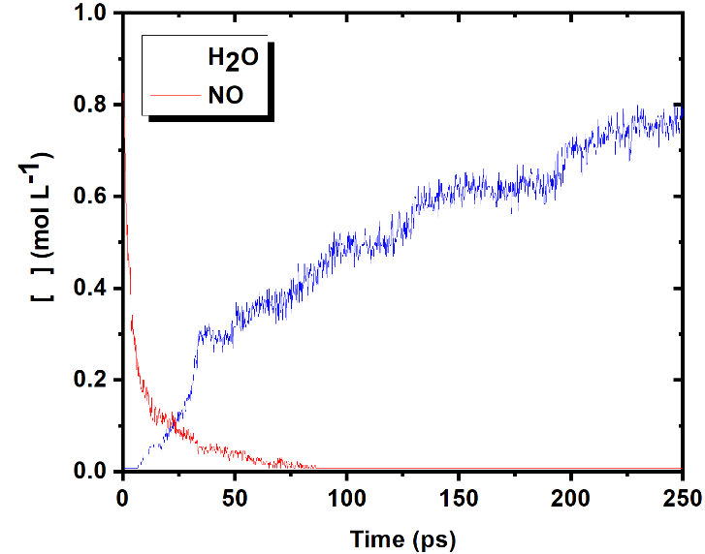

**Figure 1.** Temporal evolution of the NO and H2O concentration in the reactive molecular dynamics simulations at 1250 K on the mixture comprising NH3, NO, and O2 in a 4:4:1 ratio.

Figure 2 illustrates a snapshot of the simulation box after 30 ps into the MD-NVT trajectory at the temperature of 1250 K of the mixture containing NH3, NO, and O2 in a 4:4:1 ratio. At this stage, the majority of the molecules in the system are reagents, while only a few product molecules are observed. The system also contains numerous intermediate molecules, such as HOOH, HOO, and NH2, present in low concentrations.

The NH2 specie plays a crucial role in the reduction of NOx with ammonia, since the reaction between NH2 and NO results in the formation of nitrosamine (NH2NO), which can then undergo further reactions to ultimately yield N2 and H2O (5). At the optimal temperature range of 1000 to 1500 K, the conversion rate of NH3 to NH2 is sufficiently high to promote the reaction channel which ultimately leads to the formation of molecular nitrogen and water. This channel that involves a reaction between NH2 and NO can be described by a reaction pathway consisting of the following series of reactions (6):

NH2 + NO 🡪 NNH + OH

NNH + NO 🡪 N2 + HNO

HNO + OH 🡪 H2O + NO

**Figure 2.** Snapshots of the simulation box after 30 ps MD-NVT simulation at 1250 K on the mixture comprising NH3, NO, and O2 in a 4:4:1 ratio.

Our simulations have revealed a distinct pathway for the formation of molecular nitrogen (N2) from the reaction between HON and NO, in addition to the nitrosamine pathway:

HON + NO 🡪 N2 + OH

The primary mechanism for this pathway is the hydrogen abstraction from NH3 by NO. Figure 3 depicts the time-dependent changes in HON specie concentration during reactive molecular dynamics simulations of the mixture containing NH3, NO, and O2 in a 4:4:1 ratio at the temperature of 1250 K. The results demonstrate that the intermediate HON species is produced during the kinetic regime of the reaction, albeit at a relatively low concentration.

Although the formation of HON is highly endothermic compared to the formation of HNO through hydrogen abstraction from NH3 by NO, and the nitrosamine pathway dominates over the entire optimal temperature range, it is important to note that alternative pathways may become favourable within the temperature range of 1000 and 1500 K, and cannot be entirely ruled out. It is worth emphasizing that the force field used in the simulations accurately captures the relative endothermicity of both HON and HNO formation processes resulting from the reaction between NH3 and NO. Furthermore, the energies obtained are equivalent to those calculated using quantum mechanical methods, which reinforce the HON pathway as an alternative channel for N2 formation in the optimal temperature range.

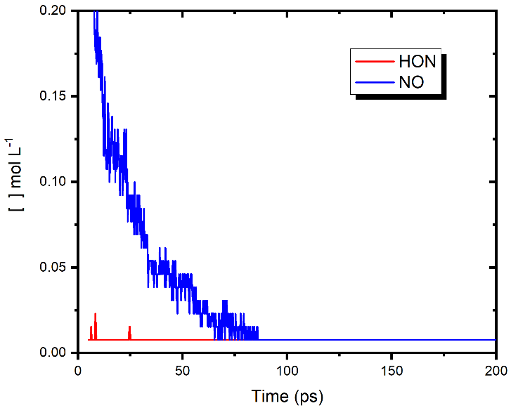

**Figure 3.** Temporal evolution of the NO and HON specie concentration in the reactive molecular dynamics simulations at 1250 K on the mixture comprising NH3, NO, and O2 in a 4:4:1 ratio.

The overall rate constant (*kov*) can be calculated from the fitted curve to the NO concentration over time. For the reaction, 2NH3 + 2NO + ½ O2 🡪 N2 + H2O, *kov* can be calculated from the slope of the tangent to the second-order reaction fitted curve. The resulting values are compiled in Table 2 and are consistent with previous studies that give a result for the reaction between NH2 and NO at 300 K of approximately 1 x 1013 at room temperature. As supported by prior research, the introduction of oxygen molecules (O2) consistently enhances the reaction rate in the selective reduction of nitrogen oxides (NOx) with ammonia or urea.

**Tabela 2.** Overall rate constants for all reactions investigated in this work.

|  |  |  |
| --- | --- | --- |
| # | Composition | *kov x 1012*cm3mol-1s-1 |
| 1 | 4NH3:4NO:O2 | 1.39 |
| 2 | 4NH3:6NO | 0.82 |
| 3 | 2(NH2)2CO:4NO:O2 | 2.15 |
| 4 | 2(NH2)2CO:6NO | 1.89 |
| 5 | 2(NH2)2CO:2NO2:2NO | 1.02 |
| 6 | 4NH3:2NO2:O2 | 1.35 |
| 7 | 4NH3:2NO2:2NO | 0.42 |

The effect of temperature on the overall rate constant was investigated for the mixture of NH3, NO, and O2 in a 4:4:1 ratio using MD-NVT simulations at various temperatures within the optimal range of 1000 to 1500 K. The resulting Arrhenius plot is presented in Figure 2 and exhibits a negative temperature dependence that is consistent with previous studies on the reaction between NH2 and NO.

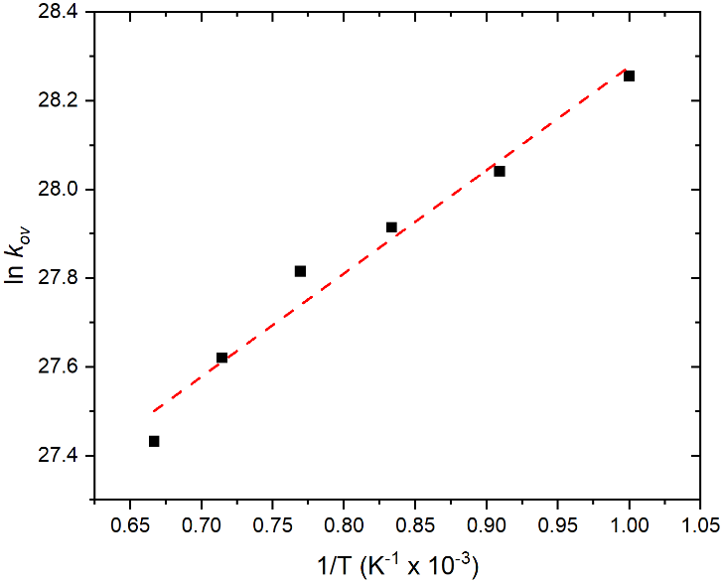

**Figure 4.** Arrhenius plot for the mixture of NH3, NO, and O2 in a 4:4:1 ratio.

## Conclusions

NOx emissions are a serious environmental and health problem, as they contribute to the formation of various harmful pollutants. To mitigate these impacts, strict regulations have been implemented to control NOx emissions. Secondary NOx emissions control systems based on SCR technology have proven to be highly effective in reducing NOx emissions. However, the SCR mechanism is still debated in the literature. Even the NOx reduction mechanism at the gas phase is not completely known at the atomic level. In this study, we use ReaxFF reactive molecular dynamics to investigate the reduction of NOx utilizing ammonia and urea at the gas phase and provide a further understanding of the reaction mechanism. The results have shown that the nitrosamine channel is the main pathway for NOx reduction at the gas phase. However, we identified an alternative route in which the HON intermediate play a major role in the formation of molecular nitrogen (N2). The results also are in fair agreement with previous studies indicating a negative temperature dependence and an increase in reaction rate when molecular oxygen (O2) is introduced into the reaction medium.

## Acknowledgement

The authors thank FAPERJ and NRJ thanks CNPq for the postdoctoral fellowship at Pennsylvania State University in Professor Adri C. T. van Duin’s group.

## References

1. M.Z. Jacobson, *Atmospheric Pollution*, Cambridge University Press; 2002.

2. P. Brimblecombe, *Cambridge Environmental Chemistry Series: Air Composition and Chemistry*, 2nd ed., Cambridge University Press, 1995.

3. P. Granger; V.I. Parvulescu, *Chemical Reviews*. **2011**, 111, 3155–3207.

4. L. Ma; Y. Cheng; G. Cavataio; R.W. McCabe; L. Fu; J. Li, *Engineering Journal*. **2013**, 225, 323–330.

5. J.A. Miller; S.J. Klippenstein; *Journal of Physical Chemistry A*. **2000**, 104(10), 2061–2069.

6. J.A. Miller; M.C. Branch; R.J. Kee, *Combustion and Flame*. **1981**, 43, 81-89.

7. T.P. Senftle; S. Hong; M.M. Islam; S.B. Kylasa; Zheng Y, Shin YK, et al., *npj Computational Materials*. **2016**, v. 2, 15011.

8. J. Budzien; A.P. Thompson; S.V. Zybin, *Journal of Physical Chemistry B*. **2009**, 113,13142–51.

9. A. Strachan; A.C.T. van Duin; D. Chakraborty; S. Dasgupta; W.A. Goddard, *Phys Rev Lett*. **2003**, 91 (9), 28.

10. A.C.T van Duin; Y. Zeiri; F. Dubnikova; R. Kosloff; W.A. Goddard, *J Am Chem Soc*. **2005**, 127(31), 1053–1062.

11. A.C.T. van Duin; S.V. Zybin; K. Chenoweth; L. Zhang; S.P. Han; A. Strachan, et al. Available from: <http://proceedings.aip.org/proceedings/cpcr.jsp>, 2006, 581-584.

12. L. Zhang; S.V Zybin; A.C.T. van Duin; S. Dasgupta; W.A. Goddard; E.M. Kober, *Journal of Physical Chemistry A*. **2009**, 113(40):10619–10640.

13. O. Rahaman; A.C.T. van Duin; W.A. Goddard; D.J. Doren, *Journal of Physical Chemistry B*. **2011**, 115(2), 249–261.