A Living Growth Model for the Fischer-Tropsch Synthesis

Caio H. Pinheiro1*, Maria A. S. Baldanza1, Juliana L. Smarzaro1, Vera M. M. Salim1, Neuman S. de Resende1, José Carlos Pinto1

1Programa de Engenharia Química/COPPE, Universidade Federal do Rio Janeiro, Cidade Universitária, Rio de Janeiro, CP 68502, 21941-972, RJ, Brazil *cpinheiro@peq.coppe.ufrj.br

Resumo/Abstract

RESUMO - Com o aumento da demanda global de energia, há uma crescente procura por fontes energéticas renováveis. Nesse contexto, a Síntese de Fischer-Tropsch (SFT) ressurge como uma alternativa promissora para a produção de combustíveis que utilizam fontes renováveis mais limpas, como o gás de síntese (CO + H2) proveniente da biomassa. A modelagem matemática se mostra uma ferramenta útil para o desenvolvimento de produtos e processos em direção a essa proposta. Nesse sentido, foi desenvolvido um novo modelo fenomenológico para a SFT, baseado em um esquema de polimerização viva, que até então nunca foi utilizado para representar o conjunto de reações de que compõem a SFT. Este estudo se concentrou na estimação dos parâmetros do modelo proposto, e os resultados obtidos indicam que o modelo apresenta boa acurácia com os dados experimentais de distribuições de tamanho de cadeia, além de mostrar que a temperatura tem um efeito direto nas constantes cinéticas.

*Palavras-chave: Síntese de Fischer-Tropsch,* *modelagem, distribuição de tamanho de cadeia, mecanismo de polimerização viva*

ABSTRACT - The increasing worldwide energy demand encourages the search for renewable and clean energy resources. In this scenario, the Fischer-Tropsch Synthesis (FTS) emerges again as a convenient alternative for fuel production, now using cleaner and renewable sources, such as syngas (CO + H2) from biomass. This goal can be tackled with the help of mathematical models that are useful for designing products and processes. For this reason, a novel phenomenological model for FTS was developed and is presented here. The model is based on a living addition polymerization scheme, which has not yet been used to represent FTS reactions. The present work focuses on the estimation of the respective model parameters, while the obtained results indicate that the model provides good fits for the available experimental carbon size distributions and that temperature exerts a significant direct effect on the kinetic rate constants.

*Keywords: Fischer-Tropsch synthesis, modeling, chain size distribution, living polymerization mechanism.*

## Introduction

Fischer-Tropsch Synthesis (FTS), a classic industrial set of reactions commonly used for syngas conversion, revives as an interesting possibility to densify the hydrogen volumetric energy. Particularly, the FTS constitutes an optional process for producing sulfur-free and nitrogen-free hydrocarbons. As a matter of fact, synthetic fuel production constitutes an economical and environmental alternative for supplying the demands of the naval and heavy aircraft sectors, two fields that are still technologically far from replacing high-energy liquid fuels for batteries in the near- or middle-term future (1,2).

Almost one hundred years after the initial development of the FTS process, its kinetics is not well understood yet and regarded as complex, primarily because of the broad amount of reactions that lead to different distributions of products. This fact makes product prediction usually difficult. However, the development of kinetic models for FTS is essential for process, simulation, design, and process optimization, as well as for the validation of hypotheses about reaction mechanisms.

The Anderson-Schulz-Flory (ASF) distribution can be used to describe the FTS product distribution efficiently and for this reason remains the most popular model in this field, mainly due to its simplicity, which has been considered almost indispensable in studies that discuss FTS selectivity (3,4). According to this approach, the distribution is related to a single parameter *α* called the chain-growth probability, which represents the ratio between the propagation rate (*rp*) and the sum of propagation and termination rates (*rp + rt*). Therefore, the catalytic performance can be discussed and characterized by evaluating the product distribution and estimating the value of *α*. Although the ASF model is robust and useful, it does not fit all reported distributions (5-8).

The current work presents a phenomenological model that describes the FTS reactions according to a living addition polymerization mechanism and focuses on the pseudo-species propagation steps. Much more than deviations, experimentally observed product distributions obtained with the catalyst system Co/SiO2 (7, 9) are clearly narrower than predicted by the ASF, and somewhat similar to the Poisson distribution. On the face of that, the FTS mechanism was revisited and described in accordance with a quasi-living polymerization scheme. It is shown that the proposed model can describe the available data successfully, suggesting that the reaction mechanism of the FTS process does not remain exactly the same for different catalyst systems.

## Model

## The reactions are assumed to occur in series and irreversibly (Pi + (-CH2-) → Pi+1), so the kinetic constants should be regarded as effective rate constants that may depend on the number of carbon atoms in the chain. The dynamic-spatial mass balance for the first reacting species can be written in the form of eq. 1, as follows:

$$P_{1}(τ ) = P_{1}(0) · exp (-K_{1} τ ) eq. 1$$

where *τ* is a measure of the residence time (τ = *z v*-1) in experiments performed in continuous tubular reactors, where *z* is the axial direction and *v* is the spatial flow velocity. As *v* is related to the volumetric gas flow rate through the catalyst bed, *τ*f can also be written as a function of the Gas Hourly Space Velocity (GHSV) in the form of eq. 2, where *ρ*cat is the catalyst density and *ε* is the bed porosity.

## For P2, the non-homogeneous linear ordinary differential equation can be solved in the form of eq. 3, where P2(0) = 0.

which can be extended for the next mass balance equations in the form:

$$P_{N}\left(τ \right)= P_{1}\left(0\right) \prod_{j=1}^{N-1}{K_{j }}\sum_{i=1}^{N-1}{\frac{exp \left(-K_{i} τ \right)+ exp (-K_{N} τ) }{\prod_{j=1,j≠i}^{N}{(K_{j}- K_{i} )}} eq. 4}$$

At this point, one must observe that *N* parameters must be estimated. To avoid superparameterization of the proposed model, an empirical model inspired by the well-known Flory distribution is proposed (10), as follows:

$$K_{i}=q^{i-1}K_{1} eq.5$$

where *q* empirically describes the expected reduction of reactivity when the molar mass of the carbon chain increases, due to reduction of chain mobility.

The objective function presented in eq. 6 is used here to evaluate the dimensionless difference between the predicted value ${(y}_{i}^{*})$ and the experimental ${(y}_{i}^{e})$ values, using the normalized molar fractions. When all variances are equal (which is usually assumed for models with only one dependent variable), as follows:

$$f\left(θ\right)= \sum_{i=1}^{N}{{(y_{i}^{*}-y_{i}^{e})}^{2}} eq.6$$

In order to estimate the vector parameter *θ*, a stochastic optimization algorithm was implemented in Python 3.10.0, based on the well-known Particle Swarm Optimization (11-12).

The computation of the confidence region of model parameters of nonlinear models can constitute a big challenge. Beale (12) was the first to propose the use of eq. 7 for evaluation of confidence regions in nonlinear estimation problems. Schwaab et al. (13) used this equation to obtain the likelihood confidence region:

$f\left(θ\right)≤f\left(\overline{θ}\right)\left(1+\frac{n}{N-n} F_{n,N-n}^{1-α}\right)$*eq. 7*

where *n* is the number of estimated model parameters and the F value is computed with the classic F-distribution with confidence level of 95%. Fortunately, the application of heuristic methods — as performed in the present work — generates many candidates that satisfy eq. 7 and reveal the detailed shape of the confidence region of model parameters.

## Experimental

Co/SiO2 catalyst preparation via incipient wetness has been reported by Smarzaro et al. (7). Particularly, the amount of precursor was designed to provide a catalyst with cobalt loading of 10 wt%.

The reaction experiments were performed in a fixed-bed reactor, using α-Al2O3 as a diluent. The catalytic tests followed three consecutive steps: reduction, cleaning, and reaction. In the first step, the GHSV was equal to 10 L h−1 g−1 under hydrogen atmosphere and the reaction temperature was increased at a rate of 5 °C min−1 until 365 °C, which was then kept constant for 10 hours. In the second step, the reactor was cooled down to the reaction temperature (210 °C, 230 °C, or 250 °C), and the system was cleaned for 30 min under He flow. Finally, the reaction was performed at steady pressure condition of 2 MPa for 24 hours. The bed dilution ratio (wt:wt) was equal to 1:1, the feed composition (vol:vol) was equal to [H2]: [CO] = 2:1 and the GHSV value was equal to 6 L h−1 g−1.

## Results

*Some aspects of the proposed model*

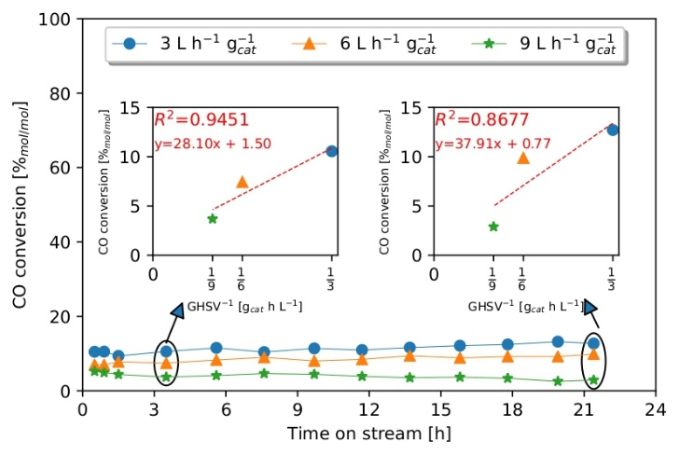The proposed model predicts several chain size distributions for different times (or GHSV values in the case of experiments performed in continuous tubular reactors), as illustrated in Fig.1. The graphs in Fig.1-a, b, and c depict *K1* as equal to 10 h−1. Increasing *q* results in a flattened distribution that is shifted towards products with higher chain sizes. On the other hand, by setting q = 0.8, an increase in *K1* shifts the distribution towards longer carbon chains, but it is not flattened, as shown in Fig.1-d, e, and f. These examples demonstrate that the *q* parameter can regulate FTS selectivity. This is because *q* influences each effective constant *K1*, as shown in eq. 5.

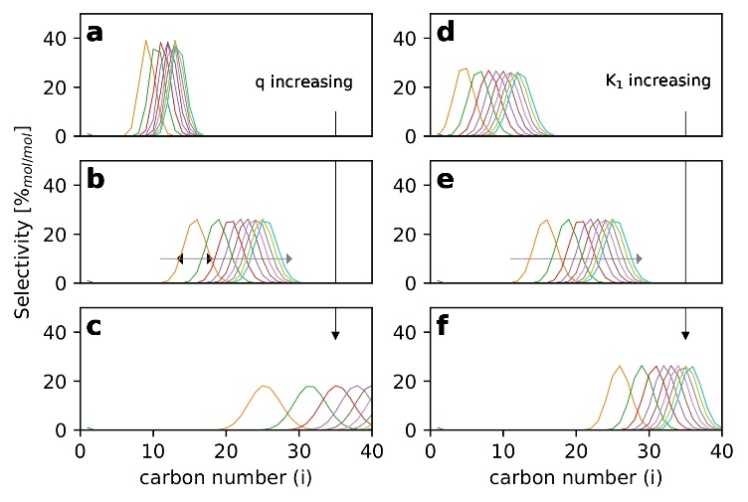

**Figure 1.** Chain size distributions as functions of the model parameters. Each distribution represents a different reaction time. (a, b, and c) *q* = 0.6, 0.8, and 0.9, respectively, and *K1* = 10 h−1; and (d, e, and f) *K1* = 0.5, 10, and 100 h−1, respectively, and *q* = 0.8

To demonstrate the dynamic selectivity behavior based on the proposed model, we cordially request the reader to view an animated video through a QR code provided in Fig. 2.



**Figure 2.** Animation of dynamic selectivity dependence of Living Growth Model parameters

*Steady-state reaction*

As depicted in Fig. 3, the system can achieve a steady state within the initial few hours of the reaction, even though the balance equations do not forecast a steady-state solution. However, since the reaction time is finite and regulated by the feed rates, the model can effectively anticipate steady-state solutions. As per usual practice, the time-on-stream (*t*) can be correlated with the flow velocity (*v*) and the axial position (*l*), in the form (*t*=*v*). Therefore, the GHSV can be employed to regulate the time-on-stream (and, therefore, the growth time). Inspired by the technique presented by Birky et al. (15), it is presumed that the examined reaction system operates under a kinetic regime. The observed linear relationships at 3.5 h and 21.4 h indicate that the likelihood of diffusion limitation can be ruled out.

**Figure 3.** Stability test results for several spatial velocities. The linear relationship between CO conversion and reactor space-time confirms the kinetic regime of the investigated system. The tests were performed with 300 mg of catalyst with varying flow rates at the reaction temperature of 210 °C and total pressure of 10 Mpa

*Experimental results*

Fig.4 illustrates that the available experimental results do not follow the usually assumed ASF pattern. The distribution profile is much narrower, and waxes are more selective than predicted by the ideal-ASF. Notably, the distribution profile found was much more selective to a narrow range of products than predicted by the ASF model.

Following the previous discussion, the kinetic constants *Ki* were estimated as functions of the chain length with the help of eq. 4. For the tests performed when the reaction temperature was varied — Fig.5-a, b, and c — there apparently was some sort of overfitting.

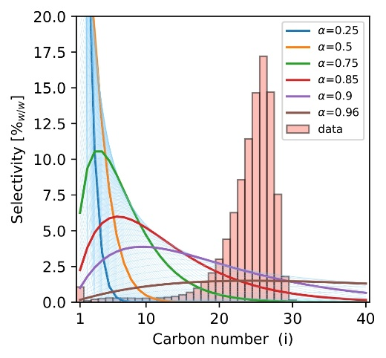

**Figure 4**. Ideal-ASF model with a single α parameter, and the selectivity distribution data for FTS

The estimated parameters are displayed as a function of chain length in Fig. 5d. Although values tended to be dispersed in the areas where the distribution values were small, it must be noted that the model parameters stayed within a relatively small range of values. As the model deviations become less sensitive to model parameters in the regions where the product distribution data becomes small, this may have already been anticipated. To some extent, the empirical model proposed in eq. 5 is validated by the fact that the model parameters tended to decrease with chain size in the region where distribution signals were more significant. On the other hand, the obtained results also imply that, as one might anticipate, the kinetic rate constants depend on the reaction temperature.

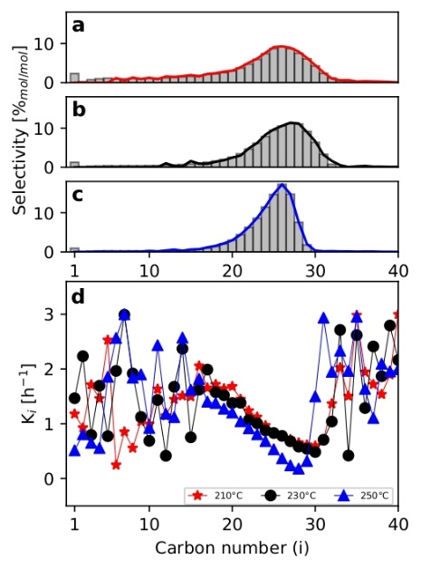

**Figure 5**. Fitted chain size distributions (a) 210 °C, (b) 230 °C, (c) 250 °C, and (d) estimated parameters as functions of the chain size

Now, as shown in Fig.6-a, b, and c, when the model parameters were estimated using eq. 5, it was found that there was a strong correlation between the FTS-selectivity data and the values that were calculated with the developed model. When T = 210 °C, 230 °C, and 250 °C were used, the correlation coefficients in these cases were 0.96, 0.96, and 0.89, respectively. Although the model performances can be regarded as very good and that the model is able to capture the main features of the observed data, one can observe some persistent deviations for small and large numbers of carbons, suggesting that eq. 5 introduced some bias and can be improved.

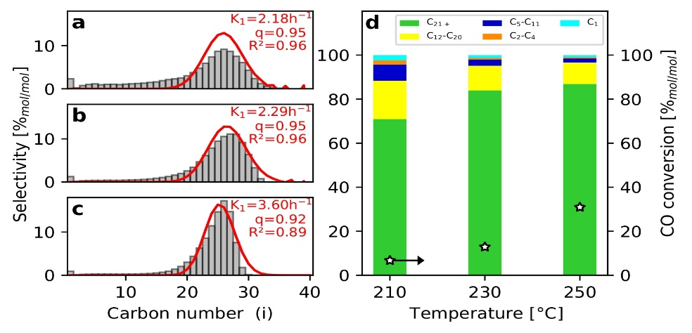

**Figure 6**. Product distribution as a function of temperature, and fitted living model: (a) 210 °C, (b) 230 °C, and (c) 250 °C

The estimated constant values (*K1* and *q*) indicated that the kinetic parameters depend on the chain length and temperature, as shown in Fig.6-a, b, and c. To support this statement and confirm whether the parameters are in fact distinct, the convergence of the objective-function values obtained by PSO were investigated, as illustrated in Fig.7-a1, b1, and c1.

The likelihood confidence regions of the estimated model parameters are displayed in Fig. 7-a2, b2, and c2. Remember that even though the graph's so-called "global minimum" is denoted by a red X, all of the gray dots that make up the region are equally likely, with a 95% confidence level. According to Fig.6-a and b, the minimum values estimated for the parameter q in this experimental range were very similar and not overly sensitive to the reactor temperature. The second parameter, however, was positively impacted by the reaction temperature, with *K1* equaling 2.17 h-1, and 2.29 h-1, respectively, for 210 °C, and 230 °C.

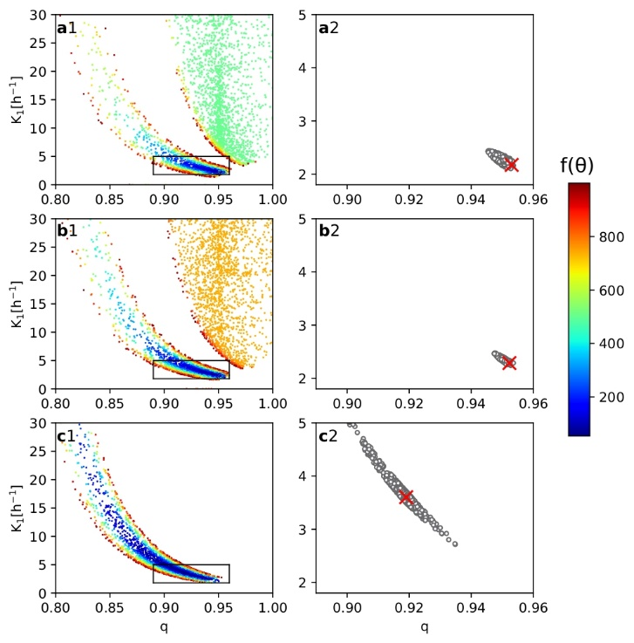

**Figure 7.** (a) 210 °C, (b) 230 °C, and (c) 250 °C. (1) Objective function final values, and (2) likelihood confidence region

However, when the temperature was higher (250 °C), the likelihood confidence region was shifted, ensuring the estimation of an undeniably different pair of parameters, as shown in Fig.7-c2. This result shows that the parameters estimated at 250 °C were significantly different from the ones estimated in the other tests, suggesting that from a certain temperature, the events linked to the living mechanism may be favored.

## Conclusions

Using the Co/SiO2 catalyst as a reference, it was shown that the chain size distributions of Fischer-Tropsh Synthesis (FTS) processes do not necessarily follow the Anderson-Schulz-Flory (ASF) distribution, resembling many times the Poisson distribution. For this reason, a new model was proposed to describe chain size distributions, based on a living addition polymerization model for FTS, where propagation reactions are irreversible. After estimating the model parameters with the help of the particle swarm optimization method (PSO), a good agreement was found between the model and the reaction data. Particularly, the reaction temperature was found to exert a significant effect on the estimated model parameters, causing an increase in kinetic rate constants and a decrease in the growth probability value.

## Acknowledgements

The authors thank CNPq (Conselho Nacional de Desenvolvimento Científico e Tecnológico, Brazil) process number 142211/2020-6.

## References

1. Viswanathan, Venkatasubramanian, and B. Matthew Knapp. *Nature Sustainability* **2019**, 88-89.
2. Drünert, S., Neuling, U., Zitscher, T., & Kaltschmitt, M. *Applied energy*, **2020**, 277, 115578.
3. Henrici‐Olivé, G., and Olive, S. *Angewandte Chemie International Edition in English*, **1976**, 15(3), 136-141.
4. Li, J., He, Y., Tan, L., Zhang, P., Peng, X., Oruganti, A., and Tsubaki, N. *Nature Catalysis*. **2018**, 1, 787-793.
5. Madon, R. J. *J. Catal.;(United States*), **1979**, 57(1).
6. Khuwijitjaru, P., Plernjit, J., Suaylam, B., Samuhaseneetoo, S., Pongsawatmanit, R., & Adachi, S. *The Canadian Journal of Chemical Engineering*, **2014**, 92(5), 810-815.
7. Smarzaro, J. L., Baldanza, M. A., de Almeida, A. J., Caytuero, A., Salim, V. M., Passos, F. B., & Teixeira da Silva, V. *Industrial & Engineering Chemistry Research*, **2021**, 60(32), 11942-11953.
8. Westphalen, G., Baldanza, M. A., de Almeida, A. J., Salim, V. M. M., da Silva, M. A. P., & da Silva, V. T. *Catalysis Letters*, **2020**, 152(7), 2056-2066.
9. Juliana L Smarzaro. Tese de Doutorado, Universidade Federal do Rio de Janeiro, 2021.
10. Ray, W. H. *Journal of Macromolecular Science - Reviews in Macromolecular Chemistry*, **1972**, 8(1), 1-56.
11. J. Kennedy and R. Eberhart. *International Conference on Neural Networks*, **1995**, pages 1942–1948
12. J. Blank and K. Deb. pymoo: Multi-objective optimization in python. **2020** Access, 8:89497–89509,
13. E. M. L. Beale. *Journal of the Royal Statistical Society: Series B (Methodological)*, **1960**, 22(1): 41–76.
14. Marcio Schwaab, Evaristo Chalbaud Biscaia, Jr., José Luiz Monteiro, and José Carlos Pinto. *Chemical Engineering Science*, **2008**, 63(6):1542–1552
15. Theodore W. Birky, Joseph T. Kozlowski, and Robert J. Davis. *Journal of Catalysis*, **2013**, 298:130–137