Microwave assisted synthesis of silver nanoparticles using starch

Eliseu da Silva Menger1, Leila Mallmann1, Silma Alberton Corrêa1*

*1 Instituto de Química, Universidade Federal do Rio Grande do Sul, UFRGS, Avenida Bento Gonçalves 9500, 91501-970 Porto Alegre, RS, Brazil. \** *e-mail: silma.alberton@ufrgs.br*

Abstract

This study describes a green synthesis method for silver nanoparticles (AgNPs) using microwave irradiation. The method utilized corn starch as a stabilizing agent and silver nitrate (AgNO3) as a metal precursor, with the pH of the medium optimized for reduction of Ag+ ions, being determine that a basic medium is required. UV-Vis spectroscopy was used to characterize the synthesized AgNPs, which were subsequently impregnated into commercial TiO2 nanoparticles (P25) and tested for the photodegradation of indigo carmine dye. The efficiency of the impregnation process was evaluated using DRS and RBS analyses, revealing a small mass of impregnated Ag and a decrease in the band gap value of the substrate. All samples demonstrated efficacy in the photodegradation of indigo carmine, with the AgNPs-impregnated TiO2 showing slightly lower activity than the non-impregnated commercial TiO2.

*Keywords: AgNPs, green synthesis, microwave, adsorption, environmental remediation*

## Introduction

When silver is in the form of nanoparticles ranging from 1 to 100 nm, it exhibits unique physical, chemical, and biological properties that are not present in bulk silver (1). Specifically, Ag nanoparticles (AgNPs) have a high surface area to volume ratio, which makes them highly reactive and effective at catalyzing various chemical reactions. Additionally, AgNPs have strong antimicrobial properties, making them useful in a variety of medical applications and in water treatment to remove pathogens (2). The synthesis of AgNPs also offers an opportunity to explore new applications in fields such as electronics, optics, and energy, as well as to improve the performance of existing applications (3). Hence, the synthesis of silver nanoparticles (AgNPs) using rapid and cost-effective methodologies holds immense technological significance. Furthermore, the increasing concern regarding the development of environmentally sustainable synthesis protocols is a contemporary trend that warrants consideration.

The most common bottom-up approach method used for the synthesis of AgNPs is the chemical reduction (4), since it has the advantages of high yield and lower energy consumption compared to physical methods. Like other chemical synthesis methods, it consists of using three main reagents: a metal precursor, a reducing agent, and a stabilizing agent. Following the principles of green chemistry, it is necessary to employ reagents with low toxicity. The use of plant extracts and natural molecules such as enzymes, vitamins, and polysaccharides for the synthesis of AgNPs has proven to be a good alternative route to classical synthesis (5).

The chemical synthesis of AgNPs at room temperature occurs very slowly and therefore requires a heating step for the reaction to occur more quickly and efficiently. However, more classic heating methods such as electric heating can consume large amounts of energy and time. As an alternative, microwave (MW) irradiation has been explored as a more economical and faster option (6), as well as offering homogeneous heating of the reaction medium. Therefore, in this work the synthesis of AgNPs by MW assisted chemistry using food grade corn starch as the stabilizing agent and AgNO3 as the metal precursor was investigated and the pH of the medium that leads to the reduction of the Ag+ ions to form the metallic AgNPs was determined.

Among the variety of possible applications of the silver nanoparticles, their capability to enhance the photocatalytic behavior titanium dioxide (TiO2) was evaluated. TiO2 has a low absorption rate for visible wavelengths, so the strategy is to add AgNPs into the TiO2 nanocomposites in order to reduce its band gap and act as electron traps (7). The addition of AgNPs to TiO2 enhances its visible light absorption, allowing for more efficient photo-remediation of organic pollutants (8). In this work, we exploit the photodegradation of the indigo carmine dye using a nanostructure based in the incorporation of AgNPs in commercial TiO2 NPs. The indigo carmine (IC) is widely used by the textile industry, especially for dyeing denim fabric used in jeans manufacturing (9). Being a disodium salt, it is considered an anionic dye, which has a maximum absorbance at a wavelength of 610 nm and presents an intense blue color.

## Experimental

*Microwave-assisted synthesis of silver nanoparticles*

For the preparation of colloidal silver nanoparticles (AgNPs), silver nitrate (AgNO3) from Plat LAB (Comércio de Artigos para Laboratórios e Serviços Ltda) was the precursor, food grade corn starch (Maizena®, Garanhuns/PE e Brazil) was the stabilizing agent, and ultrapure water (Milli-Q®) was the solvent. The starch solutions (1.25 – 10 g.L-1) were prepared by dissolving corn starch in water followed by heating until boiling point was reached and complete dissolution of the starch in the solution occurred. Then, the solutions were cooled down to room temperature. A stock solution of AgNO3 in water with a concentration of 0.5 mol/L was prepared and added to 30 mL of the starch solution with stirring using a micropipette (180 µL). The as prepared solutions of each synthesis were then placed into a polytetrafluoroethylene (PTFE) reactor and irradiated in a domestic microwave (MW) oven at maximum power of 1400 W, for 36 s. A representation of the synthesis procedure is displayed in Figure 1. In order to study the effect of the pH of the solution in the reduction of the silver ions, a series of syntheses were also performed by adding certain amounts of NaOH (3 mmol.L-1) or HNO3 (65%) aqueous solutions in the reactor.

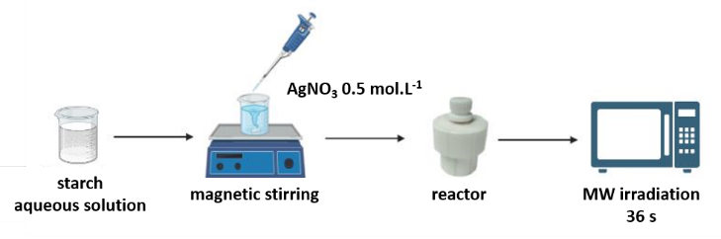**Figure 1.** Schematic representation of the synthesis of AgNPs using starch aqueous solution and MW irradiation.

*Photocatalyst preparation*

Titanium dioxide NPs powder, AEROXIDE® TiO2-P25 from EVONIK (a mixture of about 75% anatase and 25%  
rutile) was used as received from Degussa Corporation. The AgNPs obtained by MW irradiation using starch as the stabilizing agent were impregnated in the TiO2NPs (P25) by wet impregnation method. The P25 powder was dispersed in ultrapure water and subjected to sonication for 1 hour. Subsequently, colloidal AgNPs were added to achieve weight percentages (wt. %) of Ag/TiO2 at 0.5, 1.0, 1.5, and 3.0 wt. %. The suspension was kept under sonication for 1h and then allowed to settle for 3 days. The supernatant was removed, and the precipitate was transferred onto a glass plate and dried in an oven at 80°C for 12 hours. Afterward, the sample was calcined in atmospheric air for 3h at 400°C (heating rate of 3°C/min).

*Characterization*

The characterization of the colloidal nanoparticles obtained after each of the synthesis was performed by UV-Vis spectroscopy measurements in the wavelength range of 200 – 800 nm, using a Cary® 50 UV-VIS – Varian spectrometer. A Cary® 5000 – Varian spectrometer with an integrated sphere was used to evaluate the optical properties of the P25 and of the P25 impregnated with the synthesized AgNPs in the wavelength range of 200 – 800 nm. In order to determine the numerical values of the band gap for the observed systems, the Kubelka-Munk function was used (10), which relates reflectance to the energy of incident radiation [F(R) = (1-R)2/(2R), where R is the reflectance]. The values were obtained by extrapolating the linear behaviors presented by the function [F(R)*hv*]1/2, where "*h*" is Planck's constant and "*v*" is the frequency of light.

The amount of silver impregnated in the TiO2 was determined by Rutherford Backscattering Spectrometry (RBS). For this, about 30 mg of the samples obtained after calcination were suspended in 100 μL of isopropanol. Successive droplets of the suspension were deposited on a C substrate (99.8% purity, 1 mm thickness). The analyses were carried out at the Ion Implantation Laboratory (IF-UFRGS), on the 3 MV Tandetron accelerator, using a 2 MeV He+ beam with incidence perpendicular to the sample surface. Solid-state detectors were used, with a detection angle of 165° relative to the direction of the incident beam. The obtained data were analyzed using SIMNRA (11). The atomic ratios obtained were converted into mass, and the results were compared with the nominal data used in the impregnations.

An aqueous solution of indigo carmine (Merck, Brazil) dye with a concentration of 40 mg.L-1 was used in the photodegradation experiments. Initially, the adsorption of the dye in the photocatalyst was monitored. For that, 35 mg of the photocatalyst were dispersed in the 40 mg.L-1 stock solution of indigo carmine (IC) by sonication for 15 min followed by 45 min of magnetic stirring. This procedure was repeated for all degradation assays involving P25 and impregnated samples prior to the UV-Vis irradiation. The photodegradation experiments were carried out using 35 mg of the photocatalyst that were placed in a 50 mL beaker with 35 mL of the IC solution. The mixture was then sonicated for 15 min and transferred to a quartz photochemical reactor in a dark box where it remained under magnetic stirring for 45 min. For the irradiation, a high pressure Xe/Hg lamp of 350 W (Scientech) set at 60 W was used. The change in concentration of the dye was monitored regularly by measuring the absorbance at 610 nm.

The photodegradation of the indigo carmine dye in the absence of a catalyst was also evaluated under UV-Vis irradiation. For this, 35 mL of the stock solution of IC were irradiated for 120 min in a quartz reactor.

## Results and Discussion

*Ag nanoparticles synthesis and characterization*

Several synthesis parameters were varied to evaluate their influence on the reproducibility, efficiency, and optical properties of AgNPs. The obtained samples were analyzed by UV-Vis spectroscopy, because a surface plasmon resonance (SPR) band can be observed due to the collective oscillation of surface electrons in metallic silver (12). The maximum absorption wavelength (λmax) and full width at half maximum (FWHM) were employed as parameters to optimize synthesis conditions, as they are recognized indicators of nanoparticle size distribution. The conditions that yielded a sharper and narrower SPR peak, suggesting a smaller nanoparticle size distribution, were selected for subsequent syntheses.

The concentration of the silver precursor was kept constant at 3 mmol.L-1 for all synthesis and the same MW irradiation time was used, 36 s. For the first set of experiments, the concentration of starch solution was also kept constant at 10.00 g/L. The syntheses were conducted in the presence of different amounts of HNO3 and NaOH, which were added to adjust the pH of the solution and control the size and stability of the nanoparticles. UV-Vis spectroscopy was used to analyze the resulting AgNPs and determine their optical properties, results are shown in Figure 2.

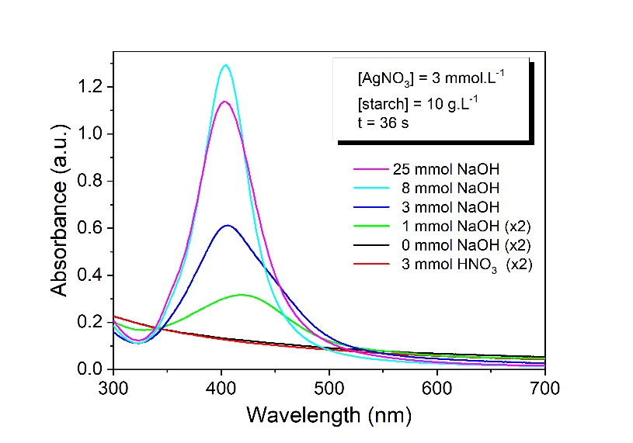

**Figure 2.** UV-Vis spectra of AgNPs synthesized with 3 mmol.L-1 of silver precursor and 10 g.L-1 starch in the presence of variable amounts of HNO3 and NaOH.

As can be seen in Figure 2, the formation of silver nanoparticles did not occur in acidic and neutral conditions, likely due to the absence of starch hydrolysis, which is a necessary step for nanoparticle formation. To investigate this further, the amount of NaOH was varied, to determine its impact on nanoparticle formation. The λmax varied between values of 404 to 418 nm. It was found that the use of concentrations lower than 8 mmol.L-1 led to shift of λmax to longer wavelengths, indicating an increase in the average size of the formed nanoparticles. In addition, a narrowing of the peak (FWHM from 132 to 54 nm) was also observed with increasing NaOH concentration, suggesting a smaller size distribution of the synthesized AgNPs.

The effect of varying the starch concentration was also evaluated. For this purpose, the starch concentration was increased from an initial concentration of 1.25 g.L-1 using the fixed optimized concentration of 8 mmol.L-1 of NaOH that led to the proper reduction of the silver ions and formation of the metallic NPs. UV-Vis results are displayed in Fig. 3 and show that increasing the starch concentration causes a shift of the band to the left (λmax from 418 nm to 408 nm), which indicates a decrease in the average size of the formed nanoparticles. Additionally, it was observed that the FWHM decreases from 86 nm for the 1.25 g.L-1 synthesis to 64 nm for the 10.00 g.L-1 synthesis, suggesting a smaller size distribution of the AgNPs. Therefore, the concentration of 10.00 g.L-1 of starch was used for the remaining experiments.

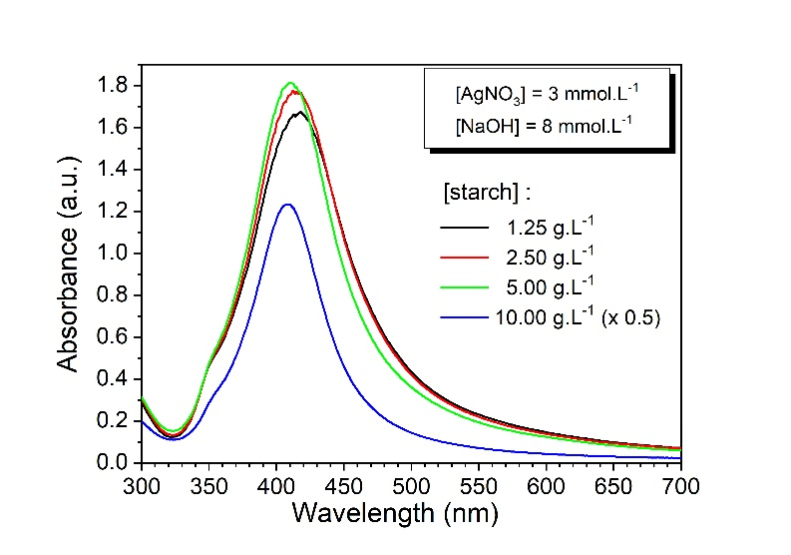

**Figure 3.** UV-Vis spectra of AgNPs synthesized with 3 mmol.L-1 of silver precursor and 8 mmol.L-1 of NaOH using different starch concentrations.

*Synthesis reproducibility*

Once the parameters of the synthesis were optimized it was important to verify if the developed method was consistent and reliable. Therefore, a reproducibility test was performed to ensure accuracy of the experimental findings. In Figure 4, there are results for 6 replicates of the synthesis of AgNPs using 36 s MW irradiation, 30 mL of a 10 g.L-1 starch solution, 8 mmol.L-1 of NaOH and 3 mmol.L-1 of AgNO3. The experiments were conducted by the same operator and using the same equipment through two different days. It is noteworthy that the UV-Vis spectra analysis showed no significant changes in the maximum absorption and the width of the absorption band among the replicates.

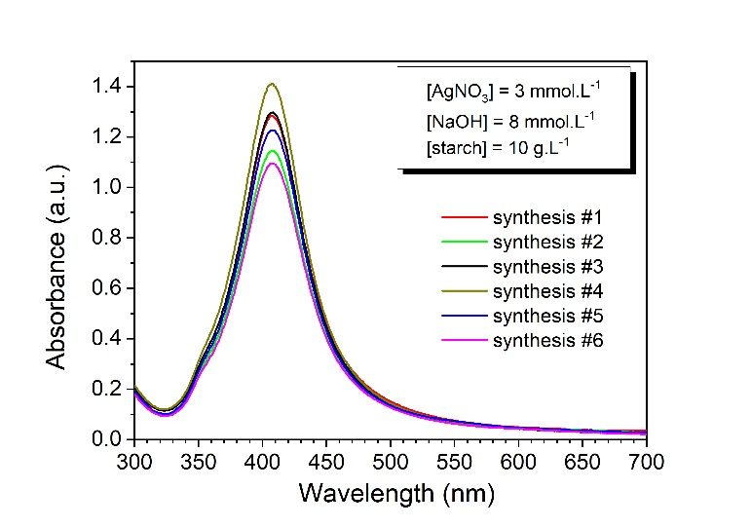

**Figure 4.** UV-Vis spectra of AgNPs for a series of synthesis using the same parameters: 3 mmol.L-1 of silver precursor, 8 mmol.L-1 of NaOH, and 10 g.L-1 starch concentration.

*Characterization of the TiO2 impregnation*

From the analysis of diffuse reflectance spectroscopy, it was possible to characterize the resulting impregnations regarding the effectiveness of AgNPs fixation. Figure 5 shows the reflectance data for the P25 sample and for the calcined samples after impregnation.

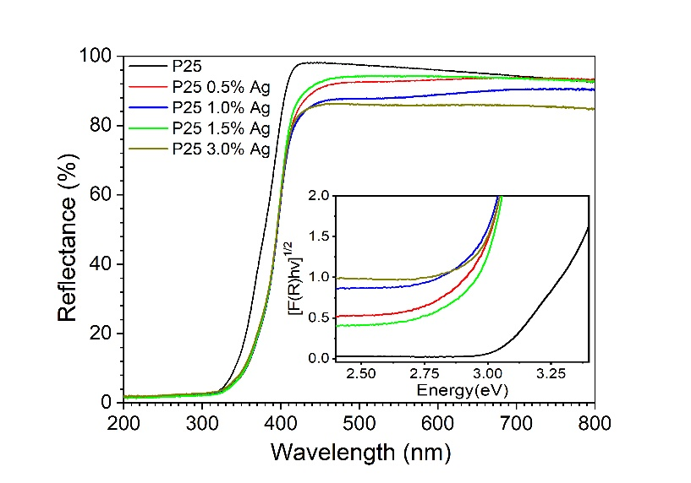

**Figure 5.** UV-Vis diffuse reflectance spectra of TiO2NPS and TiO2@AgNPs with different Ag amounts. Inset displays a zoom of the region between 2.4-3.4 eV used to determine the band gap for the data analyzed using the Kubelka–Munk model.

A decrease in reflectance for longer wavelengths can be observed in the impregnated samples compared to the non-impregnated P25. This indicates that the absorbance for lower energy irradiation, i.e. towards the visible spectrum, is slightly higher for the synthesized catalytic systems. The band gap values found were: P25, 3.17 eV; P25 0.5% Ag, 2.91 eV; P25 1.0% Ag, 2.94 eV; P25 1.5%, 2.90 eV Ag; and P25 3.0% Ag, 2.91 eV, suggesting low efficiency of the impregnations. The low effectiveness of the impregnation was confirmed by RBS for the targeted impregnations of 1.5 and 3.0% Ag by weight. For these samples, values of only 0.24 and 0.41% Ag/TiO2 wt. % were obtained, respectively, that are considerably smaller than the intended amounts used in the impregnation. Therefore, further research is necessary to improve the impregnation methods used in this system and achieve higher loading ratios of AgNPs in TiO2.

*Photodegradation of indigo carmine*

To investigate the effects of irradiation on indigo carmine, a dye solution was irradiated with an Hg/Xe lamp in the absence of a photocatalyst. The results of the photolysis test (not shown) after 120 min of irradiation at 60 W, show that the 40 mg.L-1 IC solution exhibited a degradation of 24% relative to the initial concentration. This indicates that indigo carmine dye is susceptible to photoexcitation and degradation without the presence of a catalyst. The adsorption phenomenon is also a key factor for the degradation reaction to occur and is directly related to its efficiency. Thus, adsorption tests were conducted before the photodegradation. The results of the adsorption in the dark revealed that the system reached maximum adsorption after 45 minutes of magnetic stirring. The adsorption step was conducted prior to the photodegradation tests for all samples.

UV-Vis spectra of the IC solution were collected at 15 min intervals of irradiation under 60 W using the Hg/Xe lamp. An example of the photodegradation using the sample P25 1.5 wt.% Ag is displayed in Fig. 6. Results obtained for all the photodegradation of indigo carmine experiments using TiO2 samples impregnated with AgNPs are shown in Figure 7. For comparison, the results of photolysis and adsorption tests are also shown, as well as data for the non-impregnated P25 catalyst.

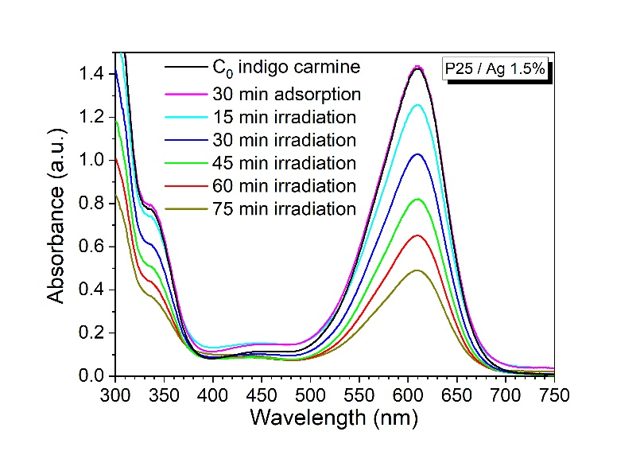

**Figure 6.** UV-Vis spectra of the indigo carmine dye in the presence of TiO2NPs (P25) impregnated with the synthesized AgNPs (1.5 wt.% Ag). The initial indigo carmine concentration was 40 mg.L-1 and the photocatalyst concentration was 1 g.L-1. Data for the indigo carmine solution and for the adsorption experiment are also shown for comparison. The irradiation was performed using a Hg/Xe lamp at 60 W.

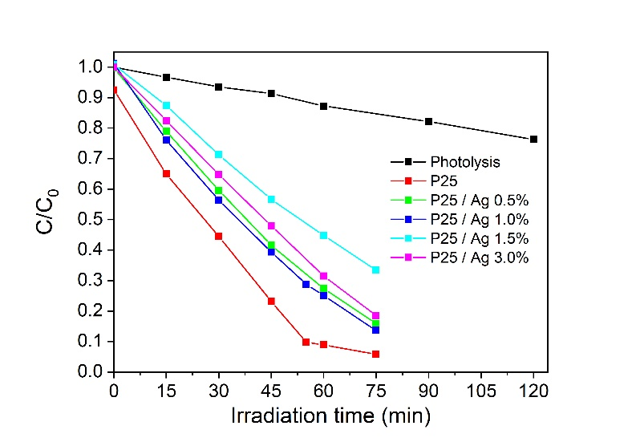

**Figure 7.** Results of the photocatalytic degradation of the indigo carmine dye using different loading of the synthesized AgNPs in commercial TiO2NPs (P25). All experiments were carried using 1 g.L-1 of the photocatalyst and irradiation by a Hg/Xe lamp (60 W).

## Conclusion

A method for a sustainable synthesis of AgNPs using food grade starch in basic medium and microwave irradiation was demonstrated. Results shown that the synthesis presented high efficiency and reproducibility. Characterization of the synthesized AgNPs by UV-Vis indicated a small particle size and homogeneous size distribution when 10.00 g.L-1 starch, 8 mmol.L-1 NaOH, and 3 mmol.L-1 AgNO3 were employed. The impregnation of commercial TiO2NPs (P25) with the synthesized AgNPs led to low values of Ag mass effectively impregnated, as revealed by DRS and RBS characterization. Photodegradation of the indigo carmine by all samples showed higher efficiency than photolysis. Furthermore, the non-impregnated commercial P25 presented higher efficiency in the photodegradation than impregnated P25, for the same irradiation period. The methodology described in this work for synthesizing AgNPs also holds potential for other applications, such as photocatalytic hydrogen generation or as an antibacterial agent.

## Acknowledgments

## The authors would like to thank to CNPq and FAURGS for the financial support.

References

1. A. Nel; T. Xia; L. Mädler; N. Li., *Science*, **2006**, *311*, 622–627.
2. M. A. Islam; M. V. Jacob; E. Antunes, *J. Environ. Manage*, **2021**, *281*, 111918.
3. A. Bouafia; S. E. Laouini; A. S. A. Ahmed; A. V. Soldatov; H. Algarni; K. F. Chong; G. A. M. Ali, *Nanomaterials*, **2021**, *11*, 2318.
4. X. F. Zhang; Z. G. Liu; W. Shen; S. Gurunathan, *Int. J. Mol. Sci.,* **2016**, *17*, 1534.
5. A. Zuhrotun; D. J. Oktaviani; A. N. Hasanah, *Molecules,* **2023**, *28*, 3240.
6. A. Kumar; K. Yun; L. Zheng; X. Sun, *Mater. Today Nano*, **2020**, *11*, 100076.
7. S. M. Gupta; M. Tripathi, *Chinese  
   Science Bulletin*, **2011**, *56*, 1639-1657.
8. M. Anjum; R. Miandad; M. Waqas; F. Gehany; M.A. Barakat, *Arab. J. Chem.*, **2019**, *12*, 4897-4919.
9. M. F. Chowdhury; S. Khandaker; F. Sarker; A. Islam, M. T. Rahman, M. R. Awual, *J. Mol. Liq.*, **2020**, *318*, 114061.
10. J. O. Marques; C. R. Bellato; C. H. F. de Souza; R. C. da Silva; P. A. Rocha, *J. Braz. Chem. Soc*., **2017**, *28*, 2301-2312.
11. M. Mayer, *AIP Conf. Proceed.*, **1999**, *475*, 541-544.
12. O. Pryshchepa; P. Pomastowski; B. Buszewski, *Adv. in Colloid & Interface Sci*. **2020,** 284, 102246.