Novel Imidazolium-Based Ionic Liquid/Mordenite composites for CO2 capture. An ONIOM-DFT study.

Rodolfo Izquierdo 1,2 *, Rafael Zadorosny 1, Gustavo Chacón 3, Jairton Dupont 3, and Hubert Stassen 2

1 Universidade Estadual Paulista (UNESP), Faculdade de Engenharia, Departamento de Física e Química, Avenida Brasil, 56 – Centro, Zip Code 15385-000, Ilha Solteira – SP, Brazil.

2 Grupo de Química Teórica, Instituto de Química, UFRGS, Av. Bento Gonçalves, 9500, Porto Alegre, RS 91540 180, Brazil.

3 Laboratory of Molecular Catalysis, Instituto de Química, UFRGS, Av. Bento Gonçalves, 9500, Porto Alegre, RS 91501 970, Brazil.

*Corresponding Authors.e-Mail Address: [reis131182@gmail.com](mailto:reis131182@gmail.com), [rodolfo.izquierdo@unesp.br](mailto:rodolfo.izquierdo@unesp.br),

Resumo/Abstract

RESUMO - As emissões de dióxido de carbono (CO2) na atmosfera influenciam drasticamente a mudança climática global. Com o atual nível de emissão de CO2, o objetivo da Agenda 2030 da ONU para desenvolvimento sustentável não será atingido. Assim, para evitar a iminente catástrofe climática é necessária uma diminuição da poluição usando captura, armazenamento e utilização de CO2 (siglas em inglês “*CCSU*”). Resolver estas questões requer o desenvolvimento de materiais a uma velocidade sem precedentes. Neste trabalho, abordaremos alguns dos resultados mais recentes no design *in sílico* de novos materiais adsorventes para *CCSU*. Demonstramos através de cálculos híbridos ONIOM-DFT a melhor *via* para sintetizar novos materiais com aplicações tecnológicas sustentáveis. Em particular, focaremos no mecanismo de formação de novos compósitos ([M]-MOR), combinando Na-MOR com alguns líquidos iônicos ([M]Cl): 1-(3-amino-etil)-3-metil-3*H*-imidazolium cloreto [2-AEMIm]Cl, 1-(3-amino-propil)-3-metil-3*H*-imidazolium cloreto [3-APMIm]Cl, *R*-1-(2-amino-propil)-3-metil-3*H*-imidazolium cloreto [*R*-2-APMIm]Cl e *S*-1-(2-amino-propil)-3-metil-3*H*-imidazolium cloreto [*S*-2-APMIm]Cl. Nossos resultados mostram que o [2-AEMIm]-MOR apresenta condições eletrônicas e estéricas para aplicações *CCSU*.

*Palavras-chave: ONIOM, DFT, CO2, mordenita, líquido iônico.*

ABSTRACT - The human carbon dioxide (CO2) emissions in the atmosphere dramatically influence global climate change. Maintaining the actual reduction in greenhouse gas emissions must not achieve the United Nations Sustainable Development Goals by 2030. Accordingly, an imminent climate catastrophe calls for a pollution decrease*, e.g.*, using technologies based on CO2 capture, storage (CCS) or CO2 capture, storage, and utilization (CCSU). Solving these issues requires the development of new adsorbent materials at an unprecedented step. Here, we demonstrated using ONIOM-DFT hybrid calculations the best way to synthesize new materials with environmentally friendly technological applications. We focused on the formation mechanism of novel composites (*i.e.*, [M]-MOR) combining Na-MOR with various ionic liquids (*i.e.*, [M]Cl): 1-(3-amino-ethyl)-3-methyl-3*H*-imidazolium cloride [2-AEMIm]Cl, 1-(3-amino-propyl)-3-methyl-3*H*-imidazolium cloride [3-APMIm]Cl, *R*-1-(2-amino-propyl)-3-methyl-3*H*-imidazolium cloride [*S*-2-APMIm]Cl, and *S*-1-(2-amino-propyl)-3-methyl-3*H*-imidazolium cloride [*S*-2-APMIm]Cl. The [2-AEMIm]-MOR composites presented electronic and steric conditions for potential applications in CCS and CCSU.

*Keywords: ionic liquid, mordenite, CO2, DFT, ONIOM*

## Introduction

Nowadays, humanity has achieved unprecedented population and economic growth (PEG). At the same time, both PEG and accelerated industrial production demand energy consumption at an unsustainable rate [1]. Unfortunately, fossil fuel-based energies dominate the global energy market—consequently, the levels of pollutants generated from fossil fuel combustion increase daily. In particular, carbon dioxide (CO2), the main greenhouse gas (GHG) emitted by human activities, is a most challenging task for mitigating global climate change [2]. In 2015, the Sustainable Development Goals (SDGs) and the Paris Climate Agreement signatories countries aimed to reach the peak of global greenhouse gas (GHG) emissions as quickly as possible and then rapidly undertake their reduction, conversely at present, most countries struggle to achieve the proposed carbon neutrality target, which is the realization of a sustainable, low-carbon economy with minimum CO2 emissions [3].

Based on the above, clean energy transformations and pollution decrease, *e.g.*, using the CO2 capture, storage, and utilization (CCSU) processes, are essential to avoid an imminent climate catastrophe. Tackling these issues requires the development of new materials with applications ranging from selective adsorbents to efficient catalysts at an unprecedented pace. In particular, the currently used leading CO2 capture technology includes the chemical absorption of acid gases (CO2 and H2S) using aqueous solutions of ethanolamines [4]. Generally, the use of amines has several drawbacks, including vaporization losses, high heat requirements for regeneration, and equipment corrosion. Fortunately, many more sustainable new methods and materials for CCSU technologies have been investigated to overcome those limitations [5–7].

Among the most promising materials to CCSU technologies, those based on absorption with solvents as ionic liquids (ILs) call attention. In 1999, Blanchard *et al.* [8] reported that CO2 has a high solubility in an IL on the imidazolium cation (Im-IL), [BMIm][BF6]. Results of experimental works using spectroscopy and theoretical studies show that interactions between CO2 and the anion moiety of the ionic compound dominate the extent of the solubility of CO2 in ILs [9]. At the same time, the cation only plays a major role when changing the precursor's functional groups (such as amino and hydroxy groups) to develop "task-specific" ILs for CO2 capture [10].

On the other hand, the zeolites (Z) are microporous materials composed by [TO4] tetrahedra (where T= Si or Al) sharing O atoms with other four [TO4] neighbors. These tetrahedra form well-defined channels with pore apertures of the n-membered ring (*n*-MR, where *n* is an integer, see mordenite (MOR) in Figure 1). The isomorphic substitution (IS) of silicon (Si4+) by aluminum (Al3+) introduces a negative charge in the zeolitic framework (zeolitic anion, Z-), which has to be compensated by exchangeable ions (Mn+, to charge compensation by ion exchange, IE), such as inorganic cations (*e.g.*, H+, Na+, and K+), and less frequently organic cations (*e.g.*, Pyridinium, C5H6N+) [11]. When these Mn+ are replaced by H+ a Brönsted acid-site (BAS) is produced (*i.e.*, protonic zeolites, H-MOR), whereas when the Mn+ is replaced by Na+ a sodium mordenite is produced (Na-MOR).

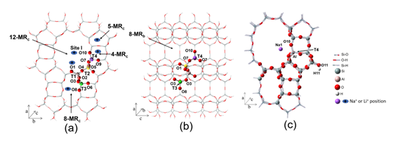

**Figure 1.** MOR fragment. Main straight unidimensional channels 12-MRc, 8-MRc, 5-MRc and 4-MRc (a). Projection of side pocket channel 8-MRb (pink, yellow, green, and purple atom balls represent crystallographic positions for IS (Tn), meanwhile red one represent the 10 non-equivalent Om where BAS can be generated) (b). Initial geometry of Na-MOR model used in this work (Site I). (c).

Some zeolites offer chemical architectures with tunable pore size and high surface area, providing enormous potential for encapsulating CO2 (*e.g.,* Na-X, and Na-SAPO-34, see Table 3 in ref. [12]) and H2S (*e.g.*, Ag-X, Fe-NaA, Cu-ETS-2, see Table 6 in ref. [13]). However, the adsorption capacities of standard zeolites decrease rapidly with the temperature and moisture, which could reduce their CO2 and H2S uptake. In addition, their selectivity to CO2, and H2S in the existence of other gases (N2, CH4, H2O, *etc.*) is not ideal [14,15]. Hence, the zeolites are susceptible to be modified for applications in the capture, storage and utilization of CO2 for unconventional applications such as undersea separation of CO2, exhaust gas in laboratory or garbage dump among others [16,17].

Strategically, targeted tailoring of the interior cages of zeolites and reversible physisorption processes by controlling weak van der Waals (dWs) forces (*e.g.*, by IE of organic cations in zeolite) could tune the acid gases' capture capacity and selectivity while softening regeneration temperatures. In this sense, Kuznicki *et al.* [18] reported the first molecular gate material, ETS-4, with adjustable pores for size-selective adsorption of molecules. Yang *et al.* [19] reported that adjusting the proportions of extra-framework K+ and Cs+ cations achieved building a molecular gate or trapdoor on ZK-5 for CO2 removal from CH4 or N2 with unusually high selectivity [19]. Shang *et al.* [20] explained the capture and separation of CO2 from N2 and CH4 in Cs-CHA through a molecular trapdoor mechanism using DFT calculations. This study based its arguments on the higher CO2 polarity concerning CH4 and N2, which creates an elongated potential over the cation. This potential favors a temporary, reversible removal of the 8-MR center, clearing the way for the CO2 to hop into the cage (see Figure1 in ref. [21]). Other separations via molecular trapdoor have recently been reported: CO2 from H2 by using Na-SSZ-27 [22] and N2 from CH4 by using K-ZSM-25 [23]. Chen *et al.* [24] recently reported a critical review of the gating and molecular trapdoor effects for gas adsorption in zeolites, emphasizing their mechanisms and applications.

We recently reported an *in silico* design of a new composite from the combination of H-MOR with imidazolium-based ionic liquids (*e.g.*, 1-(2-hydroxyethyl)-3-methyl-imidazolium chloride [HEMIm]Cl which generates [HEMIm]-MOR) with potential application in selective H2S capture from natural gas using a mechanism of H2S conformational traps similar to the trapdoor effect [25]. In our view, the main drawback to producing H2S trapdoors from IE of extra-framework inorganic cations in zeolites is a higher binding energy for and a selectivity toward H2O over H2S. Thus, we overcome this limitation by IE of organic cations in the zeolite. Unfortunately, the separations of CO2 *via* trapdoor effects were challenging for the hydroxy-functionalized composite [HEMIm]-MOR. Extending the impact to large pore-size zeolites (e.g., MOR, FAU) could open the application towards new mixed CCSU technologies. Amino-functionalized ILs inside the zeolite cavities can produce interesting modifications in a resulting composite's physical and catalytic behavior. By combining the potentialities of amino-functionalized-ILs and Na-MOR, new materials with exceptional capacities could be obtained for CO2 capture.

Here, we present a computer-aided design of multifunctional hybrid materials using the IE of Na+ by [M]+ cations of amino-functionalized Im-ILs (see Figure 2) in Na-MOR to produce a new type-[M]-MOR composites. Based on the selected [M]+ of the [M]-MOR composites, it is possible to find the main non-covalent interactions between [M]-MOR and CO2. Hence, we assumed that depending on the structure of [M]-MOR composites, new reversible adsorption mechanisms for CO2 capture with potential use in CCSU technologies could be discovered.



**Figure 2.** Scheme of the exchangeable cation fragments ([M]+) on Na-MOR proposed in this work.

## Experimental

*Calculation procedures.*

All geometry optimizations, energy and frequency calculations were carried out with the GAUSSIAN-2009 (G09) program [26]. The optimized structures were classified according to the frequency calculations. The frequencies permit distinguishing between the minimum energy structures (all frequencies positives) in reagents, intermediates, and products or the first-order saddle points (with only one imaginary frequency) in a transition state (TS). TSs have been obtained with the synchronous transit-guide quasi-Newton (STQN) methods, using the keyword OPT=QST3. The reaction thermodynamic-functions (ΔF), energy (ΔE), enthalpy (ΔH), and free energy (ΔG) were calculated at 1 bar and 298 K.

We have chosen the ONIOM two-layer (ONIOM2) methodology to model the Na-MOR and its anion. PM6 semiempirical and DFT (ωB97X-D) levels of theory have been used for the low- and the high-level calculations in the ONIOM2 methodology, respectively. In the high-level layer, the pseudopotential LanL2DZ represented Si, H, and O and the basis set 6-311++G(d,p) for the AlO4Na fragment (site T4O10).

Initially, the atomic coordinates of the MOR structure were taken from the International Zeolite Association (IZA) [27]. The designed Na-MOR cluster model had an AlNaH86O174Si106 stoichiometry (see Figure 1c). In ONIOM calculations, the high-level model consisted of 27 tetrahedrons (TO4) containing the T4O10 site, see ball and stick representation in Figure1c, whereas the real system contains 107 tetrahedrons (27T, 107T).

We studied the ionic exchange process (IE) from Na+ to [M]+ only near the position T4O10 inside the 12-MR channel (i.e., the site I in Figure 1) to produce models of [M]-MOR composites (see reaction 2 in Figure 2). Further, we evaluated the gas adsorption process (ads) by optimizing some host-guest complexes between [M]-MOR and the CO2. Finally, some key critical points of the potential energy surface (PES) generated for the different reaction pathways between [M]-MOR and CO2 were studied. The steric maps were obtained using the SambVca 2 Web application [28]

## Results and discussion

*In Silico design from ONIOM-DFT calculations of [M]-MOR using the IE of Na+ by cation of Im-ILs.*

Recently, we studied, using ONIOM-DFT calculations, the interaction of [M]Cl (where [M]+: [MMIm]+, [EMIm]+, [PMIm]+, [BMIm]+, [HEMIm]+) with H-MOR to detail the synthesis of the [M]-MOR composites similar to those studied here [25]. We established all pathways towards the formation of [M]-MOR composites containing [M]+ located inside and outside the zeolitic pore. The most feasible pathway describes the [M]-MOR formation from an ionic mechanism that involves the deprotonation of BAS (DP) on T4O10 site and ion-pair dissociation of [M][Cl] (*i.e.*, the inverse process to the ion-pair formation, IP). Afterward, *via* IP, the anionic mordenite (MOR-) interacts with [M]+ to produce [M]-MOR, and, simultaneously HCl is released. Based on the ion exchange mechanism established for those composites at Ref. [25], we propose forming four (4) new materials using a similar IE process described in reaction 1, combining Na-MOR with the amino-functionalized Im-ILs presented in Figure 2. Figure 3 shows the optimized structures of the [M]-MOR models.

It is known that the alkyl chain rotation in the imidazolium cations ([M]+) in the Im-ILs facile and varies over an extensive range of angles for little cost in energy, and the formed conformers lie within 2.7 kJ mol-1 of each other [29-32]. Conversely, by using the selected model and methodology, it was only possible to obtain an *alternate-anti* conformation around the N1-C7‒C8‒N12 dihedral angle (or N1-C7‒C8‒C9 in [3-APMIm]-MOR) ranging from 62.9º to 71.1º (or 136.0º in [3-APMIm]-MOR) for the [M]+ confined within the pore of one anionic mordenite (MOR-). This fact supports the idea that the charged framework of MOR- can act entropy-trapping and, thus, stabilizing certain unstable species through the confinement effect, as well as through the formation of extra hydrogen bonds between the H*HB* of the amino group and the O9 of the zeolite framework (see Figure 3). this type of stable conformation in [M]-MOR materials will be marked with the superscript "*HB*". In contrast to the hydroxy-functionalized material (*HB*HEMIm]-MOR recently reported by our group, the conformational sampling performed on the amino-functionalized materials reported here (see Figure 2) reveals Boltzmann populations for conformers of less than 1 % at room temperature for the other than *HB*[M]-MOR.

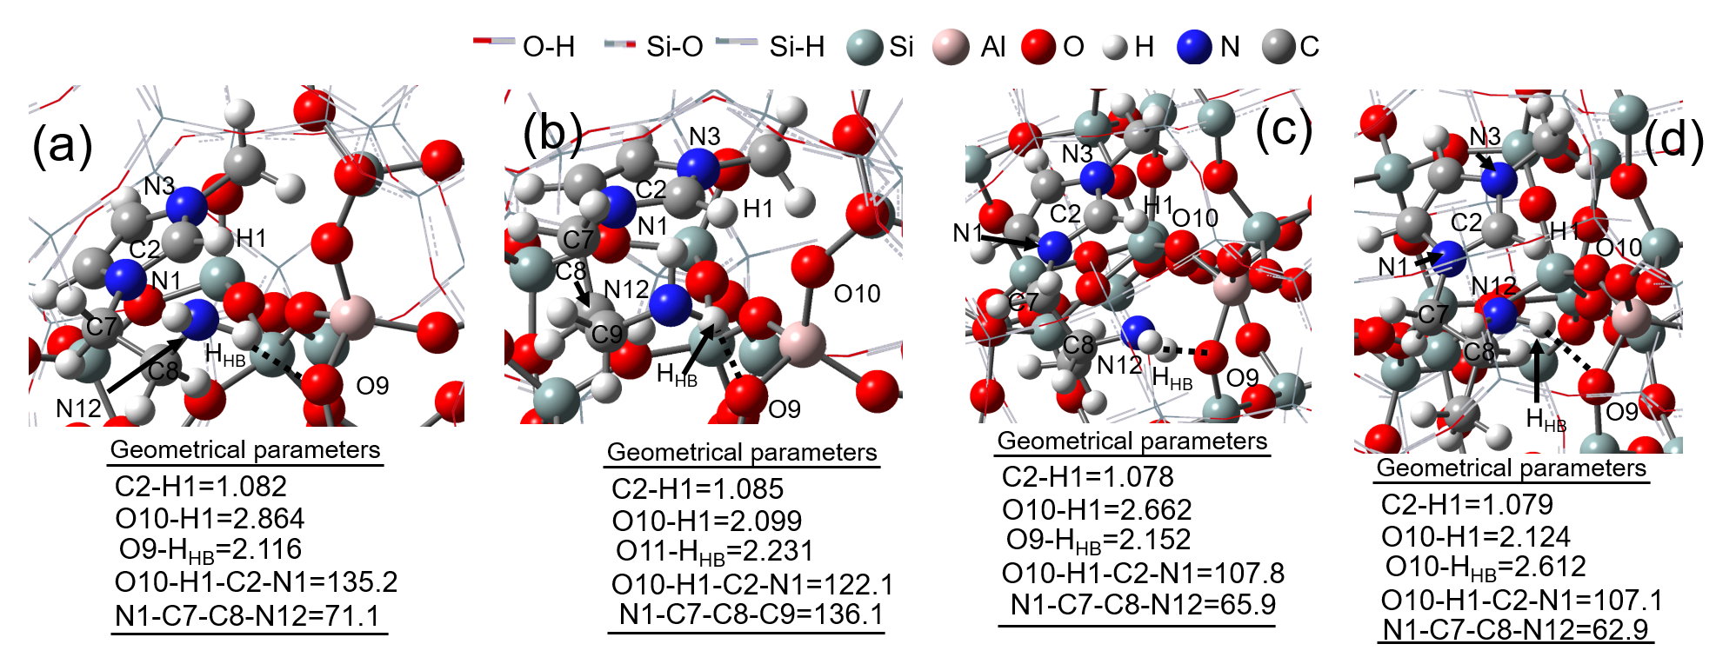

**Figure 3.** Optimized geometry of *HB*[2-AEMIm]-MOR (a); *HB*[3-APMIm]-MOR (b); *HB*[*R*-2-AEMIm]-MOR (c); *HB*[*S*-2-AEMIm]-MOR (d). Geometrical parameters, bond lengths (Å), angles (o) and dihedral (o).

Table 1 shows the ΔF values for the [M]-MOR formation by IE of Na+ by [M]+ on the T4O10 position (site I, see Figure 1). Recall that this reaction represents our model for the [M]-MOR formation. The [M]-MOR formation is exoergic, exothermic, and thermodynamically viable (*i.e.*, ΔFIE < 0 kJ mol-1). Generally, the large ΔFIE magnitudes indicate that the IE process is irreversible, and regardless of the type of [M]Cl. Consequently, a viable synthesis of the novel composites type-*HB*[M]-MOR is expected under room temperature and pressure.

Considering the small magnitudes of ∆FIE for *HB*[*R*-2-AEMIm]-MOR, we could use the confinement effect and shape selectivity of the zeolites to design new separation processes in which the mordenite selectively recognize and reject [*R*-2-AEMIm]+ cations (*i.e.*, an enantiomeric enrichment process) in a racemic mixture of the [*R*,*S*-2-AEMIm]Cl, whereas the *HB*[*S*-2-AEMIm]-MOR composite is simultaneously synthesized. Finally, the *HB*[*S*-2-AEMIm]-MOR composite could induce chirality on the mordenite, thus enhancing the applications of mordenite in molecular recognition and enantioselective catalysis.

**Table 1.** Some ΔFIE of reactions (kJ mol-1) defined in Figure 2 for the formation of [M]-MOR by IE of Na+ by [M]+ on mordenite.



*CO2 Adsorption on the [2-AEMIm]-MOR model.*

No energetic limitations were found to obtain the [M]-MOR composites proposed here. Recently Yoda *et al.* reported the application of the material [BMIm]-MOR for gas capture (*e.g.*, the H2 capture and activation process) [33]. We recently used a steric map theoretical approach to demonstrate steric limitations in the [BMIm]-MOR material, especially in the north-west (NW) quadrant in the crystallographic direction c, which could affect the diffusion of molecules such as H2 and CO2 through the composite [BMIm]-MOR (see Figure 4). Conversely, the steric maps of Figure 4 exhibit a progressive decrease of steric effect produced by the alkyl chain in the NW quadrant, with the burried volume fraction %VBurried(NW) decreasing from 45.9 % in [BMIm]-MOR-T4O10-[MMIm] to 22.8 % in [2-AEMIm]-MOR (see Figures 4b-f). Thus, no steric limitations were found to obtain the [M]-MOR composites proposed in this work (see Figures 4c-f).

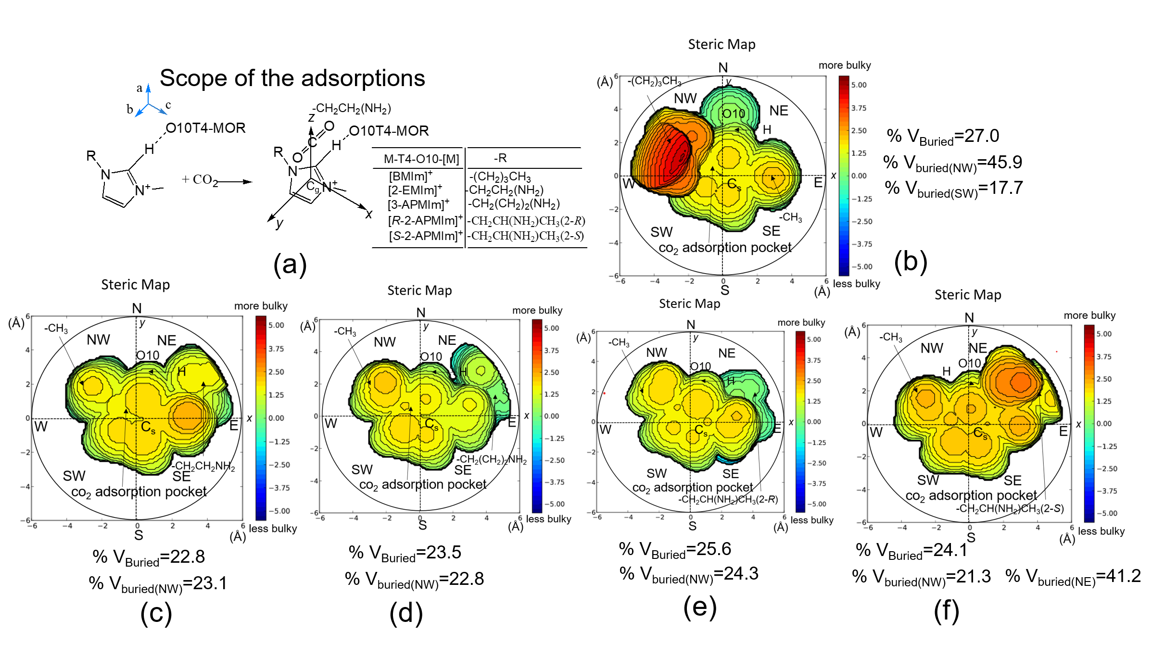

**Figure 4.** Scope of the CO2 adsorption and schematic representation of the adsorption *pocket* (adsorption site above gravity center of [M]+ (Cg)) (a) and the corresponding steric maps for adsorptions of CO2 on [M]-MOR complex: CO2-[BMIm]-MOR)(b), CO2-[2-EMIm]-MOR)(c), CO2-[3-PMIm]-MOR) (d), CO2-[*R*-2-PMIm]-MOR) (e), CO2-[*S*-2-PMIm]-MOR) (f).

In particular, the [2-AEMIm]-MOR interaction with CO2 has been evaluated. The results indicate that CO2 can be chemically captured in the amino function of [2-AEMIm]-MOR (Figure 5a), forming carbamic acid with an apparent activation energy as high as 163.3 kJ mol-1. Thus, this composite in a ***CO2-rich state*** (*i.e.*, CO2-[2-AEMIm]-MOR) can transport CO2 to the end-user. Conversely to amino-functionalized Im-ILs, CO2-[2-AEMIm]-MOR exothermically releases CO2 to complete a CCS cycle regenerating the [2-AEMIm]-MOR (***CO2-lean state***) or *via* CCSU where CO2 can be used to produce commodities (Figure 5b).

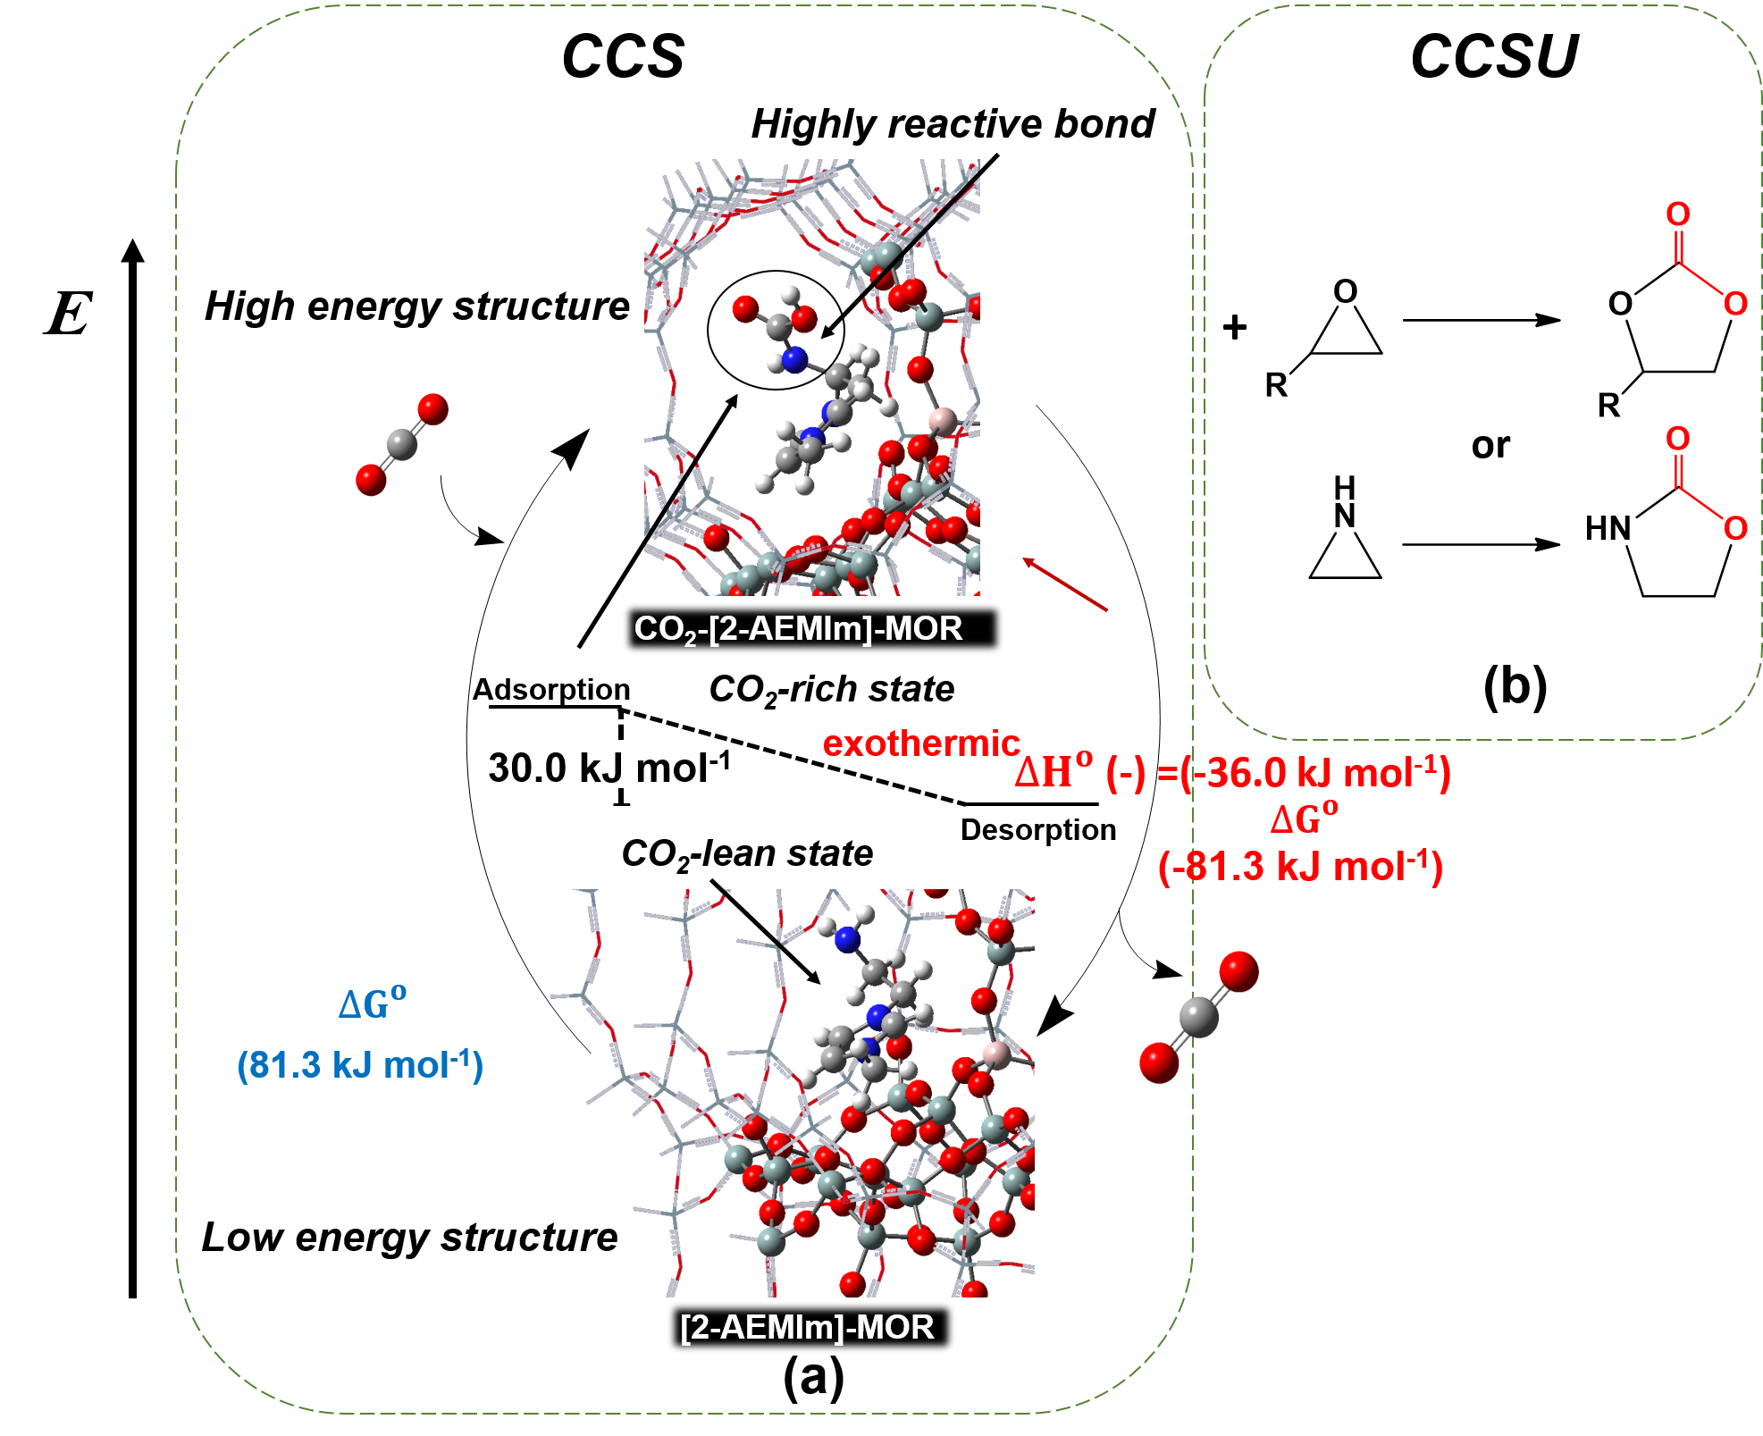

**Figure 5.** CCS concept using [2-AEMIm]-MOR (a). CCSU concept using [2-AEMIm]-MOR (b).

Conclusions

The formation mechanism for new [M]-MOR composites with [M]+= [2-EMIm]+, [3-PMIm]+, [*R*-2-PMIm]+, [*S*-2-PMIm]+ was examined using ONIOM-DFT theoretical calculations. The results indicate that no energetic or steric limitations were observed for the [M]+ penetration inside the MOR confined space. The [2-EMIm]-MOR could have applications in CO2 capture, conversion and utilization technologies.

Acknowledgments

To UNESP for the financial support through Edital PROPe 13/2022 (UNESP-project: 4432), CAPES-finance code 001, UFRGS, gridUNESP, and CESUP-UFRGS.

References

1.- Brazil | Data, https://data.worldbank.org/country/brazil?view=chart (accessed February 13, 2023).

2.- F. Chevallier; G. Broquet; B. Zheng; P. Ciais; A. Eldering, *Geophys. Res. Lett.* **2022**, 49, e2021GL097540.

3.- S. Yang; D. Yang; W. Shi; C. Deng; C. Chen; S. Feng, *Environ. Sci. Pollut. Res.* **2022,** 1–20.

4.- M. Bhattacharya; M.K. Mandal, *J. Clean. Prod.* **2017**, 156, 174–183. https://doi.org/10.1016/j.jclepro.2017.04.034.

5.- N. Álvarez-Gutiérrez; S. García; M. V. Gil; F. Rubiera; C. Pevida, *Towards bio-upgrading of biogas: Biomass waste-based adsorbents*, in: Energy Procedia, Elsevier Ltd, 2014.

6.- D.M. Cristiano; R. de A. Mohedano; W.C. Nadaleti; A.B. de Castilhos Junior; V.A. Lourenço; D.F.H. Gonçalves; P.B. Filho, *Renew. Energy.* **2020**, 154 151–160.

7.- A. Taghvaie Nakhjiri; A. Heydarinasab; O. Bakhtiari; T. Mohammadi, *J. Environ. Chem. Eng.* **2020**, 8, 104130.

8.- L.A. Blanchard; D. Hancu; E.J. Beckman; J.F. Brennecke, *Nat.* **1999**, 3996731. 399, 28–29.

9.- T.M. Gür, *Processes and Technologies, Prog. Energy Combust. Sci.* **2022**, 89, 100965.

10.- S. Lian; C. Song; Q. Liu; E. Duan; H. Ren; Y. Kitamura, *J. Environ. Sci.* **2021**, 99, 281–295.

11.- D. Bae; H. Park; J.S. Kim; J. bok Lee; O.Y. Kwon; K.Y. Kim; M.K. Song; K.T. No, *J. Phys. Chem. Solids.* **2008**, 69, 1152–1154.

12.- R.S. Liu; X.D. Shi; C.T. Wang; Y.Z. Gao; S. Xu; G.P. Hao; S. Chen; A.H. Lu, *ChemSusChem.* **2021,** 14, 1428–1471.

13.- M. Khabazipour; M. Anbia, *Ind. Eng. Chem. Res.* **2019**, 58, 22133–22164.

14.- G. Chen; S. Tan; W.J. Koros; C.W. Jones, *Energy and Fuels.* **2015**, 29, 3312–3321.

15.- R. Bai; X. Song; W. Yan; J. Yu, *Natl. Sci. Rev.* **2022**, Https://doi.org/10.1093/NSR/NWAC064.

16.- M. Yu; S. Zeng; Y. Nie; X. Zhang; S. Zhang, *Curr. Opin. Green Sustain. Chem.* **2021**, 27, 100405.

17.- S. Nanda; F. Berruti, *Environ. Chem. Lett.* 2020, 192. 19, 1433–1456.

18.- S.M. Kuznicki; V.A. Bell; S. Nair; H.W. Hillhouse; R.M. Jacubinas; C.M. Braunbarth; B.H. Toby; M. Tsapatsis, *Nat.* **2001,** 4126848. 412, 720–724.

19.- J. Yang; H. Shang; R. Krishna; Y. Wang; K. Ouyang; J. Li, *Microporous Mesoporous Mater.* **2018**, 268, 50–57.

20.- J. Shang; G. Li, R. Singh; Q. Gu; K.M. Nairn; T.J. Bastow; N. Medhekar; C.M. Doherty; A.J. Hill; J.Z. Liu; P.A. Webley, *J. Am. Chem. Soc.* **2012**, 134, 19246–19253.

21.- T. De Baerdemaeker; D. De Vos, *Nat. Chem.* **2013**, 52. 5, 89–90.

22.- C. Zhao; J. Yuan; X. Tang; W. Chen; X. Yi; H. Xia; W. Liu; A. Zheng; Z. Liu, *Chem. Commun.* **2021**, 57, 4170–4173.

23.- J. Zhao; S.H. Mousavi; G. Xiao; A.H. Mokarizadeh; T. Moore; K. Chen; Q. Gu; R. Singh; A. Zavabeti; J.Z. Liu; P.A. Webley; G.K. Li, *J. Am. Chem. Soc.* 143 **2021**, 143 15195–15204.

24.- K. Chen; S.H. Mousavi; R. Singh; R.Q. Snurr; G. Li; P.A. Webley, *Chem. Soc. Rev.* **2022**, 51, 1139–1166.

25.- R. Izquierdo; G. Chacón; N. Cubillán; H. Stassen, *Microporous Mesoporous Mater.* **2022** 112053.

26.- Frisch MJ, Trucks GW, Schlegel HB, Scuseria GE, Robb MA, Cheeseman JR, et al. 804 Gaussian 2009 rev. 2009. Wallingford,CT.

27.- Database of Zeolite Structures, http://www.iza-structure.org/databases/ (accessed July 2, 2021).

28.- L. Falivene; Z. Cao; A. Petta; L. Serra; A. Poater; R. Oliva; V. Scarano; L. Cavallo, *Nat. Chem.* **2019**, 1110. 11, 872–879.

29.- L.J. Darabi L; Zare M. *New J Chem* **2020**;44:4023–32.

30.- R. Añez; R. Izquierdo; A. Vidal; T. Cordova; A. Sierraalta; G. Chuchani; *J. Phys. Org. Chem.* **2006**, 19, 836–840.

31.- P.A. Hunt; B. Kirchner; T. Welton, *Chem. – A Eur. J.*, **2006**, 12, 6762–6775.

32.- V.H. Paschoal; L.F.O. Faria; M.C.C. Ribeiro, *Chem. Rev.* **2017**, 117, 7053–7112.

33.- E. Yoda; R. Osuga,  *React. Kinet. Mech. Catal.* **2023**, 136, 621–635. https://doi.org/10.1007/S11144-023-02364-5/FIGURES/5.