Transition metal tungstates AWO4 (A2+ = Fe, Co, Ni, and Cu) thin films and their photoelectrochemical behavior as photoanode for photocatalytic applications

Maria Joseíta dos S. Costa 1*, Aline E.B. Lima1, Ester P. Ribeiro2, Gilson dos S. Costa1, Elson Longo3, Geraldo E. Luz Jr. 1,2, Laécio S. Cavalcante2, Reginaldo da S. Santos1,2.

1Programa de Pós-Graduação em Química-PPGQ, Universidade Federal do Piauí-UFPI, Teresina, PI, 64049-550, Brazil

2PPGQ-GreeTec-CETEM, Universidade Estadual do Piauí-UESPI, Rua: João Cabral, N, 2231, P.O. Box 381, Teresina, PI, 64002-150, Brazil

3CDMF, Universidade Federal de São Carlos-UFSCar, P.O. Box 676, São Carlos, SP, 13565-905, Brazil

* Corresponding author. Email address: joseitacosta@ufpi.edu.br

Abstract

ABSTRACT - This paper discusses about a facile transition metal tungstate thin films preparation method and their remarkable photoelectrochemical properties. The films of AWO4 (A2+=Fe, Co, Ni, Cu) were deposited onto conductive fluorine-doped tin oxide (FTO) glass substrate. The results of X-ray diffraction analysis indicated the presence of crystalline films. Field emission scanning electron microscopy images revealed nanostructured materials. X-ray photoelectron studies were employed to analyze elemental and chemical composition. Optical properties show indirect transitions for all AWO4 films. Photoelectrochemical studies displayed that AWO4 films were successfully used as photoanodes in a photoelectrochemical cell under polychromatic irradiation. From electrochemical measurement, it was possible to estimate the flat band potential and so prevising suitable application of photoelectrodes. This work reports for the first time a comparative and comprehensive photoelectrochemical study with AWO4 films prepared in a simple way. The results indicate that the films can be used as photoanodes in water splitting reactions.

*Keywords: Wolframite thin films, Photoelectrochemical, Visible irradiation, Bands diagram.*

## Introduction

In the last years, the growth of the world population and expansion of industrial centers have raised serious concerns caused by pollution and demands for clean water (H2O) and energy (1). The photocatalytic process has been used to mitigate this concern and starts when the material absorbs light with energy equal to or superior to the semiconductor bandgap energy (Ebg) value (2).

Transition metal tungstates like AWO4 (with A2+ = Fe, Co, Ni, and Cu) are ternary oxide semiconductors that have attracted considerable attention due to their interesting photoelectrochemical, electrocatalytic, luminescent, and photocatalytic properties (3,4).

Thus, simple methodology, low cost, and high-performance AWO4 films still need to be investigated. To the best of our knowledge, the polymeric precursor method (PPM) has not been used to obtain transition metal tungstate AWO4 (A2+ = Fe, Co, Ni, and Cu) thin films. In addition, this is the first time that a detailed photoelectrochemical study of these materials has been presented.

Therefore, in this paper, AWO4 (A2+ = Fe, Co, Ni, and Cu) thin films were synthesized by the PPM and deposited on the transparent conductive substrate (FTO-glass) using a simple drop-casting method. After thermal treatment, the film’s photoelectrochemical behaviors were investigated. These studies are important and can provide information about the potential use of films in photocatalytic applications, such as H2O splitting.

## Experimental

*Synthesis of AWO4 thin film by polymeric precursor method*

A tungsten metal citrate (Cit-W, pH = 7) was initially prepared using deionized water (DI-H2O) as a solvent, 0.135 mol citric acid (C6H8O7) as a complexing agent and 0.045 mol tungstic acid (H2WO4) as a network modifier forming a transparent solution with concentration of 0.4256 μmol L-1. After homogenization, bivalent cation precursors (A = Fe2+, Co2+, Ni2+, and Cu2+) were added to citrate, respectively. The 150 g citrate with each bivalent cations was heat-treated and stirred at 90 ºC for 2 h. Ammonium hydroxide (NH4OH) was used to adjust the pH~7. This solution was polymerized with the addition of 2.467 g ethylene glycol (C2H6O2, polyalcohol); after reaction at a temperature of approximately 90 ºC is formed a polyester and H2O. The citric acid/metal molar ratio was set at 3:1 and 60:40 for citric acid/ethylene glycol to promote citrate polymerization. The polymerized solution was heated until H2O evaporated and a polymeric resin formed about 24 h and cooled to 16 ºC. For films preparation previous cleaned, an adhesive tape was used to define the geometrical area of the films (1.0 cm2); then, 80 μL resin was dripped onto the FTO-glass (Sigma-Aldrich R-7Ω cm-2) by dropping casting 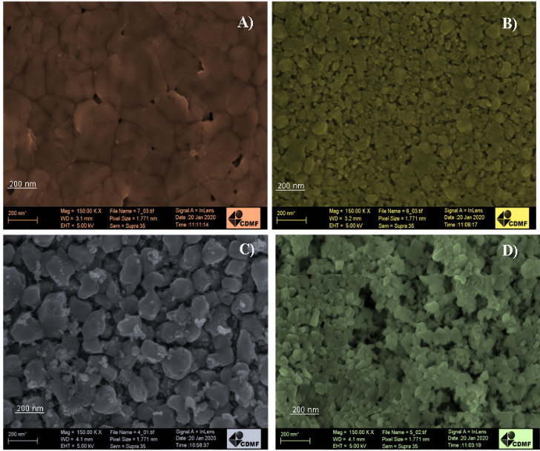method, heated at 100 ºC for 1 h (10 ºC /min) and heat-treated at 500 ºC for 2 h (2 ºC/min) in a muffle furnace. To form a second and third layer, the resin was dropped again, heated and one unique thermal treatment was realized.

## Results e Discussion

*Structural, morphological and optical characterization of AWO4 films*

The crystal structures of the resulting samples were identified by the X-ray diffraction (XRD) patterns. The XRD patterns are recorded in the range of 10–80º as shown in Fig. 1(a–d). Diffraction signals suppressed and marked with the symbol “•” correspond to the FTO transparent conductive glass substrate.

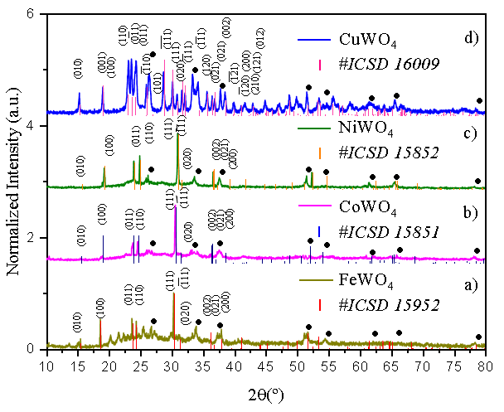For FeWO4, CoWO4, and NiWO4 films displayed in Fig. 1(a-c), the XRD patterns show diffraction signals which are characteristic of wolframite-type monoclinic phase structure with space group (P2/c) as determined by the Inorganic Crystal Structure Database (ICSD) card No. 15952, 15851, and 15852 for FeWO4, CoWO4, and NiWO4 crystal, respectively (5,6). On the other hand, the XRD pattern for the CuWO4 sample (Fig. 1(d)) shows typical diffraction peaks for triclinic structure (ICSD No. 16009) with space group (P1 ̅) (7).

**Figura 1.** XRD patterns of (a) FeWO4, (b) CoWO4, (c) NiWO4, and (d) CuWO4 thin films synthesized by the PPM.

FE-SEM images for the morphology, particles size, and surface of AWO4 (A2+ = Fe, Co, Ni, and Cu) films are shown in Figs. 2(a-d), respectively. The FeWO4 film presented in Fig. 2(a) indicates that has a well-sintered nanoplates-like structure with an average particles size of ca. 92 nm. Fig. 2(b) shows the morphological surface for CoWO4 film with irregular spherical nanoparticles and an average particles size of ca. 27 nm. Whereas, the NiWO4 film exhibits an irregular surface morphology formed by polyhedron interconnected particles (Fig. 2(c)) and an average particles size of ca. 75 nm. Fig. 2d shows that CuWO4 film is formed by irregular nanoparticles with an average size of 24 nm.

**Figura 2.** FE-SEM images of the surface of the (a) FeWO4, (b) CoWO4, (c) NiWO4, (d) and CuWO4 films.

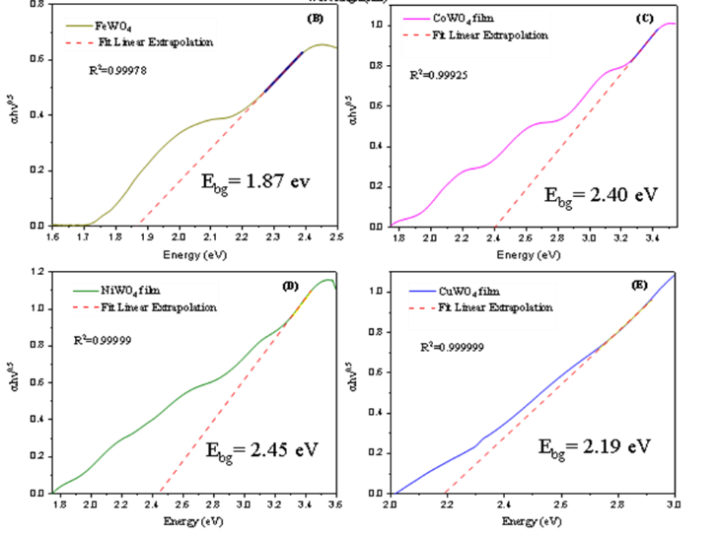The optical properties of these films were examined with UV-vis spectra registered in transmittance mode and estimated the bandgap energy (Ebg) by Wood-Tauc plot method as shown in Fig. 3. As illustrated in Figs.3, the Ebg of FeWO4, CoWO4, NiWO4 and CuWO4 films are estimated to be about 1.87, 2.40, 2.45, and 2.19 eV, respectively. These Ebg values are slightly close that on registered in other studies (8-14).

**Figura 3.** (a) UV-Vis transmittance curves of films and band gap energy estimated by Wood-Tauc plot method for (b) FeWO4, (c) CoWO4, (d) NiWO4 and (e) CuWO4 film.

*Photoelectrochemical behavior of AWO4 films*

Figs. 4(a–d) show the photoelectrochemical behavior of AWO4 (A2+ = Fe, Co, Ni, and Cu) films with different deposited layers on FTO-glass was examined by linear sweep voltammetry (LSV) curves were registered at 1mVs-1 under chopped 0.10 Hz polychromatic irradiation. All AWO4 films displayed a more negative photo-potential after irradiation condition, which means, in the dark the open-circuit-potential (OCP) value is more positive than OCP registered under irradiation condition (Elight-on < Elight-off vs. Ag/AgCl). This negative photo-potential is characteristic of n-type semiconductor oxides (15). Thus, LSV curves were registered toward anodic direction and positive photocurrents were observed as applied bias until OER signals under dark condition. To investigate the influence of AWO4 film layers on photocurrent response, samples were prepared with one, two, and three layers.

**Figura 4.** LSV curves plots of (a) FeWO4, (b) CoWO4, (c) NiWO4, and (d) CuWO4 photoanodes in inert 0.1 mol L-1 Na2SO4 solution (pH ~5.6) irradiated with chopped polychromatic light (0.1Hz), respectively.

.

The photocurrent density measurements by LSV curves were utilized to estimate the flat band potential (Efb) of these semiconductors, following the Butler-Gärtner model (16,17), as displayed in Figs. 5(a-d). Gärtner–Butler analysis is an alternative method of determining the Efb is based on the measurement of the square of the photocurrent density as a function of electrode potential. The Efb is predicted to be at the intercept of the square of the photocurrent density with the potential axis (18).

In previous studies, we demonstrated that mass transport mechanism (i.e. migration or diffusion) in the system does not alter the recombination exponential profile of transient photocurrent utilized to determine the lifetime (19). As observed in Fig. 6(a) and schematically represented in Fig. 7(b), an initial anodic photocurrent spike Jin indicates the injection of electrons in the CB owing to the electron/hole charge separation process. At the same time, electrons are transported to the conductor substrate to be collected by the external circuit; the holes are moved towards the semiconductor surface where they are reduced by the species in the electrolyte. Simultaneously, the photocurrent decreases exponentially with time until it reaches a steady-state photocurrent density (Jst) because of charge recombination.



**Figura 5.** Variation in the square of the photocurrent density with applied potential, for (a) FeWO4, (b) CoWO4, (c) NiWO4, and (d) CuWO4 electrode in 0.1 mol L-1 Na2SO4 aqueous solution, under polychromatic irradiation obeying Butler-Gärtner model and (e) the experimentally determined band diagrams.



**Figura 6.** (a) Photocurrent density-time (J-t) curves of the annealed films measured under polychromatic illumination with chopped 300 s light on/off at 0.7 V vs. Ag/AgCl, (b) schematic representation of photocurrent transient curve and (c) normalized plot of current-time dependence for AWO4 (A2+ = Fe,Co, Ni, and Cu).

The slope of the plot provides photocurrent transient (τ), which is related to the charge recombination lifetime in each

electrode. The recombination lifetime values were calculated at about 83, 32, 25, and 40 s for the FeWO4, CoWO4, NiWO4 and CuWO4 films, respectively. These lifetime values for the NiWO4, CoWO4 and CuWO4 films are smaller than the FeWO4 film. Therefore, the photoelectrochemical properties were observed in different wolframite films with anodic photocurrent and capable of harvesting visible light allowing several photoelectrochemical applications.

## Conclusion

In summary, the FeWO4, CoWO4, NiWO4, and CuWO4 thin films onto FTO-glass were synthesized with success by the PPM method via drop-casting. XRD patterns analyses confirmed the presence of wolframite-type monoclinic structure for FeWO4, CoWO4, and NiWO4 films, while the CuWO4 film exhibits a triclinic structure. The AWO4 (A2+ = Fe, Co, Ni, and Cu) films showed an ability to absorb in the visible light region, which suggests being excellent harvesters of sunlight for energy conversion applications, such as H2O oxidation. Morphological features showed by means of FE-SEM images revealed the presence of nanostructured oxides with irregular shapes and the diverse average size of particles. The PEC testing under illumination revealed anodic photocurrent and negative photopotential characteristics of n-type semiconductors oxides. In inert electrolyte, the CuWO4 electrode showed the highest photocurrent density value of 48 μA cm-2 at 1.0 V vs. Ag/AgCl (1.53 V vs. RHE). In addition, all electrodes demonstrated excellent chemical stability for photoelectrochemical oxygen evolution reaction with constant bias potential at 0.7 V vs. Ag/AgCl (1.23 V vs. RHE). From Ebg and Efb values were possible to assemble a diagram of bands (CB and VB) positions, which leads to deducting the greatest applicability of electrodes in PEC, exploring these AWO4 (A2+ = Fe, Co, Ni, and Cu) films as electrodes with a high potential to H2O-splitting photocatalysts.

## Acknowledgements

## The Brazilian authors acknowledge the financial support from the Brazilian research financing institutions: CNPq (312318/2017-0 and 408036/2018-4), CCN2-PPGCM-UFPI-LIMAV, GERATEC-UESPI-CETEM, FAPESP-CDMF (13/07296-2) and CAPES.

## References

1. P. Kumar, D. P. Saroj, Water-energy-pollution nex- us for growing cities. *Urban Climate*, **2014**, *10*, 846-853.
2. S., Garcia-Segura, E. Brillas, Applied photoelectrocatalysis on the degradation of organic pollutants in wastewaters, *Journal of Photochemistry and Photobiology C: Photochemistry Reviews*, **2017**, *31*, 1–35.
3. U. M. García-Pérez, A. Martinez-de la Cruz, J. Peral, Transition metal tungstates synthesized by co-precipitation method: Basic photocatalytic properties. *Electrochimica Acta*, **2012**, *81*, 227– 232.
4. P. Chen, H-Y. He, H2 evolution from H2O/H2O2/MWO4 (M = Fe2+, Co2+, Ni2+) systems by photocatalytic reaction. *Research on Chemical Intermediates*, **2014**, *40*, 1947–1956.
5. C. Escobar, H. Cid-Dresdner, P. Kittl, I. Duemler, The Relation between “light wolframite” and common wolframite, *American Mineralogist*, **1971**, *56*, 489-498.
6. H. Weitzel, Kristallstrukturverfeinerung von Wolframiten und Columbiten. *Zeitschrift für Kristallographie*, **1976**, *144*, 238-258. https://doi.org/10.1524/zkri.1976.144.16.238
7. L. Kihlborg, E. Gebert, CuWO4, a distorted wolframite-type structure. *Acta Crystallographica, Section B: Structural Crystallography and Crystal Chemistry*, **1970**, 26, 1020-1026.
8. P. K. Pandey, N. S. Bhave, R. B. Kharat, Structural, optical, electrical and photovoltaic electrochemical characterization of spray deposited NiWO4 thin films. *Electrochimica Acta*, **2006**, *51*, 4659–4664.
9. J. E. Yourey, B. M. Bartlett, Electrochemical deposition and photoelectrochemistry of CuWO4, a promising photoanode for water oxidation. *Journal of Materials Chemistry*, **2011**, 21, 7651-7660.
10. J. Zhang, Y. Wang, S. Li, X. Wang, F. Huang, A. Xie, Y. Shen, Controlled synthesis, growth mechanism and optical properties of FeWO4 hierarchical microstructures, Cryst*. Eng. Commun*, **2011,** 13, 5744-5750.
11. T. Ejima, T. Banse, H. Takatsuka, Y. Kondo, M. Ishino, N. Kimura, M. Watanabe, I. Matsubara, Microscopic optical and photoelectron measurements of MWO4 (M=Mn, Fe, and Ni). *Journal of Luminescence*, **2006**, *119*, 59-63.
12. C. Ling, L. Q. Zhou, H. Jia, First-principles study of crystalline CoWO4 as oxygen evolution reaction catalyst. *RSC Advances,* **2014**, *4*, 24692-24697.
13. R. Bharati, R. A. Singh, B. M. Wanklyn, On electrical transport in CoWO4 single crystals. *Journal of Materials Science*, **1981**, *16*, 775-779. https://doi.org/10.1007/BF02402795
14. C. M. Tian, M. Jiang, D. Tang, L. Qiao, H. Y. Xiao, F. E. Oropeza, J. P. Hofmann, E. J. M. Hensen, A. Tadich, W. Li, D. C. Qi, K. H. L. Zhang, Elucidating the electronic structure of CuWO4 thin films for enhanced photoelectrochemical water splitting*, Journal of Materials Chemistry A*, **2019**, *7,* 11895-11907. https://doi.org/10.1039/C8TA12070F
15. H.G. Oliveira, L.H. Ferreira, R. Bertazzoli, C. Longo, Remediation of 17-α-ethinylestradiol aqueous solution by photocatalysis and electrochemically-assisted photocatalysis using TiO2 and TiO2/WO3 electrodes irradiated by a solar simulator. *Water Research*, **2015**, 72, 305-314.
16. W.W. Gärtner, Depletion-layer photoeffects in semiconductors, *Physical Review*, **1959**, *116*, 84-87. https://doi.org/10.1103/PhysRev.116.84
17. M.A. Butler, Photoelectrolysis and physical properties of the semiconducting electrode WO2. *Journal of Applied Physics,* **1977**, *48*, 1914-1920.
18. A. Hankin, F. E. Bedoya-Lora, J. C., Alexander, A. Regoutz, G. H. Kelsall, Flat band potential determination: avoiding the pitfalls. *Journal of Materials Chemistry A,* **2019**, *7*, 26162–26176.
19. M.J.S. Costa, G.S. Costa, A.E.B. Lima, G.E. Luz Jr, E. Longo, L. S. Cavalcante, R.S. Santos, Investigation of charge recombination lifetime in γ-WO3 films modified with Ag0 and Pt0 nanoparticles and its influence on photocurrent density. *Ionics*, **2018**, 24, 3291-3297.