Biomass supported WO3 as catalyst for high efficiency sulfides oxidation

Yamakawa, Gabriel F.1; Assis, Marcelo1, 2; Reis, Roberta Y. N. 1;Ribeiro, Lara K.1; Longo, Elson1.

1Center for Development of Functional Materials (CDMF) Federal University of São Carlos (UFSCar) Washington Luis Highway, km 235’ 13565-905, São Carlos (Brazil); gabriel_yamakawa2@hotmail.com; [gabrielyamakawa@estudante.ufscar.br](mailto:gabrielyamakawa@estudante.ufscar.br)

2Department of Analytical and Physical Chemistry Jaume I University Vicent Sos Baynat Avenue 12071, Castellón de la Plana (Spain)

Resumo/Abstract (Helvética, tam. 12)

ABSTRACT – Herein the application of a WO3/chitosan catalyst to obtain sulfones and sulfoxides. The applied WO3 was obtained by the method of coprecipitation and was immobilized to the chitosan support. The obtained WO3 has a monoclinic crystalline structure, the chitosan showed an amorphous nature, while the WO3/chitosan compounds showed a similar crystalline structure to the WO3.There was no homogeneity in the distribution of WO3 over the support. The optimal values of time, temperature, WO3 ratio, solvent, oxidant and mass of catalyst were obtained; 60°C, 120 minutes, 20% of WO3 and 10mg of catalyst with 2 mL of acetonitrile and 25 µL of H2O2 for the formation of over 98% sulfones, methanol was used in 90 minutes, forming 80% sulfoxides. The stability was observed, allowing the scaling of the process, maintaining values of conversion. The catalyst was efficient for the oxidation of seven other sulfides. A mechanism was suggested with a main contribution of the hydroperoxyl radical and the deficit of electronic density. The obtained catalyst showed itself as an excellent alternative to be applied in sulfide oxidation reactions.

*Keywords: Chitosan, WO3, Oxidation, Sulfones, Sulfoxides.*

RESUMO – Aqui a aplicação de um catalisador WO3/quitosana para obtenção de sulfonas e sulfóxidos. O WO3 aplicado foi obtido pelo método de coprecipitação e foi imobilizado ao suporte de quitosana. O WO3 obtido possui estrutura cristalina monoclínica, a quitosana apresentou natureza amorfa, enquanto os compostos WO3/quitosana apresentaram estrutura cristalina semelhante ao WO3. Não houve homogeneidade na distribuição do WO3 sobre o suporte. Foram obtidos os valores ótimos de tempo, temperatura, relação WO3, solvente, oxidante e massa de catalisador; 60°C, 120 minutos, 20% de WO3 e 10mg de catalisador com 2 mL de acetonitrila e 25 µL de H2O2 para formação de mais de 98% de sulfonas, metanol foi utilizado em 90 minutos, formando 80% de sulfóxidos. A estabilidade foi observada, permitindo o escalonamento do processo, mantendo os valores de conversão. O catalisador foi eficiente para a oxidação de outros sete sulfetos. Um mecanismo foi sugerido com uma contribuição principal do radical hidroperoxila e o déficit de densidade eletrônica. O catalisador obtido mostrou-se uma excelente alternativa para ser aplicado em reações de oxidação de sulfetos.

*Palavras-chave: Quitosana, WO3, Oxidação, Sulfonas, Sulfóxidos.*

## Introduction

The use of sulfones and sulfoxides in the production of pharmaceuticals1 and medicines2 have grown a lot recently. With that in mind, finding a way to produce these reactants efficiently and selectively is of great importance.

The most common reaction that result in sulfones and sulfoxides is the oxidation of sulfides, which produce both at the same time. The sulfoxides are a product of the partial oxidation, while the sulfones come from the total oxidation of these materials, which means that the challenge is to find a way to induce the total or partial oxidation to have the most selectivity towards any of the products.

To achieve such goals, one technique is vastly used in this kind of reactions, which is heterogeneous catalysis. Although they represent a large portion of the reactions that occur in the industry3, it’s important to emphasize them. More specifically, it’s common to see semiconductor oxides in oxidation reactions, mainly because of the characteristics intrinsic to this kind of materials, that make it easy to activate their active sites4, with non-expensive techniques, such as the use of light or heat. Using oxidants like H2O2 or peracids in combination with acetic acid can also help with the activation of the catalyst5.

The tungsten trioxide is interesting to be explored because of some of its characteristics, mainly when in its monoclinic structure. Studies showed that the recombination of the pair electron-hole is compromised in this form, which makes the semiconductor an extremely active catalyst when talking about oxidation.

The goal in this paper is to combine these interesting characteristics of the WO3­ with an equally interesting support. With that in mind, a carbon-based support was the ideal combination to try. Taking in consideration that one of the downsides of using these materials is the high price attached to it6, using chitosan, a highly available biomass makes this less of an issue. Besides, chitosan has some interesting characteristics of its own, which makes it an even more attractive support when in combination with WO3.

## Experimental

*WO3 synthesis*

The Synthesis of the WO3 through the coprecipitation method. A mixture of 1.21 mmol of sodium tungstate, 1.20 mmol of ammonium oxalate and 33 mL of deionized water was added to a reactor with temperature control. To this initial mixture, 9 mL of chloric acid was added under constant agitation until the formation of suspended tungstic acid. 8 mL of H2O2 was then added to the reaction, keeping it under agitation. The formed precipitate was dissolved, obtaining a perfectly clean solution. Then, 30 mL of ethanol was added to the system under agitation for 10 minutes, obtaining another clean and stable solution. The synthesis occurred at 85°C. The obtained material was washed with deionized water for 5 times, dried at 80°C for 12 hours and was then calcinated at 500°C in a microwaves oven for 30 min, with a heating rate of 2°C/min.

*WO3 fixation on the support*

To fixate the obtained WO3 in the support, a naturally obtained chitosan biopolymer was used.

Initially, 250 mg of chitosan was weighted along with the respective mass of WO3 in the proportions of 10, 20 and 40% (w/m). To a first Becker, the mass of chitosan was added along with 20 mL of acetone, while on a second becker, the mass of WO3 was added along with 10 mL of acetone. The second becker was agitated in ultrasound for 5 minutes, which was then added to the first becker containing the chitosan. The new mixture was again agitated in ultrasound for 20 min, the obtained solutions was then dried at 60°C. The obtained powder was calcinated at 300°C for 120 min in a furnace, with heating rate of 2°C/min. The obtained samples were named QT1W, QT2W and QT4W for the proportions of 10, 20 and 40% of (w/m) WO3/chitosan, respectively.

*Characterizations*

The obtained materials were characterized through XRD in a Rigaku equipment, model DMax2500PC. It was operated in 40kV and 60 mA utilizing Cu-Kα radiation (λ = 1,5406 Å). A scan rate of 0.02°/min was used in na interval of from 10° to 100°. The powder diagrams were compared to diffraction patterns accordingly to ICSD crystallographic sheets. The Raman data was obtained through an iHR550 equipment, equipped with a charge device coupled to an Argon ion laser, operating at 633 nm and200 mW. The SEM and EDS images were acquired using a Hitachi TM4000Plus II Zeiss LEO 1550, operating at 15kV.

*Catalytic process*

The catalytic process was realized in 4 mL vials under magnetic agitation at 700 rpm. The experimental procedure was done dispersing the catalyst in a solution containing 0.1 mmol of sulfide substrate and 2 mL os solvent, along with 15 µL of hexadecane, followed by the addition of an oxidant to the reaction. The charge parameters of the catalyst (10, 7.5, 5, 2.5 mg), solvent type (Acetonitrile, Ethanol, Methanol, Isopropanol, Acetone, n-Octane and Chloroform), type of oxidant (H2O2, TBHP, Iodobenzene and air), oxidant volume (0.6-0.2 mmol), time (30, 60 and 120 min) and temperature (30, 50, 60 and 70°C) were optimized during the tests. At the end of each Catalysis process, the solution was diluted in 2 mL of Ethil acetate and an aliquot of 2 mL was taken to be analyzed in gas chromatographer (Agilent 8860) with flame ionization detector (FID) using an apolar column (Agilent J&W HP-5). The analysis were made in duplicates. Experiments with scavengers following the same optimized conditions, adding equimolar quantities of the scavengers: Ascorbic acid, tert-butanol, Potassium bifitalate, EDTA, ammonium oxalate, p-benzoquinone and silver nitrate. To analyze the recyclability of the catalyst, the experiment was repeated using the same catalyst 4 times. The catalytic scope was obtained using different commercial sulfide sans and sulfones thioanisole and thiophene based. A scaling test was also made, scaling the reaction 5, 10 and 20 times, utilizing volumetric flasks of 25, 50 and 100 mL, scaling all the reagents in the reaction.

## Results and Discussion

*Characterizations*

**Figure 1** shows the XRD spectra in comparison with the JCPDS pattern of the monoclinic WO3, confirming the synthesis of the wanted material. It can also be observed the amorphous characteristic of the chitosan, whilst the synthesized catalysts maintain the crystalline organization from the WO3.

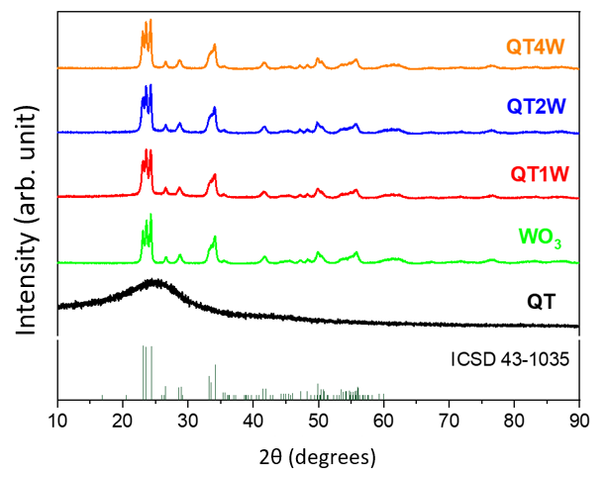

**Figure 1.** XRD: (a) WO3, (b) chitosan, (c) QT1W, (d) Qt2W, (e) QT4W.

**Figure 2** shows the Raman spectra that help visualize the structure of the obtained materials and understand them better. In **2(a)** the modes in 352, 809 and 944 cm-1 represent the vibration corresponding to the oxygen stretch in the [WO6] cluster and the δ flexion vibration. In **2(b)** the modes in 1370 and 1550 cm-1 represent the bands D and G from carbon-based materials7. Curiously, the modes that refer to the WO3 can’t be seen in the synthesized catalysts, one of the hypotheses for that to happen is that the WO3 isn’t homogeneously spread over the surface of the support, which can mean that the observed region simply doesn’t contain WO3.

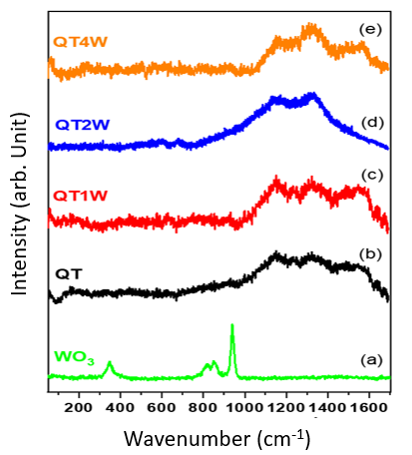

**Figure 2.** Raman spectra of (a) WO3, (b) chitosan, (c) QT1W, (d) QT2W and (e) QT4W.

**Figure 3** shows us the image obtained from SEM and EDS of the QT2W catalyst. In it, it’s possible to observe the spread from the WO3 over the support, which corroborates with the hypotheses presented beforehand about the WO3 modes not appearing in the catalyst’s spectra.

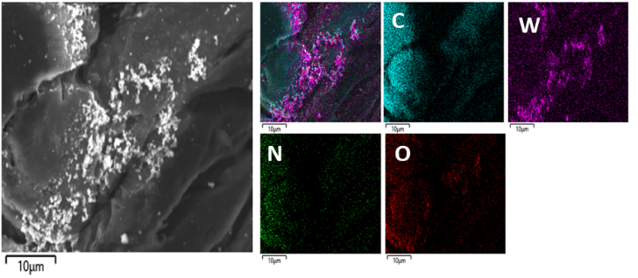

**Figure 3**. SEM and EDS image of the QT2W catalyst.

*Catalytic process results*

The catalytic process was optimized, and the best results obtained were as it follows:

**Image 5** shows that ate the temperature of 60°C and 120 min of reaction time, the catalyst QT2W obtained 100% conversion of sulfides to sulfones, using acetonitrile as solvent and H2O2 as oxidant, which will be the conditions used in the following tests. It’s important to note that the same result was obtained at the temperature of 70°C and 120 minutes with both QT4W and QT2W, but since the temperature was too close to the boiling point of acetonitrile the test at 60°C was made to find even better conditions for the reaction. The molecule used for these tests was the thioanisole which oxides as shown in **image 4**.

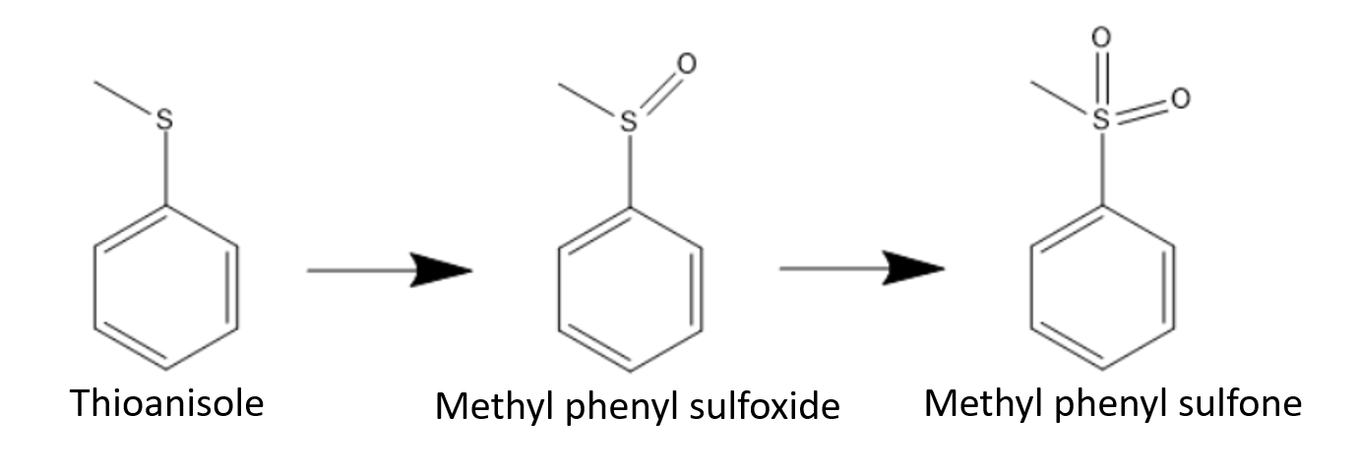

**Figure 4.** Thioanisole Oxidation model

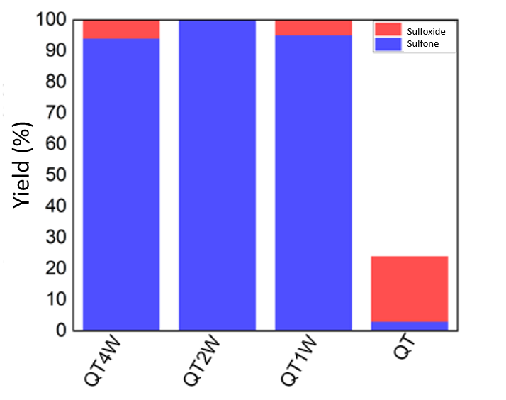

**Figure 5.** Conversion to sulfones and sulfoxides at 70°C and 120 minutes

With temperature and time set, a test to choose the best oxidant was made with H2O2, TBHP, air and iodobenzeno, which showed that the H2O2 is really the best performing oxidant, maintaining the 100% conversion to sulfones, while the other could barely hit 20% conversion to sulfoxides, so the following tests were performed with the peroxide.

Next, the quantity of oxidant and the ideal mass of catalyst were also tested, and it was showed that the quantities used until now were the minimum ideal for the conversion to sulfones. It was also confirmed the effectivity of the synthesized catalyst since the test of quantity of oxidant was performed with and without catalyst, showing the difference between both results. The following tests were then performed with the use of 25 µL of H2O2 and 10 mg of catalyst.

The **figure 6** shows us the difference between using different solvents in the process, and a few results are interesting to be explored. First, the test shows that acetonitrile is the best performing solvent, maintaining the same 100% conversion of sulfides to sulfones. The next interesting result is the one obtained from the use of methanol, that shows a conversion of 100% of sulfides, but with a selectivity towards the formation of sulfoxides, showing that the synthesized catalyst can be used in the selective formation of both products of the oxidation, maintaining the same conditions and changing only the solvent used in the process. The last result that is worth pointing out is the one using n-octane as the solvent. The reason for that is because this solvent is the fuel model utilized to test the oxidation of sulfides in fuels, which can also be an environmental problem. Although it isn’t as selective as using acetonitrile, the conversion of sulfides was high enough that the products can be easily removed from fuels, making it so that the catalyst have another application.

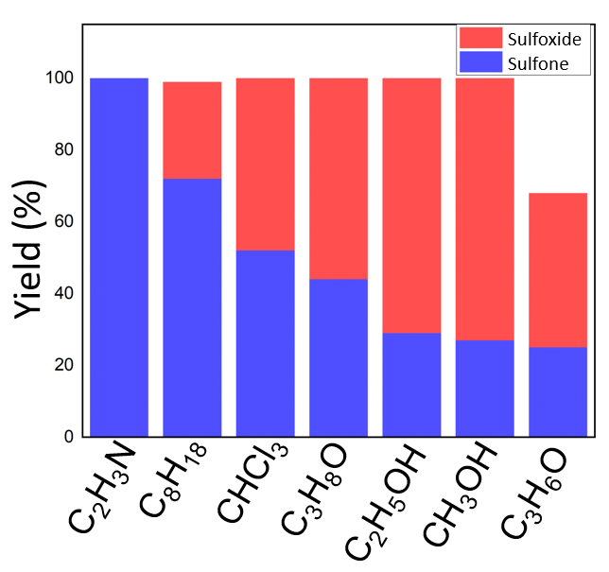

**Figure 6.** Use of different solvents in the reaction.

Since the optimized conditions were found, the tests of scaling, recycling and the scope can be performed. Firstly, the recycle test was made with both acetonitrile and methanol, so the durability and reproducibility can be observed. **Figure 7(a)** expose the results, showing that the catalyst maintains its conversion of sulfides, although losing selectivity. **7(b)** on the other hand shows that, with methanol being used, the conversion and the selectivity is maintained, showing that the catalyst is indeed durable and has the ability of reproduce good results.

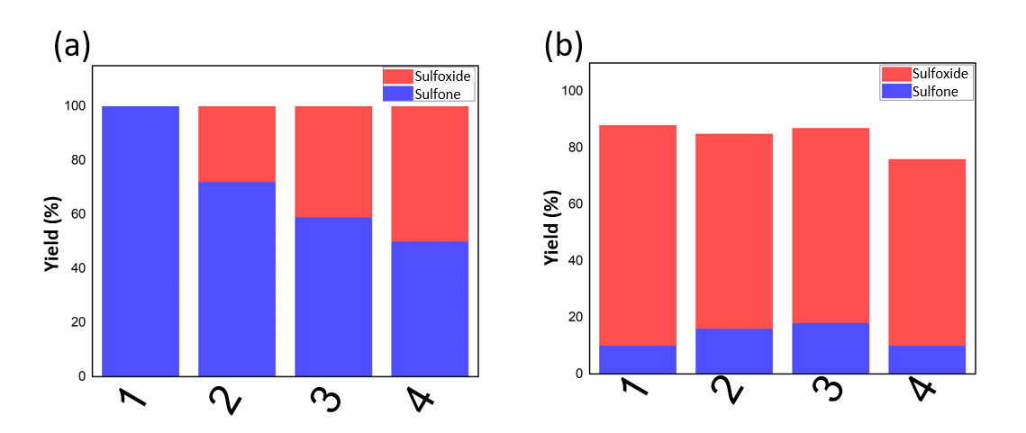

**Figure 7.** Catalysts sulfide oxidation recycle with (a) acetonitrile and (b) methanol.

The scaling was then made, and **figure 8** exhibits the results. It can be observed that the process maintains its conversion but loses a bit of selectivity, like what happened in the last test of recyclability. It’s possible that this happened because of the different environment used for the tests, once 4 mL vials are more easily controlled, making sure that the temperature and agitation is uniform throughout the whole reaction. When using volumetric flasks, it’s more difficult to ensure that the whole reaction has the same conditions, which might explain the results obtained, the bigger the flask, the more difficult it is to ensure the conditions, the worse the result.

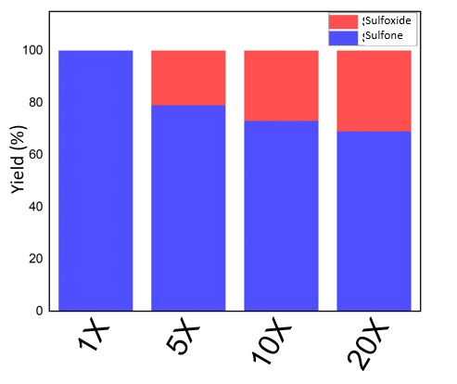

**Figure 8.** Catalytic scaling using acetonitrile as solvent.

Lastly, the scope was described using 7 other commercial sulfides oxidating them to sulfones. A few of the tested sulfides were oxidated in conditions milder conditions, obtaining >90% of sulfones conversion in 60 minutes of reaction, which was the case for the p-substituted thioanisole derivates (4-Chlorothianisole, 4-Methoxythianisole, Methyl p-tolyl sulfide). Others were oxidated in the same conditions as the thioanisole, reaching >95% in 120 minutes of reaction which were the aliphatic thioethers (Diethyl Sulfide), but the thiophene could only reach 68% conversion in the same conditions. Finally, some of them needed more extreme conditions to reach acceptable levels of conversion, which was the case for Diphenylsulfane that needed a higher quantity of oxidant (0.05 ml of H2O2) to reach 95% conversion, while Dibenzothiophene needed even more extreme conditions to reach 100% conversion, with 8 hours (480 minutes) and 0.3 mL H2O2.

*Mechanism*

**Figure 9** exhibits the results obtained for the scavenger’s test. Each scavenger species is responsible for the detection of a specific reaction path. The ones that have the most impact in the result, in other words, the ones that obtain the worst result compared to the original without the scavengers, are responsible to remove the species that have the most impact on the mechanical pathway of the reaction. With, figure **9** shows that 2 of the scavengers have the most impact in the reaction, which are the p-benzoquinone and the ammonium oxalate, responsible for the detection of hydroperoxyl radical and the electronic density deficit, respectively. It’s important to note that this is a preliminary and indirect test, that only indicates what the path of the mechanism can be, and therefore should not be used as the only mechanism test.



**Figure 9.** Scavengers test.

## Conclusions

The accomplished tests show that the synthesized WO3 had monoclinic crystalline structure and was successfully supported in the carbon-based biomass chitosan support. The optimized conditions for the catalytic process were 60°C, 120 min, 2 mL of acetonitrile, 25 µL of H2O2 and 10 mg of the QT2W catalyst.

The solvent is the most important condition to be observed since it can direct the selectivity of the process solely by changing which solvent is being used. The recyclability test showed a reasonable result for acetonitrile and the formation of sulfones, while it was stable for the formation of sulfoxides using methanol, although less selective. The scaling test shows it’s possible to scale the obtention of sulfones, while also oxidating different substrates. The indirect action mechanism given by the scavenger’s test suggest partial conclusions about the possible participation of ⦁O2- and ⦁OH in the oxidation of sulfides, but more tests must be done to conclude the mechanism correctly.

## Referências

1. Ashton Acton, Q. (2013). *Sulfones—Advances in Research and Application* (Q. Ashton Acton, Ed.; ScholarlyBrief). ScholaryEditions.
2. Staniszewska, M., Gizińska, M., Kazek, M., de Jesús González-Hernández, R., Ochal, Z., & Mora-Montes, H. M. (2020). New antifungal 4-chloro-3-nitrophenyldifluoroiodomethyl sulfone reduces the Candida albicans pathogenicity in the Galleria mellonella model organism. *Brazilian Journal of Microbiology*, *51*(1), 5–14. https://doi.org/10.1007/s42770-019-00140-z
3. Wacławek, S., Padil, V. V. T., & Černík, M. (2018). Major Advances and Challenges in Heterogeneous Catalysis for Environmental Applications: A Review. *Ecological Chemistry and Engineering S*, *25*(1), 9–34. https://doi.org/10.1515/eces-2018-0001
4. Reis, R. Y. N., Goulart, L. A., Mascaro, L. H., & Alves, S. A. (2022). A critical view of the contributions of photoelectrochemical technology to pharmaceutical degradation. *Journal of Environmental Chemical Engineering*, *10*(3). https://doi.org/10.1016/j.jece.2022.107859
5. Catarinella, M., Grüner, T., Strittmatter, T., Marx, A., & Mayer, T. U. (2009). BTB-1, ein niedermolekularer Inhibitor des mitotischen Motorproteins Kif18A. *Angewandte Chemie*, *121*(48), 9236–9240. https://doi.org/10.1002/ange.200904510
6. Ali, Md. E., Rahman, Md. M., Sarkar, S. M., & Hamid, S. B. A. (2014). Heterogeneous Metal Catalysts for Oxidation Reactions. *Journal of Nanomaterials*, *2014*, 1–23. https://doi.org/10.1155/2014/192038
7. Sorribes, I., Ventura-Espinosa, D., Assis, M., Martín, S., Concepción, P., Bettini, J., Longo, E., Mata, J. A., & Andrés, J. (2021). Unraveling a Biomass-Derived Multiphase Catalyst for the Dehydrogenative Coupling of Silanes with Alcohols under Aerobic Conditions. *ACS Sustainable Chemistry & Engineering*, *9*(7), 2912–2928. https://doi.org/10.1021/acssuschemeng.0c08953