Unveiling metal-support interactions over one-dimensional (Pt,Fe)-supported catalysts

Guilherme B. Strapasson1,2,*, Davi S. Leite1, Ângela A. Teixeira-Neto3, Cristiane B. Rodella2, Daniela Zanchet1

1 Institute of Chemistry, University of Campinas, UNICAMP, Campinas, SP, Brazil

2 Brazilian Synchrotron Light Laboratory, CNPEM, Campinas, SP, Brazil

3 Brazilian Nanotechnology National Laboratory, CNPEM, Campinas, SP, Brazil

* g216373@dac.unicamp.br

Resumo/Abstract

RESUMO - O design e a otimização de sítios cataliticamente ativos (sítios metálicos, ácidos e redox) são importantes para o desenvolvimento de catalisadores ativos, seletivos e estáveis. As interações metal-suporte podem modular o desempenho catalítico de catalisadores metal-óxido para diversas reações, onde as propriedades eletrônicas e geométricas da fase metálica podem ser influenciadas. Além disso, sistemas com alta dispersão da fase metálica podem resultar em uma interface metal-óxido com superfícies ricas em defeitos e propriedades eletrônicas aprimoradas, podendo afetar diretamente a ativação de ligações C-O e C-C e o *spillover* de H2. Investigamos catalisadores 1D de (Pt,Fe)-suportados com concentrações ultrabaixas de Pt, com o objetivo de obter alta dispersão de Pt. Esses catalisadores foram empregados na reação de hidrodesoxigenação da acetona, na qual catalisadores de (Pt,Fe)-supportados em TiO2@Nb2O5 demonstraram uma melhora na clivagem de ligação C-O e estabilidade ao longo do tempo, resultando em quase 100% de desoxigenação. Foi demonstrado que, mesmo com cargas ultrabaixas de Pt, é possível alcançar modificações significativas na capacidade de hidrogenação e, consequentemente, no desempenho catalítico.

*Palavras-chave: Catálise heterogênea, óxidos metálicos nanoestruturados, hidrodesoxigenação, interação metal-suporte.*

ABSTRACT – The design and tuning of catalytically active sites (e.g. metallic, acid, and redox sites) is crucial for the development of active, selective, and stable catalysts. Metal-support interactions can tailor the catalytic performance of metal-oxide catalysts for various reactions, in which the electronic and geometric properties of the metal phase can be impacted. Moreover, systems with high dispersions of the metal phase may lead to a metal-oxide interface with defect rich surfaces and enhanced electronic properties, that can directly impact C-O and C-C bond activation and H2 spillover. Thus, we explored one-dimensional (Pt,Fe)-supported catalysts with ultra-low loadings of Pt, aiming for high dispersions of Pt. These catalysts were employed in the acetone hydrodeoxygenation reaction, in which (Pt, Fe)-supported over TiO2@Nb2O5 structures presented an enhanced C-O bond cleavage and stability over the time on stream, resulting in almost 100% of deoxygenation. It was demonstrated that even with ultra-low loadings of Pt, expressive modifications in the hydrogenation capability, and consequently, in the catalytic performance, can be achieved.

*Keywords: Heterogeneous catalysis, nanostructured metal oxides, hydrodeoxygenation, metal-support interaction*

## Introduction

Catalyst design and engineering of active sites have helped the development of catalytic systems with unique properties. A class of materials explored in heterogeneous catalysis is nanostructured metal oxides, especially those of one-dimensional morphology (1D). Reducible metal oxide supports that associate redox and acid properties in combination with a metallic phase can result in potential catalytic systems for different reactions. The hydrodeoxygenation (HDO) reaction is one of the main biomass-derivate upgrading processes to obtain biofuels and deals with the selective cleavage of C-O bonds under a hydrogen-rich atmosphere combined with a solid catalyst, reducing the oxygen content to produce hydrocarbons as the main products. Generally, this reaction occurs through a bifunctional mechanism that requires a metallic site for hydrogenation/dehydrogenation and an acid/oxophilic site that adsorbs the -oxy compound and promotes C-O bond activation and dehydration steps (*1*, *2*). However, the reaction network can also encompass other pathways, such as metal-catalyzed demethylations and C-C hydrogenolyses (*3*); Brønsted/Lewis acid-catalyzed condensations (*4*); and oxygen vacancy-mediated direct deoxygenation (*5*).

In the case of supported metal catalysts, the metal-support interaction (MSI) can play a critical role in tuning the catalytic behavior. The reactivity, selectivity, and stability of catalysts can be tailored by regulating the MSI at the interface between the metallic phase and the support, and both parts have an essential role in the catalytic reactions (*6*). One of the main strategies to tune MSI involves the design of metal/oxide interfaces, which enables significant changes in the electronic structure and geometric configuration of metal species (*7*, *8*). In special, highly dispersed and stable metallic particles can result in promising catalytic systems due to the high availability of metallic sites, however, reaching higher dispersions of metal supported over oxides is still challenging.

**Figure 1:** (a) SEM micrograph of TiO2NRs; (b-c) HR-TEM of TiO2NRs and FFT of (c) as inset; (d) (001) and (110) planes of TiO2 (B) unit cell of the respective planes observed in (c); (e) XRD patterns of calcined TiO2NRs and TiO2NRs@Nb2O5 core@shell; (S)TEM of reduced (f) TiO2NRs 5 wt.% Fe (inset showing the cuboidal Fe@FeOx particle in higher magnification); and (g-h) TiO2NRs@Nb2O5 5 wt.% Fe.

In this context, our main goal was to explore new synthetic approaches that tailors the Pt dispersion and interaction with oxidic supports. For that, ultra-low loadings of Pt were selectively deposited over 1D Fe-supported catalysts using the strong electrostatic adsorption method. These catalysts were evaluated in the acetone HDO reaction and the correlation between electronic and structural properties with the preferential reaction pathways and catalytic performance were investigated.

## Experimental

TiO2 nanoribbons (TiO2NRs) were synthesized using a hydrothermal route, while core@shell-like TiO2NRs@Nb2O5 nanostructures were prepared through wet impregnation of the Nb precursor to obtain 10 at.% Nb (Nb:Ti). Fe-supported catalysts (5 wt.%) were prepared through the incipient wetness impregnation method over oxide nanostructures, while ultra-low loadings of Pt (0.01-0.09 wt.%) were impregnated by its selective-electrostatic adsorption over Fe oxide surface (*9*). Vapor phase acetone 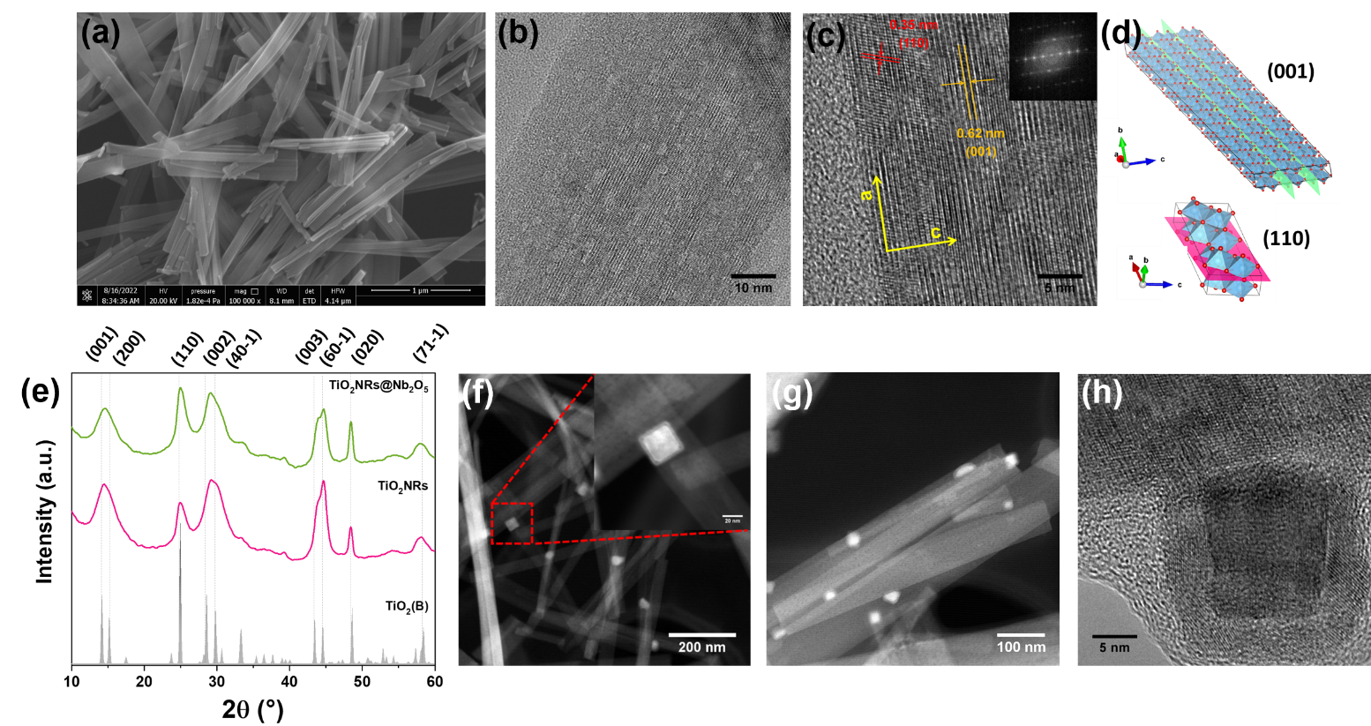HDO reaction was conducted at 350 °C in a plug-flow tubular reactor equipped with a quartz tube. The main products detected in acetone HDO were CH4, propylene/propane (C3), isobutene/isobutane (C4), 2-methyl-pentene/2-methyl-pentane (C6), isopropanol (IPA), 4-methylpent-3-an-2-one/4-methylpentan-2-one (C6O), and 2,6-dimethyl-4-heptanone and its position isomers (C9O). The molar sum of the deoxygenated products CH4, C3, C4, and C6 was used for the Degree of Deoxygenation (DOD) calculation. Textural, structural, and electronic characterizations of the catalysts were conducted using various techniques, such as N2 physisorption, XRD, XPS, SEM, TEM, TPR, and FTIR of adsorbed model molecules.

## Results and Discussion

Well-defined nanoribbons (NRs) with a few micrometers in length were obtained for the bare TiO2 material, as can be observed through the SEM micrograph presented in Figure 1a. Some cavities along the NR can be observed through HR-TEM (Figure 1b), as well as interplanar distances of 0.62 nm and 0.35 nm, related to (001) and (110) planes, respectively (Figure 1c,d). SEM and TEM images of TiO2NRs impregnated with 10 at.% Nb (Nb:Ti) were similar to that observed for the bare TiO2NRs, demonstrating that Nb was evenly dispersed over its surface. EDS analysis performed during TEM measurements (not shown) demonstrated that Nb percentage varied from 5-10 at.% in the center of the 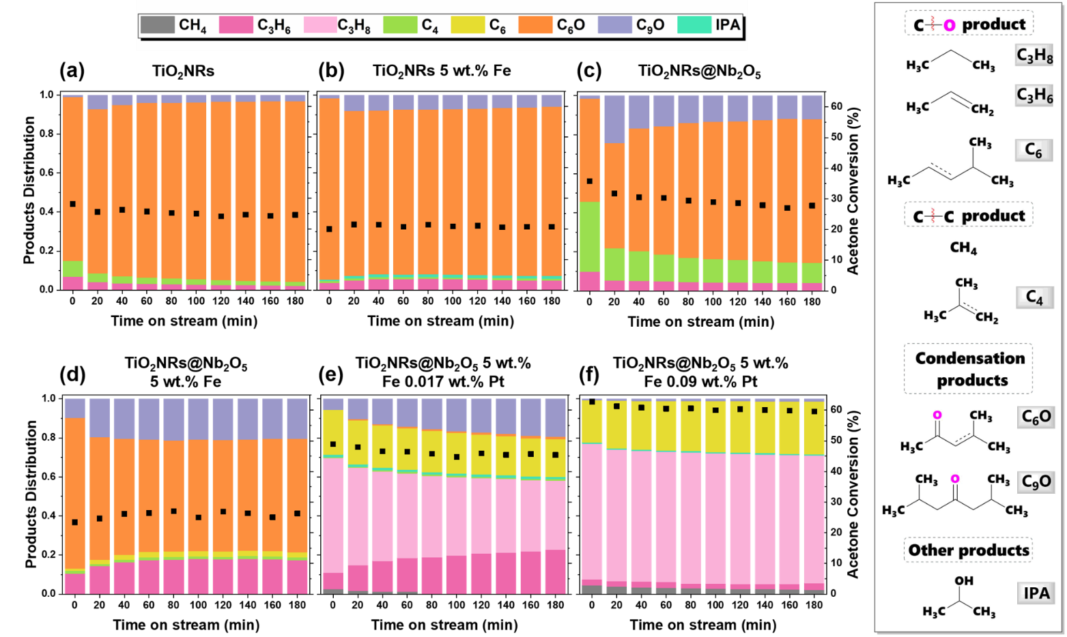NRs, however higher percentages of Nb were observed in the edges of the NRs (> 20 at.%), corroborating the formation of core@shell-like structures. XRD patterns (Figure 1e) demonstrated that the bare TiO2NRs led to the formation of TiO2 (B) crystal structure (ICSD CollCode 41056), while crystalline phases related to Nb oxides were not observed for the TiO2NRs@Nb2O5 core@shell. The relative intensities within the XRD pattern suggest a preferential growth along a- and c-axis, in agreement with NRs structure. However, the redox pairs of both oxides (Ti3+/Ti4+ and Nb4+/Nb5+) are active just at high temperatures (> 600 °C) (*10*, *11*), resulting in low DODs over HDO reactions conducted at lower temperatures (Figure 2a,c). Thus, 5 wt.% Fe-supported catalysts were prepared over both supports through an incipient wetness impregnation method. (S)TEM images of both reduced Fe-supported catalysts (Figures 1f-h) presented particles with cuboidal morphology in the 15-30 nm range. We assume that the particles epitaxially grew over the supports, driven by matching interplanar distances of the support and the Fe phase, as previously demonstrated for other systems (*12*). Moreover, it is possible to observe that the Fe crystallites are composed of a core@shell structure (see inset of Figure 1f and Figure 1h), in which the denser core is associated with metallic Fe, while the shell is associated with an oxidized phase of Fe. Interplanar distances obtained through TEM analysis, combined with XPS measurements, demonstrated that the phase of the shell can be related to the spinel structure of Fe3O4 (not shown). The oxidation of the surface of these particles could be due to the passivation step and/or the exposition to the atmosphere after reduction. XRD measurements were also conducted over the calcined and reduced Fe-supported catalysts (not shown), however, it was not possible to observe diffraction peaks related to Fe phases. Further electronic and structural characterization is underway to better understand the hypothesized epitaxial growth and to identify the electronic behavior of the Fe phase over both supports.

Figure 2: Products distribution (bars) and conversion (squares) of acetone HDO reaction as a function of TOS at 350 °C for (a) TiO2NRs; (b) TiO2NRs 5 wt.% Fe; (c) TiO2NRs@Nb2O5; (d) TiO2NRs@Nb2O5 5 wt.% Fe; (e) TiO2NRs@Nb2O5 5 wt.% Fe 0.017 wt.% Pt; and (f) TiO2NRs@Nb2O5 5 wt.% Fe 0.9 wt.% Pt. Total feed of 100 mL min-1: 3.6 mL min-1 acetone, 76 mL min-1 H2, balance He. 50 mg of catalyst for each test. Products structure are presented in the right panel.

Acetone HDO reaction was employed for this set of catalysts, in which different reaction pathways can occur, as presented in Figure 3. Both the bare TiO2NRs and the Fe-supported catalyst presented similar catalytic performances (Figures 2a,b), with acetone conversions around 25% and preferential formation of condensation products, mainly C6O, representing more than 90% of the total products. The addition of Fe to the system did not favor deoxygenation to a great extent, suggesting that AS are still the main active sites. On the other hand, when Fe was supported over 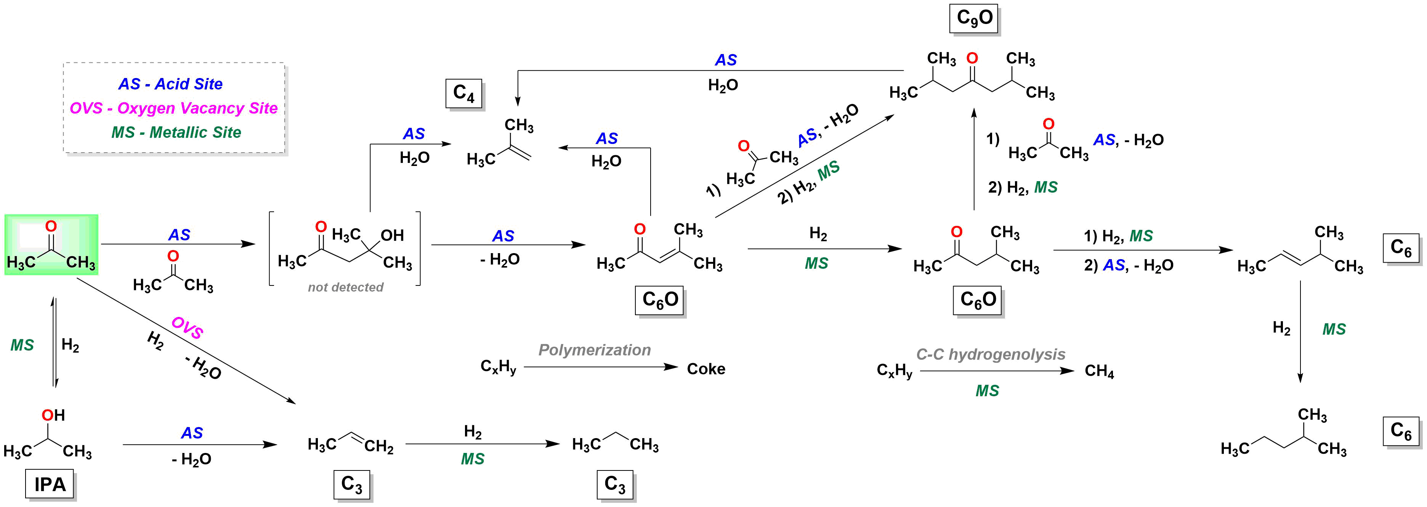TiO2NRs@Nb2O5 core@shell, the selectivity was significantly affected. The bare TiO2NRs@Nb2O5 (Figure 2c) presented conversions around 30% along the TOS, with DODs of ~10% and favoring condensation products, similar to that observed for the bare TiO2NRs. The Fe-supported catalyst led to higher DODs (~20%), where propane and C6 were the main deoxygenated products (Figure 2d); however, the formation of condensation products was still high (about ~80% of the total products). Additionally, a test employing a physical mixture of TiO2NRs@Nb2O5 and Fe2O3 nanoparticles was conducted (not shown), but the catalytic performance was similar to that observed for the bare TiO2NRs@Nb2O5 (Figure 2c). It suggests that the catalytic behavior observed for the Fe-supported TiO2NRs@Nb2O5 could be associated with the formation of interfacial sites. Aiming for higher DODs, ultra-low loadings of Pt (0.017-0.09 wt.%) were impregnated over the Fe-supported TiO2NRs@Nb2O5, in which expressive modifications in the catalytic behavior were observed (Figure 2e,f). The lower Pt loading (i.e. 0.017 wt.% Pt, Figure 2e) led to DODs of about 80% along the TOS, with propane and propene as the main products (together they represent about 60% of the total products). On the other hand, the higher Pt loading (0.09 wt.% Pt, Figure 2f) resulted in DODs of almost 100% over the entire TOS, with propane as the main product, representing about 60%. Additional tests employing ultra-low loadings of Pt will be also carried out without Fe and with different loadings of Pt, aiming for the rationalization of metallic and acid sites, to achieve an optimized DOD of the reactional stream.

Figure 3: Proposed scheme of acetone HDO reactional pathways. Adapted from (*13*).

## Conclusions

The presented data demonstrated that the MSI over 1D metal oxides can lead to the preferential growth of iron oxide particles (e.g. cuboidal morphology). The catalytic performance suggested that interfacial active sites were generated for the Fe-supported TiO2NRs@Nb2O5 catalyst, directly affecting the products distribution and leading to greater DODs. The addition of ultra-low loadings of a more hydrogenating specie, i.e. Pt, led to expressive modifications in the products distribution, resulting in DODs of almost 100% over the entire TOS. It demonstrates that even with ultra-low loadings of Pt, expressive modifications in the hydrogenation capability, and consequently, in the catalytic performance, can be achieved.

## Acknowledgements

We would like to thank FAPESP (2018/01258-5, 2020/12986-1, and 2022/11173-2), CNPq, and CAPES. We also thank the Brazilian Nanotechnology National Laboratory (LNNano) and Brazilian Synchrotron Light Laboratory (LNLS), an open national facility operated by the Brazilian Center for Research in Energy and Materials (CNPEM) of the Brazilian Ministry for Science, Technology, Innovations, and Communications (MCTIC).

## References

1. C. A. Teles *et al.*, *Catal. Letters*. **2016**, 146, 1848–1857.

2. Y. S. Yun, C. E. Berdugo-Díaz, D. W. Flaherty, *ACS Catal.*, **2021**, 11193–11232.

3. W. Zhang, Y. Zhang, L. Zhao, W. Wei, *Energy and Fuels*. **2010**, 24, 2052–2059.

4. J. Sun *et al.*, *J. Am. Chem. Soc.* **2016**, 138, 507–517.

5. T. Prasomsri, T. Nimmanwudipong, Y. Román-Leshkov, *Energy Environ. Sci.****2013****,*6, 1732–1738.

6. Y. Lykhach *et al.*, *J. Mater. Chem. A*. **2018**, 6, 23078–23086.

7. T. W. van Deelen, C. Hernández Mejía, K. P. de Jong, *Nat. Catal.* **2019**, 2, 955–970.

8. Z. Wang *et al.*, *Nat. Commun.* **2022**, 13, 1–10.

9. C. Navas-Cárdenas, N. Benito, E. E. Wolf, F. Gracia, *Int. J. Hydrogen Energy*. **2022**, 47, 20867–20880.

10. J. G. A. B. Silva, R. C. Santos, E. Rodríguez-Castellón, L. S. G. Teixeira, L. A. M. Pontes, *Mol. Catal.* **2021**, 507.

11. C. Zhang, H. He, K. ichi Tanaka, *Appl. Catal. B Environ.* **2006,** 65, 37–43.

12. P. Tancredi *et al.*, *Nano Res.* **2019**, 12, 1781–1788.

13. G. B. Strapasson *et al.*, *Appl. Catal. B Environ.*, **2023**, 122863.