Synthesis of modified Zeolitic imidazolate Frameworks (ZIFs) for Catalytic CO2 Conversion

Daniel Rapachi1*, Vanessa B. Mortola2, Marcos A. Gelesky1

1Laboratory of Catalysis and Inorganic Synthesis, Graduate Program in Technological and Environmental Chemistry, School of Chemistry and Food, Federal University of Rio Grande, Avenue Itália, km 08, 96201900, Rio Grande, RS, Brazil.

2Laboratory of Catalysis and Chemical Reactors, School of Chemistry and Food, Federal University of Rio Grande, Avenue Itália, km 08, 96201900, Rio Grande, RS, Brazil.

Resumo/Abstract

RESUMO – Estruturas zeolíticas imidazolato são materiais que apresentam características desejáveis, o que que possibilita sua aplicação em inúmeras reações, especialmente na hidrogenação de moléculas plataformas. Portanto, este estudo descreve a síntese das estruturas zeolíticas imidazolato 67 e 8, modificadas com de paládio. Os resultados obtidos confirmam a formação da estrutura sodálita com morfologia dodecaédrica, após a modificação foi possível observar que não houve mudanças significativas nas estruturas das zeolíticas imidazolato 67 e 8.

*Palavras-chave: ZIF-67, ZIF-8, Pd, conversão do CO2.*

ABSTRACT – Zeolitic imidazolate frameworks, are materials that have desirable characteristics, enabling their application in numerous reactions, particularly in the hydrogenation of platform molecules. Therefore, this study describes the synthesis of the zeolitic imidazolate 67 and 8 frameworks, modified with palladium. The results obtained confirm the formation of the sodalite structure with dodecahedral morphology, after the modification it was possible to observe that there were no significant changes in the structures of the zeolitic imidazolate 67 and 8.

*Keywords: ZIF-67, ZIF-8, Pd, CO2 conversion.*

## Introduction

Zeolitic imidazolate frameworks (ZIFs) are widely versatile materials due to their desirable structural characteristics of zeolites and metalorganic structures, such as high surface areas, porosity, crystallinity and stability (1-3). Such characteristics make them potential to be used in catalysis, desorption, separation, sensors and several other applications (4).

Among the numerous structures, the ZIF-8 and ZIF-67 stand out, consisting of zinc and cobalt ions, respectively, and of the 2-methylimidazole ligand. These materials have a sodalite structure and a high surface area (>1000 m2 g-1) (5-7), which make them potential materials to be used as support for metallic nanoparticles and to be applied as catalysts . Hu *et al*. (8) describe the synthesis of ZIF-8 modified with Ru, used as a catalyst in the hydrogenation reaction of CO2 to formic acid. Tian et al. (9) describe the synthesis of Au/ZIF-67, an efficient catalyst for the photocatalytic reduction of CO2 to CO.

Thus, this study aims to develop heterogeneous catalysts of ZIF-67, ZIF-8, Pd/ZIF-67 and Pd/ZIF-8, with potential catalytic application in the transformation of CO2.

## Experimental

*Synthesis of ZIFs and Pd/ZIFs.*

The synthesis of the ZIF-67 structure was performed as described by Li *et al*. (10), using nitrate cobalt hexahydrate, 2-methylimidazole and methanol.

The ZIF-8 structure was synthesized according to Schein *et al*. (11), using nitrate zinc hexahydrate, 2-methylimidazole and methanol. The synthesized structures were impregnated with PdCl2 and reduced with 4 bar of hydrogen gas at 75°C.

## Results and Discussion

ZIFs are materials that have defined structural and morphological characteristics. The morphology of ZIF-67 and ZIF-8 without modification are presented in Figures 1((a) and (b)) and 2 ((a) and (b)). Both materials showed a dodecahedral and homogeneous shape. As a function of the average size, it was verified by transmission electron microscopy (TEM), that the ZIF-67 and ZIF-8 support without modification, presented an average size of 365 ± 85 nm and 99 ± 16 nm, respectively.

The nitrogen adsorption analysis showed that the ZIF-67 without modification, presented high micropore area (1272 m2 g-1).

Figure 3 shows the X-ray diffractograms of the modified ZIFs and ZIFs structures. ZIF-67 and Pd/ZIF-67 (Figure 3a) presented sodalite structure. The same is observed for the ZIF-8 and Pd/ZIF-8, Figure 3(b). After impregnation/reduction of palladium ions in ZIF-67 and ZIF-8, metallic Pd was observed by X-ray energy dispersive spectroscopy, confirming the presence of palladium in ZIF-67 and ZIF-8.

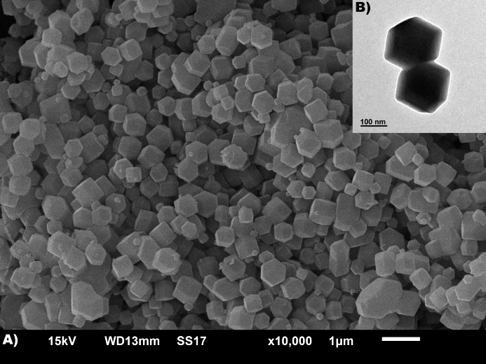

**Figure 1.**  a) SEM and b) TEM image of the ZIF-67 structure.

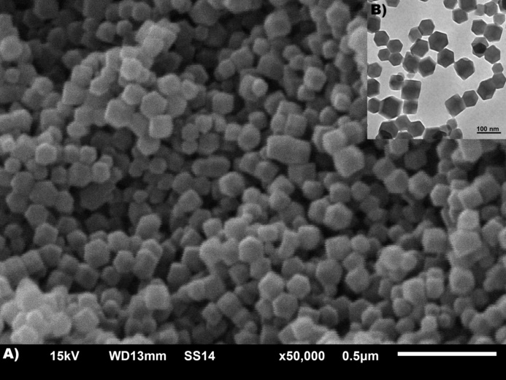

**Figure 2.**  a) SEM and b) TEM image of the ZIF-8 structure.

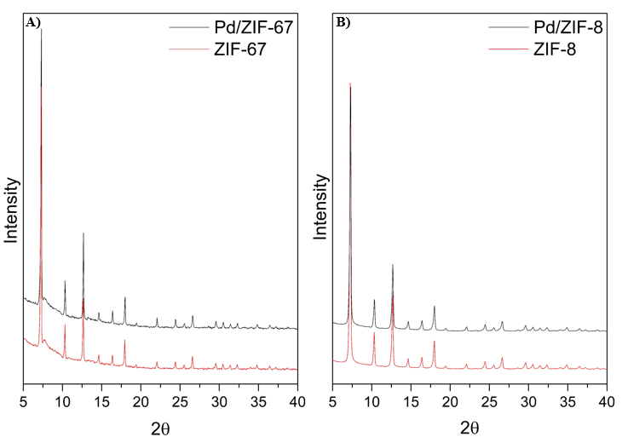

**Figure 3.**  X-ray diffractogram of a) ZIF-67 and b) ZIF-8, before and after modification (normalized data).

The morphological and structural characteristics of ZIF-67, ZIF-8 and Pd/ZIFs, suggest that they may present a high catalytic activity for the transformation of CO2.

## Conclusions

Through this study it was possible to obtain the structures ZIF-67 and ZIF-8, with sodalite structure high surface area and homogeneous morphology. The modified materials kept the ZIFs structure and a presence of Pd. The materials have potential catalytic activity in the conversion of CO2 to CO and formic acid, using thermochemical or photochemical activation.

Acknowledgment

The authors would like to thank CAPES (Coordination for the Improvement of Higher Education Personnel) for partial financial support and PPGQTA for scholarships, and CEME-SUL (Microscopy Center of the South Zone) and CIA (Integrated Analysis Center) analyzes the carried out.

## References

1. J.C. Tan, T.D. Bennett, A.K. Cheetham. *Proceedings of the National Academy of Sciences*, **2010**, 107, 9938-9943.

2. M.N. Timofeeva, et al. *Russian Chemical Bulletin*, **2022**, 71, 599-612.

3. P. Kukkar, K.H. Kim, D. Kukkar, P. Singh. *Coordination Chemistry Reviews*, **2021**, 446, 214109.

4. H.N. Abdelhamid. *Applied Organometallic Chemistry*, **2022**, 36.

5. C. Duan, Y. Yu, H. Hu. *Green Energy & Environment*, **2022**, 7, 3-15.

6. R. Banerjee, et al. *Science*, **2008**, 319, 939-943.

7. K.S. Park, et al. *Proceedings of the National Academy of Sciences*, **2006**, 103, 10186-10191.

8. X. Hu, et al. *Journal of CO2 Utilization*, **2022**, 60, 101992.

9. T. Tian, et al. *Materials Today Nano*, **2023**, 21, 100293.

10. X. Li, Z. Li, L. Lu, L. Huang, L. Xiang, J. Shen, S. Liu, D.R. Xiao. *Chemistry–A European Journal*, **2017**, 23, 10638-10643.

11. A. Schejn, L. Balan, V. Falk, L. Aranda, G. Medjahdi, R. Schneider. *CrystEngComm* , **2014**, 16, 4493-4500.