**Surface treatment of 3D printed stainless steel monolith for improved Al2O3 washcoat adhesion**

**Ellen Pietschmann1*, Ana C. S. Luz1, Rafael V. Eleutério1, Maíra O. Palm1, Diego A. Duarte2, Rafael C. Catapan1**

*1Laboratory of Applied Catalysis, Joinville Center of Technology, Federal University of Santa Catarina, Joinville, SC, Brazil.*

*2Laboratory of Surface Treatments, Joinville Center of Technology, Federal University of Santa Catarina, Joinville, SC, Brazil.*

*\*ellen.p@posgrad.ufsc.br*

**Resumo/Abstract**

RESUMO – Monólitos metálicos estruturados para aplicações catalíticas são promissores, porém requerem etapas de pré-tratamento para garantir boa adesão do suporte cerâmico. Este trabalho propõe tratamentos de superfície para aumentar a rugosidade e a consequente adesão de alumina a monólitos de aço inoxidável fabricados por manufatura aditiva. Resultados promissores de adesão foram obtidos com ataque ácido e tratamento térmico a 900 ºC por 5 h, com menor teor de óxido de ferro na superfície, 7,5% de perda de massa do suporte nos testes de aderência e molhabilidade melhorada em relação à amostra sem tratamento.

*Palavras-chave: Substrato metálico, pré-tratamento, monólito impresso, alumina, catalisador.*

ABSTRACT – Structured metallic monoliths for catalytic applications are promising, however, they require pretreatment steps to ensure good adhesion of the ceramic support. This study proposes surface treatments to increase the roughness and consequent adherence of alumina to 3D-printed stainless steel monoliths. Promising results were achieved with acid etching and thermal treatment at 900 °C for 5 h, resulting in a lower iron oxide content on the surface, 7.5% mass loss of the support in adhesion tests, and improved wettability compared to the untreated sample.

*Keywords: Metallic substrate, pretreatment, printed monolith, alumina, catalyst.*

## Introduction

Metallic substrates for catalysts offer a series of advantages against typical ceramics: better thermal conductivity, lower heat capacity and greater resistance to thermal and mechanical shock (1). Structured catalysts open possibilities for use of thinner walls and lower pressure drop (2). The combination with additive manufacture can improve even more these advantages with designs of high complexity (3). However, the use of metals requires a pretreatment step to improve surface roughness and promote the formation of oxide layers for good support and catalyst coating adhesion (4). The objective of this work is to evaluate a pretreatment step to ensure adherence of alumina (Al2O3) for catalytic applications.

## Experimental

*Printing and treatment of monoliths.* Stainless steel 316L monoliths were printed via Selective Laser Melting (SLM) by Alkimat Technologies Ltda. based on the geometry proposed by Papetti et al. (5). The strut diameter, cell length, thickness, and diameter with lateral walls were selected as 0.6 mm, 1.4 mm, 12.7 mm, and 15 mm, respectively. The 3D CAD software SolidWorks was used to design the samples with a porosity of 83% and a specific surface area of 1030 m²/m³. The samples were cleaned in ultrasonic bath at 40 kHz, 80 VA (Eco-sonics Q3.0/40) in acetone for 60 min and dried at 120 ºC for 1 h. Sample M0 (Monolith 0) has only been cleaned. The samples subjected to 800 ºC and 900 ºC for 5 h in a 13 ºC/min heating rate were named M800 and M900, respectively. One sample etched with 5 wt% nitric acid solution for 10 min at room temperature and calcined at 900 °C for 5 h was named MA900.

*Washcoat preparation and dip-coating procedure.* The alumina washcoat composition and preparation were based on the procedure of Danaci et al. (6), where 3 wt% Polyvinyl alcohol (PVA, Mowiol 40-88, Sigma-Aldrich) and 1 wt% 0.2 M acetic acid were added to 74 wt% deionized water, stirred at 60 °C for 2 h and left resting overnight. Afterwards, 20 wt% γ-alumina (ThermoScientific, 134 m²/g) and 2 wt% colloidal silica (Ludox TMA, Sigma-Aldrich) were added and the solution was stirred at room temperature for 24 h. The samples were dipped for 1 min into the slurry, excess solution was gently removed by air blowing and left to dry at 100 ºC overnight. They were calcined at 500 ºC with 6 ºC/min heating rate for 2h and weighted before and after the procedure to measure the alumina deposition.

*Characterization.* A Hitachi HT3030 Scanning Electron Microscopy (SEM) was used to evaluate morphology. For wettability, Ramé-Hart Model 590 Advanced Automated Goniometer/Tensiometer with 1 μl droplets of the washcoat solution for three different places was used. The pictures were analyzed with ImageJ software and drop Snake method (7) to determine the contact angles (θ). For the adherence test the monoliths were immersed in water and subjected to an ultrasonic bath for 30 min in an Eco-sonics Q3.0/40 (40 kHz, 80 VA) at room temperature and left at 100 ºC to dry. Adherence was calculated as the percentage ratio of retained alumina to the amount of initially deposited alumina.

## Results and Discussion

Figure 1(a) shows the CAD Design. The samples before the treatments were visually rough (Fig. 1 (b)) and minor magnification on SEM exposed the staircase effect and printing defects (Fig. 1 (c)). The small spherical particles that were not sintered during printing represent these defects, although they can improve roughness and surface area and enhance coating adhesion.

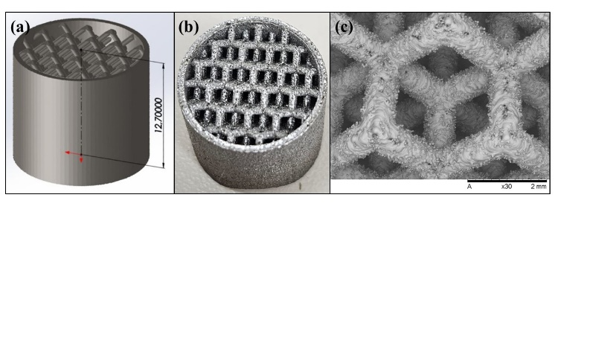

**Figure 2.** Images of the stainless steel monolith (a) CAD, (b) after printing and (c) SEM image at x30 magnification.

Figure 2 exhibits the monolith’s surface after the treatments. As comparison purposes, the sample without treatment is also shown (Fig.2 (a)). All treatments (Fig.2 (b-d)) improved the surface’s roughness. Fig. 2 (b) exhibits structures of iron oxide, which were expected for the 800 ºC treatment (8). Higher temperatures favor migration of Cr to the surface (9), which is proven by iron oxide absence in Fig. 2 (c-d).

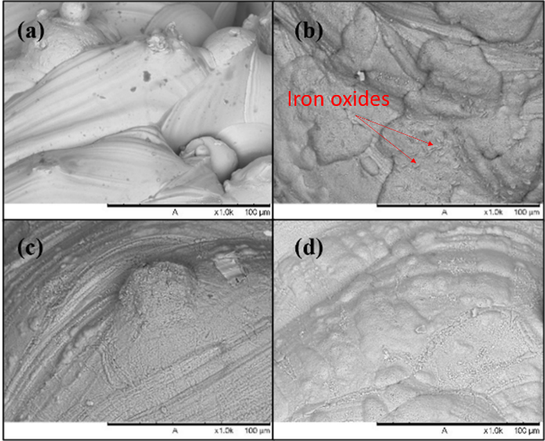

**Figure 2.** SEM images of monoliths (a) M0, (b) M800, (c) M900 and (d) MA900 at x1,000 magnification.

The original surface was hydrophilic (10º < θ < 90°) as shown in Fig. 3 (a). After calcination all samples presented improved wettability (Fig. 3 (b-d)).

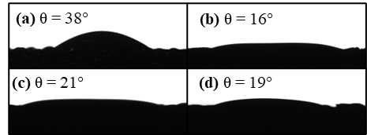

**Figure 3.** Contact angle (θ) images of samples (a) M0, (b) M800, (c) M900 and (d) MA900.

Al2O3 deposition was 1 ± 0.09 wt% after washcoat. Adherence test in untreated M0 had weight loss of 9.8%. M800 sample lost 4.9 wt%, in agreement with Agrafiotis et al. (10) that roughness generated by iron oxide improves adherence by mechanical mechanisms, although it benefits Cr migration beyond the alumina coating at high application temperatures, which is undesirable. Sample M900 exhibited 19.3% loss most likely to the smoothening of the surface by chromium oxides. Sample MA900 resulted in 7.5% loss, indicating that the acid treatment could overcome the issue since the higher temperature promoted Cr migration.

## Conclusions

Tailored designed and 3D printed stainless steel monoliths were treated at different temperatures and etching conditions. The optimal treatment for adherence and stability in a catalytic application was 5 wt% HNO3 dipping for 10 min and 900 ºC for 5 h. More surface and catalytic characterizations will be done in the future.

## Acknowledgements

The authors are thankful for the Multi-User Facility infrastructure from Santa Catarina State University's Technological Sciences Center for the analysis. This work was funded by FUNDEP Rota2030, BMW Brazil Group, AVL South America and Ágora Tech Park under the project 27192*17. Diego A. Duarte thanks the financial support from CNPq (grant no. 307408/2021-3).

## References

1. W. Wang; S. Zhao; X. Tang; C. Chen; H. Yi, *Environ Sci Pollut.* **2022**, 29, 55367-55399.
2. J. A. Santander; G. M. Tonetto; M. N. Pedernera; E. López, *Int. J. of H. En.* **2017**, 42(15), 9482-9492.
3. O. H. Laguna; P. F. Lietor; F. J. I. Godino; F. A. Corpas-Iglesias, *Mat. & Des.* **2021**, 208, 109927
4. J. A. Santander; E. López; G. M. Tonetto; M. N. Pedernera, *Ind. Eng. Chem.* **2014**, 53, 28, 11312-11319.
5. V. Papetti; P. D. Eggenschwiler; A. D. Torre; F. Lucci; A. Ortona; G. Montenegro, *Int. J. of Heat and Mass Transfer* **2018**, 126, 1035-1047.
6. S. Danaci; L. Protasova; F. Snijkers; W. Bouwen; A. Bengaouer; P. Marty, *Chem. Eng. and Proc. – Proc. Int*. **2018**, 127, 168-177.
7. A.F. Stalder; G. Kulik; D. Sage; L. Barbieri; P. Hoffmann, *Col. And Surf. A: Phys. And Eng. Asp.* **2006**, 286, 92-103.
8. F. G. Duran; P. Belzunce; L. E. Cadús, *Surf. Eng.* **2020**, 36(5), 456-476.
9. J. P. Bortolozzi; T. Weiss; L.B. Gutierrez; M. A. Ulla, *Chem. Eng. J.* **2014**, 246, 343-352.
10. C. Agrafiotis; A. Tsetsekou; C.J. Stournaras; A. Julbe; L. Dalmazio; C. Guizard, *J. Eur. Ceramic Soc.* **2002**, 22, 15-25.