DFT+U Study of Strain Engineered CO₂ Reduction on a CeO₂(110) Facet
Carla V. Soares^{1*}, Nilton Rosenbach Jr². e Claudio J. A. Mota¹
¹Universidade Federal do Rio de Janeiro - Instituto de Química - Cidade Universitária CT Bloco A, 21949-900, Rio de Janeiro, Brasil, Laboratório de Reatividade de Hidrocarbonetos e Catálise Orgânica (LARHCO).
²Faculdade de Ciências Exatas e Engenharias, Universidade do Estado do Rio de Janeiro, Av. Manuel Caldeira de Alvarenga, 1203, Rio de Janeiro, RJ, Brazil. *carlavsoares@iq.ufrj.br
Resumo/Abstract

RESUMO - Foi realizada uma avaliação sistemática do impacto das vacâncias de oxigênio presentes na superfície do CeO₂ em sua atividade de redução de CO₂ através de cálculos periódicos da Teoria do Funcional da Densidade. Os cálculos revelaram que o CO₂ adsorvido na superfície do CeO₂ adota uma configuração em ponte, similar à espécie carbonato, para todas as superfícies de CeO₂, independentemente da natureza e localização das vacâncias. Estas configurações de geometria foram utilizadas como reagentes para explorar a redução de CO₂ em CO através de cálculos NEB (Nudged Elastic Band).
Palavras-chave: Superfícies de CeO₂, DFT, conversão de CO₂, hidrocarbonetos

ABSTRACT - Herein, a systematic assessment of the impact of oxygen vacancies present at the CeO₂ surface on its CO₂ reduction activity was performed by periodic Density Functional Theory calculations. These calculations firstly revealed that the adsorbed CO₂ at the CeO₂ surface initially adopts a preferentially bent configuration for all CeO₂ surfaces invariant of the nature/location of the vacancies. These geometry-optimized configurations further served as starting points to explore CO₂ reduction into CO via DFT-based Nudged Elastic Band calculations.
Keywords: CeO₂ surfaces, DFT, CO₂ conversion, hydrocarbons

Introduction
Excessive emission of CO₂ has emerged as an environmental challenge over the last few decades. This pressing issue calls for urgent exploration of efficient and cost-effective technologies aimed at mitigating atmospheric CO₂ and suppressing the greenhouse effect. One promising approach for producing clean energy involves the conversion of CO₂ into fuels like CH₄, higher hydrocarbons and CH₃OH. However, achieving a significant conversion through catalytic reactions remains a formidable obstacle due to the inherent thermal stability of CO₂ against its initial reduction. Among the potential catalysts, ceria (CeO₂) has garnered substantial attention for its viability in facilitating the initial CO₂ reduction¹. Herein, a systematic investigation of the impact of oxygen vacancy on CeO₂ was investigated by periodic DFT calculations for the initial reduction of CO₂. Among the ceria polymorphs, CeO₂ (110) has been chosen owing to its remarkable catalytic property and stability.

Methods
DFT calculations were performed by using the Vienna ab initio Simulation Package (VASP)^{2,3}. The Perdew-Burke-Ernzerhof functional (PBE) is used for the exchange-correlation. Ionic cores are described by the projector augmented wave method (PAW) with a plane wave energy cutoff of 520 eV. The slab model of the ceria (110) surface was cleaved from the geometry-optimized bulk structure (lattice parameter of a = 5.41 Å), and the bottom two atomic layers of the five-layer slab are maintained fixed. A value of U = 4.5 eV was considered for the Ce 4f states. The Brillouin zones are sampled using a (3×2×1) Monkhorst-Pack grid.

Results
The vacancy formation energy on the first layer of CeO₂ (110) surface was calculated to be 44.0 kcal/mol. A similar value of oxygen vacancy formation energy was found by Cheng et al.⁴ Adsorbed CO₂, with adsorption energy of -41.1 kcal/mol, on the neighboring site of the oxygen vacancy is activated into a bent configuration with <OCO = 123.9° (Figure 1a). The two symmetrical C−O bonds in the bent structure have lengths of 1.28 Å and 1.30 Å, and the C−O bond length in which the C atom interacts with the surface O atom of ceria is 1.33 Å. The energy required for the generation of oxygen vacancy in the second layer was 55.8 kcal/mol, in agreement with the value obtained by Pérez-Bailac et al.⁵ The CO₂ molecule is adsorbed with binding energy of −59.8 kJ/mol, and bent configuration (with <OCO = 126.7° and C−O bond length of 1.28 Å), which is similar to the structure computed for the adsorption on the vacancy in the first layer (Figure 1b).

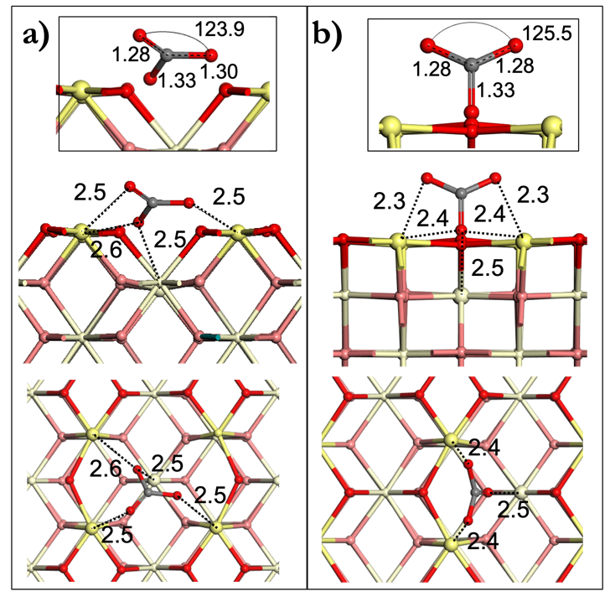

Figure 1. Adsorbed configuration of reactant of CO₂ conversion on surface ceria with vacancy (a) in the first layer and (b) in the second layer.

Conclusions
The most stable adsorbed configurations are the bent structure of CO₂. These configurations were used as starting points for the CO₂ conversion to CO on ceria surfaces. The Nudged Elastic Band calculations are being performing to construct a reaction energy diagram for the mechanistic pathways for CO₂ reduction to CO and hydrocarbons on CeO₂ (110) surface.

Acknowledgments
The authors acknowledge FAPERJ, CNPq and CENAPAD-SP.

References
- Ebrahimi, P., Kumar, A., Khraisheh and M. Catalysts, 2022, 12, 1101.
- G. Kresse and J. Hafner, Phys. Rev. B, 1996, 47, 558.
- G. Kresse and J. Furthmüller, Comput. Mater. Sci. 1996, 6, 15.
- Cheng, Z., Lo and C. S. Phys. Chem. Chem. Phys., 2016, 18, 7987.
- Pérez-Bailac, P., Lustemberg, P. G., Ganduglia-Pirovano, M. J. Phy. Cond. Matter, 2021, 33, 504003.

