DRIFT-FTIR Analysis of CO Adsorbed on Supported Metals: Probing Metal Single-Atom in Carbon Nitrides

Isadora Guedes Farias1; Ivo Freitas Teixeira1

[isadoragfarias@gmail.com](mailto:isadoragfarias@gmail.com)*; [ivo@ufscar.br](mailto:ivo@ufscar.br)

1.Rod. Washington Luís, s/n - Monjolinho, São Carlos - SP, 13565-90.[1]

Resumo/Abstract

RESUMO - Os nitretos de carbono (C3N4) são polímeros semicondutores promissores muito empregados em reações de conversão de energia por vias fotocatalíticas, devido à sua estrutura estável bidimensional e boas propriedades eletrônicas. Esses materiais oferecem excelentes sítios de coordenação para estabilizar átomos isolados, tornando-os ideais para uso como fotocatalisadores em *single-atom catalysis*. Este estudo utilizou DRIFT-FTIR para analisar a adsorção de moléculas de CO em metais suportados, especificamente Ni-PHI, Fe-PHI and Pt-PHI preparados a patir de Na-PHI, para entender o impacto de diferentes concentrações de metal no modo de coordenação. O processo experimental envolveu o aquecimento da amostra a 350°C usando hélio, a introdução de CO e, em seguida, a purga com hélio. Os espectros resultantes mostraram bandas distintas indicando CO quimissorvido. Números de onda mais baixos (abaixo de 2100 cm-1) indicaram CO coordenado com múltiplos metais de transição, especialmente em amostras com alta carga de metal, sugerindo a formação de aglomerados. Números de onda mais altos (acima de 2150 cm-1) indicaram CO coordenado de forma única, sugerindo a presença de átomos metálicos isolados. Pesquisas adicionais com diferentes concentrações de níquel estão planejadas para validar essas descobertas, potencialmente revolucionando a caracterização da catalisadores de átomo único.

*Palavras-chave: Nitreto de carbono, adsorção, fotocatalisadores, DRIFT-FTIR.*

ABSTRACT – Carbon nitrides (C3N4) are promising semiconducting polymers widely used in energy conversion reactions through photocatalytic pathways, owing to their stable two-dimensional structure and good electronic properties. These materials provide excellent coordination sites for stabilizing isolated atoms, making them ideal for use as photocatalysts in single-atom catalysis. This study employed DRIFT-FTIR (Diffuse Reflectance Infrared Fourier Transform Infrared Spectroscopy) to analyze the adsorption of CO molecules on supported metals, specifically Ni-PHI, Fe-PHI e Pt-PHI prepared from Na-PHI, in order to understand the impact of different metal concentrations on the coordination mode. The experimental process involved heating the sample to 350°C using helium, introducing CO, and then purging it with helium. The resulting spectra exhibited distinct bands indicating chemisorbed CO. Lower wavenumbers (below 2100 cm-1) suggested CO coordinated with multiple transition metals, especially in samples with high metal loading, implying cluster formation. Higher wavenumbers (above 2150 cm-1) indicated uniquely coordinated CO, implying the presence of isolated metal atoms. Further investigations using different nickel concentrations are planned to validate these findings, potentially revolutionizing the characterization of single-atom catalysts.

*Keywords: Carbon nitride, adsorption, photocatalysts, DRIFT-FTIR.*

## Introduction

Carbon nitrides (C3N4) are promising semiconducting polymers for photocatalytic energy conversion reactions. They provide a two-dimensional support for stabilizing isolated atoms due to their uniformity, controlled structure, and high nitrogen content, resulting in well-defined coordination sites. Thus, they are suitable for use as photocatalysts.1 However, the field of single-atom-mediated catalysis is limited by the resolution of analytical methods. DRIFT-FTIR is an important tool with great potential for assessing the existence of single atoms.2 Therefore, the objective of this study was to utilize DRIFT-FTIR with CO as a probe molecule to investigate the bands of adsorbed CO on supported metals**.**

## Experimental

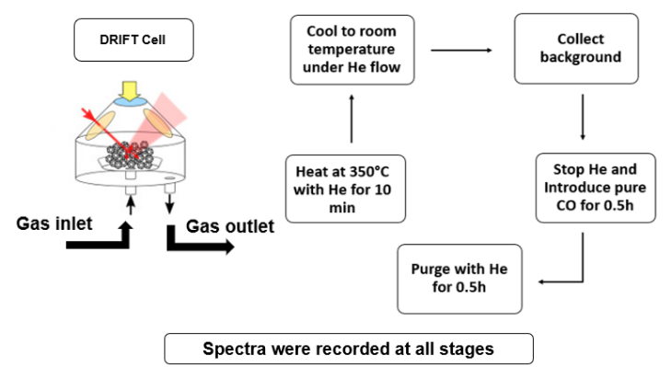Ni-PHI, Fe-PHI, Pt-PHI and Na-PHI have been studied in order to analyze how each supported metal behaves and observe changes in the coordination mode at different metal concentrations.

## Results and discussion

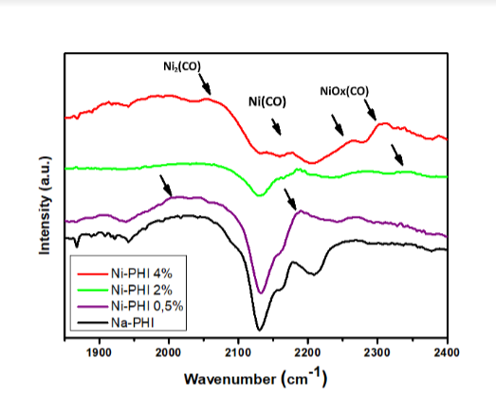Figure 1: FTIR-DRIFT spectra of Ni-PHI (0.5, 2 and 4%) and Na-PHI with chemisorbed CO.

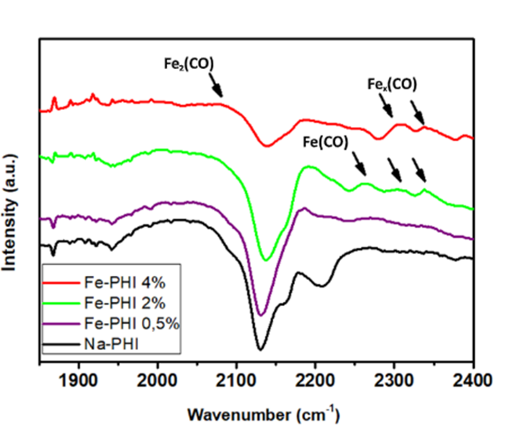Figure 2: FTIR-DRIFT spectra of Fe-PHI (0.5, 2 and 4%) and Na-PHI with chemisorbed CO.

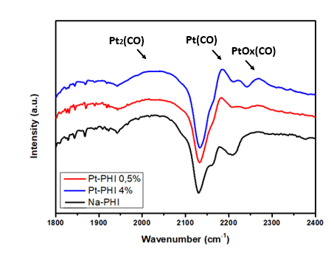Figure 3: FTIR-DRIFT spectra of Pt-PHI (0.5 and 4%) and Na-PHI with chemisorbed CO.

1.Rod. Washington Luís, s/n - Monjolinho, São Carlos - SP, 13565-90.

## Conclusions

Bands below 2100 cm-1 suggest CO coordinated to multiple metals, more prominent with higher metal content, indicating cluster formation. Bands above 2150 cm-1 point to single-coordinated CO and metal single-atoms. This work could revolutionize single-atom catalysis characterization, with potential applications in energy conversion.

## Acknowledgment

The authors are thankful to FAPESP, CAPES, CNPQ and LNNano.

## References

1. Bavykina, A.; Kolobov, N.; Khan, I. S.; Bau, J. A.; Ramirez, A.; Gascon, J., Metal–Organic Frameworks in Heterogeneous Catalysis: Recent Progress, New Trends, and Future Perspectives. Chemical Reviews 2020, 120 (16), 8468-8535.
2. Colombari, F. M.; SILVA, M. A. R. da; Homsi, M. S.; Souza, B. R. L. de; Araujo, M.; Francisco, J. L.; Silva, G. T. S. T. da; Silva, I. F.; Moura, A. F. de; Teixeira, I. F.. Graphitic carbon nitrides as platforms for single-atom photocatalysis. Faraday Discussions, [S.L.], v. 227, p. 306-320, 2021. Royal Society of Chemistry (RSC). http://dx.doi.org/10.1039/c9fd00112c.

1. Endereço atual.