The role of Iron and Manganese Single Atoms on Crystalline Carbon Nitrides for Selective Photocatalytic C-H Oxidation

Marcos A. R. da Silva1*, Carla S. Cunha1, Nadezda V. Tarakina2, José B. G. Filho3, Guilherme F. S. R. Rocha1, Gabriel A. A. Diab1, Luana L. B. da Silva1, Hamilton A. S. Júnior1, Davide Ravelli4, Ivo F. Teixeira1.

1 Universidade Federal de São Carlos, Departamento de Química, 13565-905, São Carlos, SP, Brazil

2 *Department of Colloid Chemistry, Max Planck Institute of Colloids and Interfaces, Am Mühlenberg 1, D-14476 Potsdam, Germany*

*3 Department of Chemistry, ICEx, Federal University of Minas Gerais, 31270-901, Belo Horizonte, MG, Brazil*

*4 Department of Chemistry, University of Pavia, viale Taramelli 12, 27100 Pavia, Italy*

*\*marcosgusto96@gmail.com*

Resumo/Abstract

RESUMO - A catálise por *single atoms* tem ganhado relevância na ciência contemporânea devido à sua excepcional capacidade de reunir as vantagens das catálises homogênea e heterogênea. Metaloenzimas de ferro e manganês, contendo espécies de metal-oxo como sítios ativos, demonstraram ser eficazes em reações de oxidação C-H na natureza, inspirando os cientistas a emular seus sítios ativos em sistemas catalíticos sintéticos. Neste trabalho, *single atoms* de ferro e manganês foram suportados em nitretos de carbono cristalinos na forma poli(heptazina imida) (PHI), sendo empregados como fotocatalisadores para a oxidação do tolueno, demonstrando notável seletividade para benzaldeído. O protocolo foi então estendido para a oxidação seletiva de diferentes substratos, incluindo alquil aromáticos, álcoois benzílicos e sulfetos. Investigações detalhadas do mecanismo revelaram que os fotocatalisadores contendo ferro e manganês funcionam de maneira semelhante através da formação de espécies M=O de alta valência.

*Palavras-chave: Fotocatálise, Single-Atoms, Oxidação Seletiva, Nitretos de Carbono, Poli(heptazina imida).*

ABSTRACT - Single atom catalysis is a field of paramount importance in contemporary science due to its exceptional ability to combine the domains of homogeneous and heterogeneous catalysis. Iron and manganese metalloenzymes, with metal-oxo species as catalytic active sites, have been shown to be effective in C–H oxidation reactions in nature, inspiring scientists to mimic their active sites in synthetic catalytic systems. Herein, a simple and versatile cation exchange method was successfully employed to stabilize low-cost iron and manganese single atoms in poly(heptazine imides) (PHI). The resulting materials were in turn employed as photocatalysts for toluene oxidation, demonstrating remarkable selectivity towards benzaldehyde. The protocol was then extended to the selective oxidation of different substrates, including alkyl aromatics, benzyl alcohols and sulfides. Detailed mechanism investigations revealed that iron- and manganese-containing photocatalysts work similarly via the formation of high-valent M=O species.

*Keywords: Photocatalysis, Single Atoms, Selective Oxidation, Carbon Nitrides, Poly(heptazine imide).*

## Introduction

Single atom catalysts (SACs) have garnered significant attention from the scientific community due to their impressive features. These include the exceptional activity and selectivity resulting from their unique electronic structures and active sites’ chemical environment (1). SACs are closely related to homogeneous complexes in that they both involve isolated metal sites within well-defined environments created by organic ligands. This resemblance enables the possibility of creating homogeneous-like mechanisms in heterogeneous materials, which can achieve similar yields, while also being highly recyclable and robust due to the nature of the support.

One of the most important homogeneous catalysts in nature, cytochrome P450 enzymes, contain iron atoms coordinated to porphyrin rings as active sites, which react with molecular oxygen (O2) to produce highly reactive iron-oxo intermediates (Fe=O). The same chemical environment could be mimic using metal single atoms coordinated on solid supports. The utilization of poly(heptazine imide) materials for stabilizing single atoms has been steadily increasing in recent years, enhancing the significance of carbon nitrides in the field of single atom catalysts (SACs).

## Experimental

Poly(heptazine imide) and metal-PHI (Fe and Mn) materials were synthesized with similar procedures reported elsewhere (3). Photooxidation of C(sp3)-H bonds in the presence of the prepared photocatalysts was evaluated using toluene as substrate and molecular oxygen (O2) as terminal oxidant. The reactions were carried out in acidic (by H2SO4) acetonitrile by using a 410 nm LED (100 W) as the irradiation source.

## Results

**Figure 1** exhibit the XRD spectra for Fe and Mn-PHI catalysts. The structure’s integrity is mostly preserved after the addition of metals. A narrow intense (100) peak at 8o on the XRD pattern of PHI is related to the heptazine units repeating throughout the framework; a set of several overlapping reflections with maximum position at around 27o corresponds to the (001) plane in the structure which relates to the distance between heptazine layers.

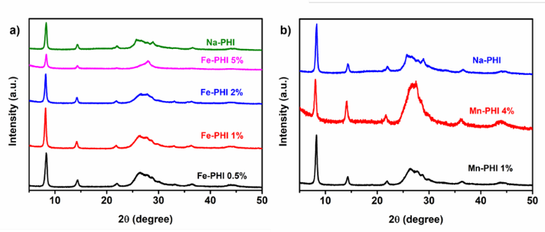

**Figure 1.** XRD patterns of: **(a)** Fe-PHI and **(b)** Mn-PHI materials with different metal loadings compared with pristine Na-PHI.

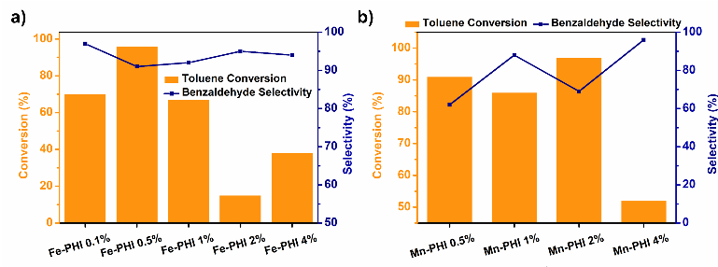The results observed for both Fe-PHI and Mn-PHI indicate that toluene is selectively oxidized towards benzaldehyde. Fe-PHI exhibit higher toluene conversions when Fe content is below 2%. The selectivity does not seem to change for these materials, showing results above 90% for all the photocatalysts (**Figure 2a**). In this system, Fe-PHI 0.5% (50 mg) is the best catalyst for benzaldehyde production, with 96% of conversion and 92% of selectivity. For manganese photocatalysts, Mn-PHI 1% exhibits the highest benzaldehyde yield (86% of conversion and 90% of selectivity) upon irradiation at 410 nm (10 W) for 12 h (**Figure 2b**).

**Figure 2.** Toluene photooxidation results for different loadings of: **(a)** Fe-PHI and **(b)** Mn-PHI.

The versatility of these photocatalysts for C(sp3)-H oxidation was investigated using substrates with different substituents on the aromatic ring of toluene. As depicted in **Table 1**, a wide range of structures can undergo oxidation to yield aldehydes. Remarkably, benzyl alcohol exhibits an exceptional selectivity, producing benzaldehyde with a remarkable yield of 97% in just 7 hours when using Mn-PHI catalyst. This further demonstrates the high selectivity of this material. Moreover, the production of aldehydes extends to various substrates with terminal CH2-OH bonds, as illustrated in **Table 1**. Moreover, the oxidation ability of these materials extends to sulfides and thiols.

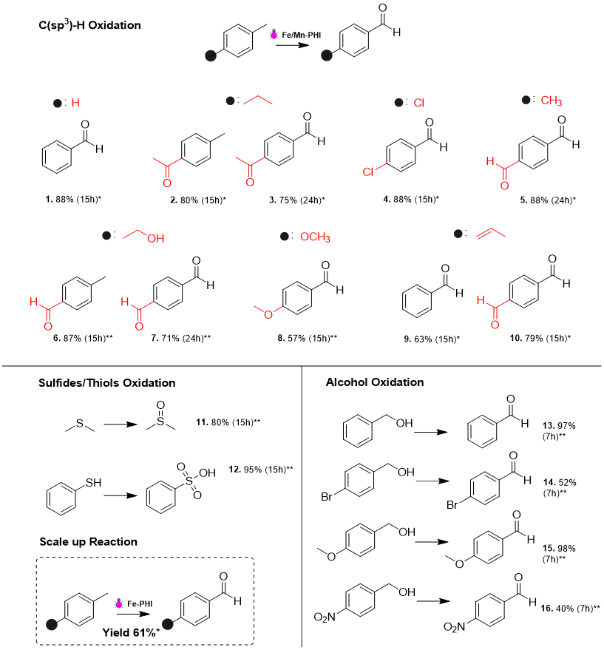**Table 1.** Substrate scope for photocatalytic oxidation using Fe-PHI (*) and Mn-PHI (**).

## Conclusions

In this work, we successfully employed a simple and versatile cation exchange method to synthesize Fe-PHI and Mn-PHI single atoms photocatalysts, which were employed in the oxidation of several molecules such as hydrocarbons, alcohols and S-compounds.

Acknowledgements

The authors are thankful to FAPESP, CNPQ and CAPES.

## References

1. S. K. Kaiser et al. Chemical reviews, **2020**, 120, 21, 11703-11809.
2. S. Mitchell; J. Pérez-Ramírez. Nature Communications, **2020**, 11, 1, 4302.
3. M. A. R. da Silva et al. Applied Catalysis B: Environmental, **2022**, 304, 120965.