Selective Fe-based catalysts to obtain nitrosobenzene via aniline conversion in liquid phase
Nathália B. Amaral¹, André L. D. Lima¹ , José B. G. Filho¹, Marcelo G. Rosmaninho¹, and Adilson Cândido Silva*¹
¹Departamento de química, Universidade Federal de Ouro Preto, campus morro do Cruzeiro, Bauxita, 35400-000 Ouro Preto – MG.
*¹ adilsonqui@ufop.edu.br
Resumo/Abstract

RESUMO - Hematita (α-Fe2O3) e goethita (α-FeOOH) sintetizadas pelo método de microemulsão foram aplicadas na oxidação de anilina em fase líquida. Os catalisadores foram caracterizados por espectroscopia Mössbauer a 298 K, adsorção/dessorção de N2. Os espectros de Mössbauer confirmam a aquisição das fases de ferro desejadas. Os dados do BET mostraram que os catalisadores GtME e HmME apresentaram áreas de 257 e 27 m2.g-1, respectivamente. Um estudo cinético foi realizado e conversões de 60% e 90% de anilina foram obtidas para hematita e goethita, respectivamente, em uma reação de 24 horas. A hematita apresenta uma seletividade de 96% ao nitrosobenzeno, enquanto a goetita atingiu uma seletividade de 93% ao azoxibenzeno. A hematita apresentou rendimento de 57,6% para nitrosobenzeno.
ABSTRACT - Hematite (α-Fe2O3) and goethite (α-FeOOH) synthesized via microemulsion method were applied in liquid-phase aniline oxidation. The catalysts were characterized by Mössbauer spectroscopy at 298 K, N2 adsorption – desorption isotherms. Mössbauer spectra confirm the acquisition of the desired iron phases. BET data showed that GtME and HmME catalysts presented areas of 257 e 27 m2 .g -1, respectively. A kinetic study was carried out and conversions of 60% and 90% of aniline were obtained for hematite e goethite, respectively, in a 24-hour reaction. Hematite presents a selectivity of 96% to nitrosobenzene, whereas goethite achieved a selectivity of 93% to azoxybenzene. Hematite presented yield of 57.6% to nitrosobenzene.
Keywords: Hematita, goethita, anilina, nitrosobenzeno.

Introdução
Hematite (α-Fe2O3 ) and goethite (α - FeOOH) are two of several iron polymorphs. α-Fe2O3, which has already been found on Mars, is responsible for the planet's reddish hue[1]. Due to several characteristics, these materials become promising catalysts, with several reports on their use in catalysis due to the cost or ease of synthesis.[2] Aniline is an organic compound applicable in the chemical industry, being used in the production of medicines, rubbers, dyes, fungicides, among others. Despite its wide applications, aniline is considered a hazardous waste and a possible human carcinogen. When oxidized, aniline leads to the formation of phenylhydroxylamine, nitrosobenzene and nitrobenzene. The reaction between aniline and phenylhydroxylamine can lead to condensation, producing the compound azobenzene. The reaction of phenylhydroxylamine with nitrosobenzene causes condensation, producing azoxybenzene.[3]

Experimental
2.1 Catalyst synthesis
Hematite (HmME) and goethite (GtME), respectively, were synthesized via microemulsion method. In the synthesis of GtME, 100 mL of microemulsion were prepared, in the proportions of 50 g octanol, 10 g butanol, 35 g water, 15 g CTAB (Cetyltrimethylammonium bromide). 40.4 g of Fe(NO3 ).9H2O were dissolved in the microemulsion solution under stirring. 200 mL of KOH 5 mol.L-1 were rapidly added and the volume of 2L was completed with distilled water. The solution was placed in a polyethylene bottle and dried in an incubator 70°C for 60 hours. In the synthesis of HmME, 50 mL of microemulsion were prepared, in the proportions of 45% hexanol, 16% butanol, 15% water, 24% CTAB. 4.0 g of Fe(NO3 ).9H2O were dissolved in the microemulsion solution under stirring. 30 mL of KOH 1 mol.L-1 were added at 90°C, with a pH correction between 8 and 9.Subsequently, 5 mL de NaHCO3 1 mol.L-1 were added at 90°C. Suspension was held in a polyethylene bottle for 48 hours, at 90°C. The material was then calcinated at 500°C, at a heating rate of 10°C.min-1.

2.2 Kinetic Study.
Aniline oxidation was made under constant stirring of 300 rpm, in which the contact time was changed between 1, 3, 6 e 24 hours, keeping a temperature of 25ºC, a fixed volume of hydrogen peroxide and using acetonitrile as solvent. 0.10 mL of aniline, 10.0 mg of catalyst, 3.0 mL of acetonitrile and 1.0 mL of H2O2 35%v/v were added in a test tube. This tube underwent magnetic stirring and constant temperature in an acrylic tub connected to a thermostatic bath. After the stipulated time, reaction medium underwent centrifugation at 300 rpm for 5 minutes, in order to separate the catalyst from the liquid phase. 50 μL of sample were pipetted and 950 μL of acetonitrile were added. 1.0 μL of this solution were injected in a gas chromatograph.

2.2. Catalysts Characterization
Powder XRD data was obtained in a diffractometer (RIGAKU, model GEIGERFLEX) using CuKα radiation (λ = 1.5406 Å, 40 kV and 20 mA). The diffraction pattern was recorded from 20 to 80° 2θ (Bragg angle) at a scan rate of 0.6o min-1 . Mössbauer spectra were obtained in a Mössbauer spectrometer (CMTE, model MA250) with a 57Co/Rh radiation source at room temperature (298 K). Nitrogen adsorption/desorption isotherms were obtained in a Quantachrome Autosorb iQ analyzer.

Resultados e Discussão
3.1 Catalysts Characterization
Mössbauer spectroscopy and XRD are presented in Fig. 1.
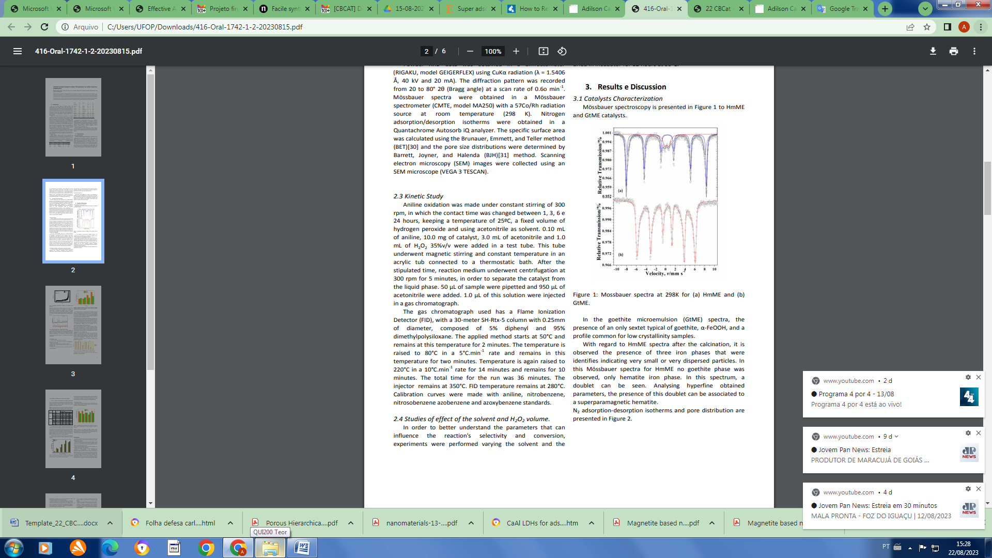 | 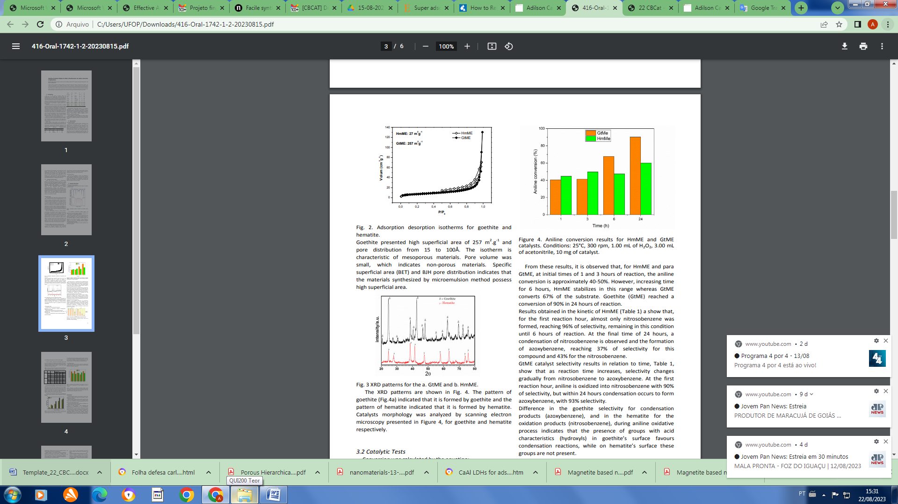
(a) | (b)
Figura 1. Mossbauer spectra at 298K for HmME and GtME (a), XRD patterns for the GtME and HmME (b)
In the goethite microemulsion (GtME) spectra, the presence of an only sextet typical of goethite, α-FeOOH, and a profile common for low crystallinity samples. With regard to HmME spectra after the calcination, it is observed the presence of three iron phases that were identifies indicating very small or very dispersed particles.

3.2 Catalytic Tests
Conversion was calculated by the equation: (Conversion (%)= ((Converted substrate moles))/(Initial substrate moles) x100). Selectivity was calculated by the following equation: Selectivity (%) = (mol of product/sum of total mols of products) x 100. In Figure 2 is presented the aniline conversion and s electivity for HmME and GtME.
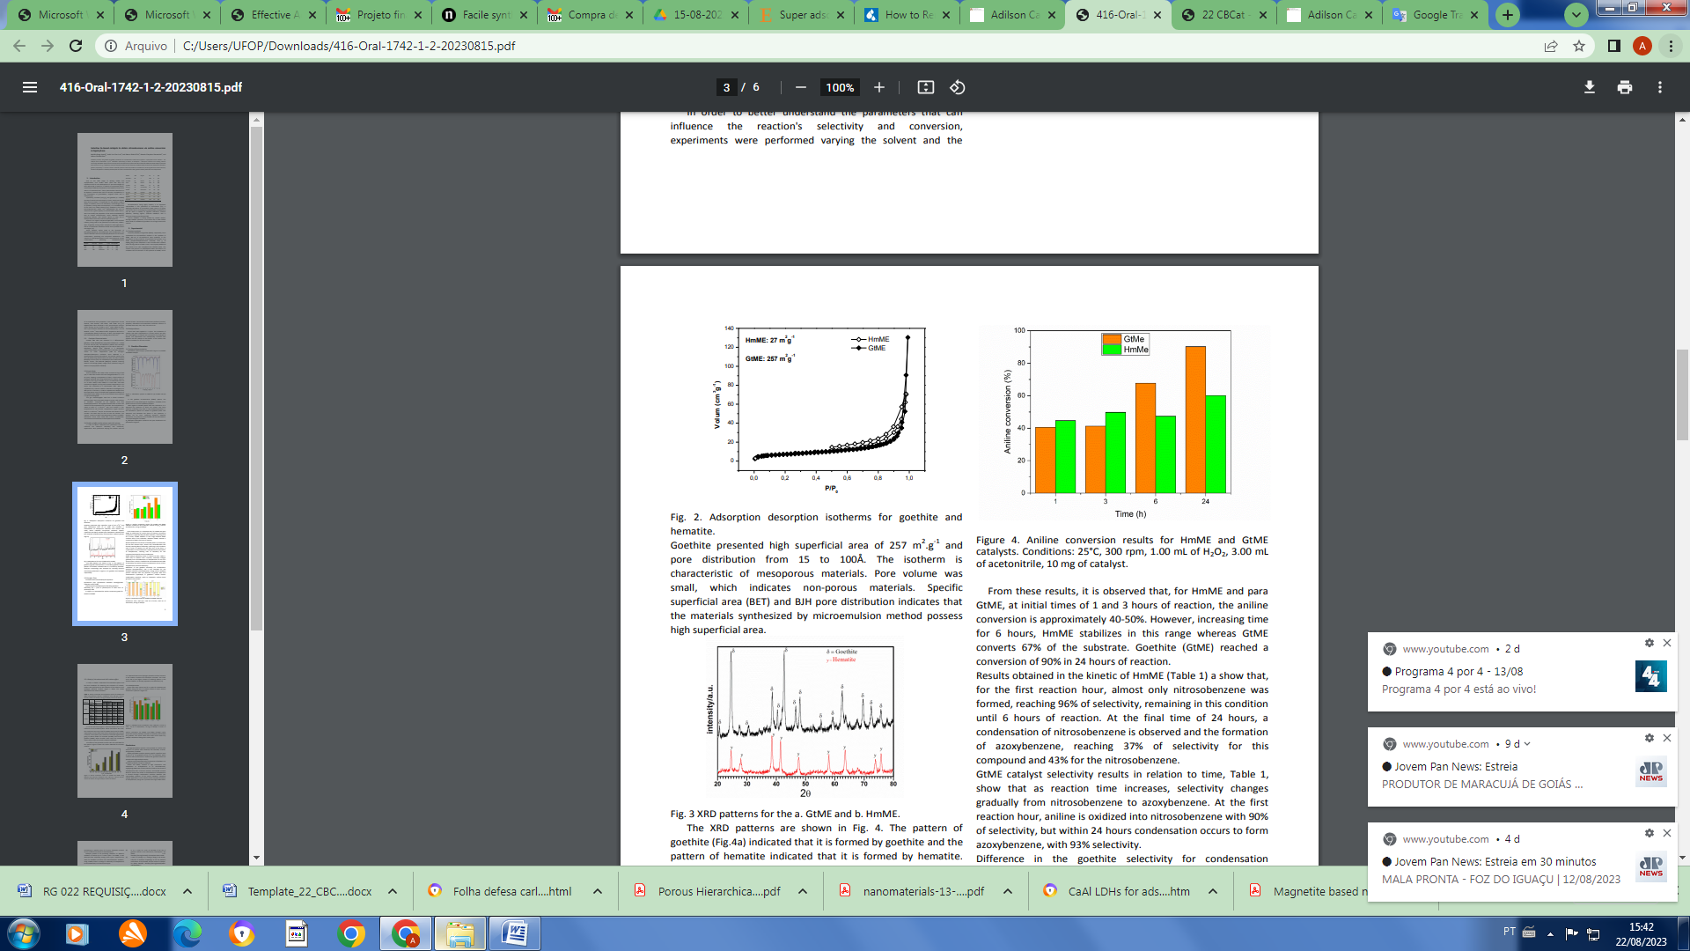 | (a)
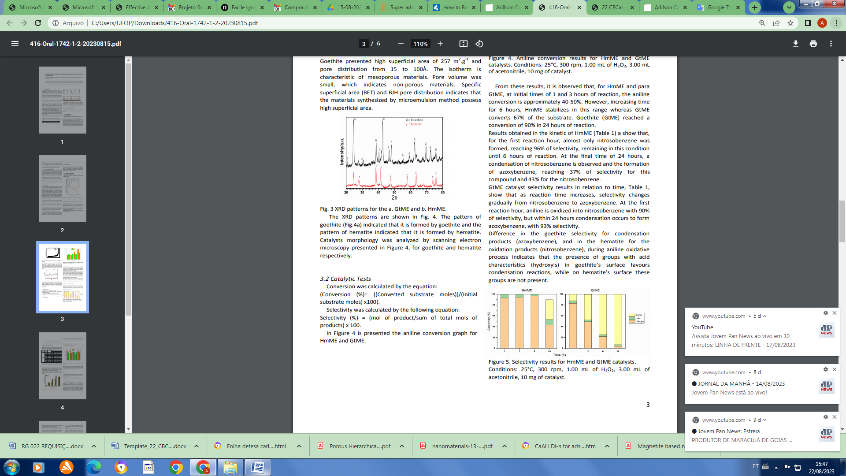 | (b)
Figura 2. Aniline conversion (a) and Selectivity results for catalysts. Cond.: 25°C, 300 rpm, 1.00 mL of H2O2 , 3.00 mL of acetonitrile, 10 mg of catalyst.
For HmME and GtME, at initial times of 1 and 3 hours of reaction, the aniline conversion is approximately 40-50%. However, increasing time for 6 hours, HmME stabilizes in this range whereas GtME converts 67% of the substrate. Goethite (GtME) reached a conversion of 90% in 24 hours of reaction. Results obtained in the kinetic of HmME (Fig. 2b) a show that, for the first reaction hour, almost only nitrosobenzene was formed, reaching 96% of selectivity, remaining in this condition until 6 hours of reaction. At the final time of 24 hours, a condensation of nitrosobenzene is observed and the formation of azoxybenzene (37%), and 43% for the nitrosobenzene.

Conclusões

HmME and GtME catalysts possess specific superficial area of 257 m2 .g -1 for goethite and 27 m2 .g -1 for hematite, which confirms that microemulsion method can generate small size particles with high catalytic activity. Catalytic tests presented aniline conversions of 40-90% in its oxidation products, using iron catalysts. Agradecimentos
We acknowledge and thank the founding agencies, CAPES, CNPq, FAPEMIG.

Referências
- A. Rufus; N. Sreeju; V. Vilas; D. Philip, J. Mol. Liq. 2017, 242, 537–549
- H. Liu; T. Chen; R.L. Frost, Chemosphere, 2014,103, 1-11.
- A.D. Lima; H. V Fajardo; A.E. Nogueira; M.C. Pereira; L.C.A. Oliveira; J.P. Mesquita, A.C. Silva, N. J. Chem. 2020, 44, 8710-8717.

