Innovative Approaches to OCM: Investigating Autothermic Potential and Space Velocity Impact on C2+ Product Formation

Vitor D. Lage1*, Antônio José de Almeida1, Tahyná Fontoura1,2, Normando Jesus2, José Carlos Pinto1, Henrique Pacheco1*

1Programa de Engenharia Química – PEQ/COPPE – Universidade Federal do Rio de Janeiro, Cidade Universitária, Rio de Janeiro CEP 21941-972, RJ, Brasil.

2*Braskem S.A., Rua Marumbi, 1400, Campos Elíseos, Duque de Caxias 25221-000, Brazil*

Resumo/Abstract

RESUMO - Este estudo explora o potencial do acoplamento oxidativo do metano (OCM) como uma solução viável para a valorização de CH4. Para isso, um catalisador convencional, Mn–Na2WO4/SiO2, foi preparado. O efeito da velocidade espacial no desempenho catalítico e o comportamento autotérmico foram avaliados. Os testes catalíticos revelaram uma relação complexa entre a velocidade espacial e o rendimento de produtos C2+. O comportamento autotérmico foi demonstrado, com um aumento de temperatura distinto entre 700-750 °C. O estudo destaca a importância da otimização das condições operacionais para um rendimento de produtos aprimorado e eficiência energética nos processos de OCM.

*Palavras-chave: OCM, metano, produtos C2+, comportamento autotérmico*

ABSTRACT - This study explores the potential of oxidative coupling of methane (OCM) as a viable solution to CH4 upgrading. For that, a conventional Mn–Na2WO4/SiO2 catalyst was prepared. The effect of space velocity on catalytic performance and autothermic behavior were evaluated. The catalytic tests revealed a complex relationship between space velocity and C2+ product yield. Autothermic behavior was demonstrated, with a distinct temperature surge at 700-750 °C. The study highlights the importance of optimizing operational conditions for enhanced product yield and energy efficiency in OCM processes.

*Keywords: OCM, methane, C2+ products, autothermic behavior*

## Introduction

The rise in the prospect of unconventional natural gas reservoirs highlights methane's potential as a fuel and chemical source. However, remote locations often render CH4 transportation economically unfeasible, leading to its underutilization and greenhouse gas emissions. Oxidative coupling of methane (OCM) offers a solution by directly converting CH4 into valuable C2 hydrocarbons, notably ethane and ethylene (1,2)

While promising, OCM displays challenges rooted in thermodynamics and kinetics that have hindered its widespread adoption (3). Moreover, catalyst development stands at the forefront of OCM research, with Mn–Na2WO4/SiO2 leading as the state-of-the-art catalyst due to its high C2 yields (∼10–25%) and stability (∼500 h) (1). Beyond catalysts, OCM's viability relies on reactor engineering and process intensification. This involves analyzing various reactor concepts, exploring different feed compositions, and enhancing reactor performance by investigating the effects of operational conditions on ethylene yields (2).

This study examines how operating conditions, particularly space velocity, impact C2+ product yield using Mn–Na2WO4/SiO2 catalyst. Additionally, it delves into the autothermic potential of an OCM catalyst system, investigating if reaction-generated heat could lower energetic requirements. To achieve this, a temperature-measuring system within the catalytic bed was developed.

## Experimental

*Catalyst Preparation*

A conventional 2 wt.% Mn-5 wt.% Na2WO4/SiO2 catalyst (Mn) was previously prepared via incipient-wetness impregnation in our group (4–6). Mn(NO3)2·4H2O and Na2WO4·2H2O were dissolved in deionized water (equal to silica pore volume) and added to the silica under stirring until incipient wetness. The sample was dried at 110  °C overnight and thermally treated at 800 °C (1 °C·min−1, 5 h) in static air.

*Catalyst Characterization*

XRD measurements were collected (5-90°, 0.02°·step-1, and 50 s·step-1) using a Miniflex Rigaku diffractometer (CuKα1, λ = 1.5418 Å, Ni-filter). The metallic content on samples was determined by XRF using a Rigaku Primini spectrometer (Pd source).

*Catalytic Testing and Autothermic Behavior*

Steady-state reactions were conducted in a quartz fixed-bed catalytic reactor (inner diameter = 10 mm) with 100 mg of catalyst (180-250 μm) mixed with 400 mg of SiO2. Prior to reaction, the catalyst was pretreated at 700 °C (100 mL·min−1 25% O2/N2). OCM catalytic activity was assessed at 700, 750, and 800 °C. The gaseous outlet was analyzed via an online gas chromatograph (Shimadzu GC-2014) with TCD and FID. The reactions were carried out with 50, 100, and 150 mL·min−1 flow rates of CH4:O2:N2 (molar ratio 2:1:1) with N2 serving as GC internal standard.

The autothermic-profile measurements were carried out in the same reactor as the catalytic tests. In this setup, the temperatures of the catalyst bed (1 cm of height) and of the outlet gas were monitored using K-type thermocouples placed in the center of the catalyst bed and 1 cm after it.

## Results e Discussion

*Catalyst Characterization*

XRD revealed peaks primarily corresponding to α‑cristobalite, Mn2O3, and Na2WO4 consistent with prior findings for Mn–Na2WO4/SiO2 catalysts (4–6). XRF analysis confirmed successful impregnation of the intended 2 wt.% Mn and 5 wt.% Na2WO4.

*Catalytic Testing and Autothermic Behavior*

**Figure 1** depicts the influence of space velocities on both catalytic performance and autothermic behavior, achieved by varying the feed flow rate: 50, 100, and 150 mL·min−1.

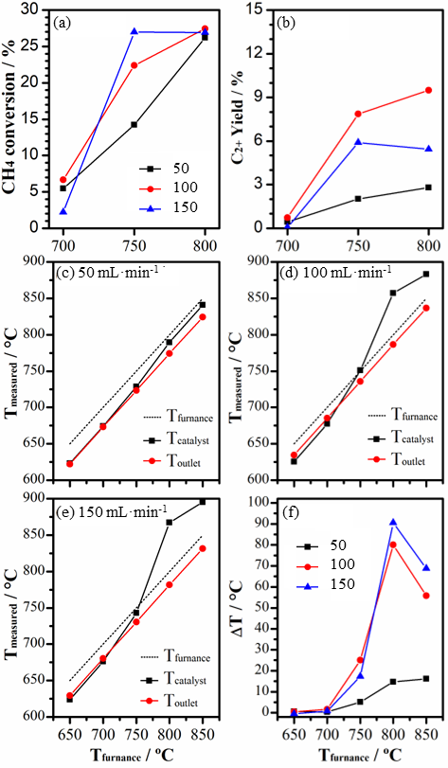

**Figure 1.** Effect of space velocity on catalytic performance (a, b), and autothermic behavior (c-f).

Catalytic performance was evaluated based on CH4 conversion and C2+ product yield (including ethane, ethene, propane, and propene). The autothermic behavior was assessed by analyzing the temperature of the catalyst bet (Tcatalyst), the temperature of the furnace (Tfurnace), and the temperature differential between the two (ΔT).

Increasing the space velocity exhibited a distinct trend akin to a volcano plot, revealing that an elevation from lower to mid-range values resulted in an increase in C2+ product yield. Nonetheless, upon further increasing space velocity, a loss in yield was observed (Figure 1b).

Regarding autothermic behavior, the increase in space velocity accentuated the autothermic leap (Figure 1c-e). Notably, this temperature surge manifested consistently within the range of 700 to 750 °C across all three flow rates. The most substantial temperature differential (ΔT) was recorded at 800 °C for all three flow rates. Beyond this point, a subsequent decline in ΔT ensued (Figure 1f).

Noteworthy, both peak catalytic performance and initiation of autothermic behavior happened around the 750 °C mark. Around this analogous temperature range (700-800 °C), orthorhombic Na2WO4 loses crystallinity, transitioning to its molten state—an alteration that conspicuously influences its activity (4).

## Conclusions

This work sought to investigate the influence of space velocity on C2+ product yield and autothermic behavior using an Mn–Na2WO4/SiO2 catalyst. These results serve as proof of concept that reaction-generated heat could lower energy requirements. It also highlighted the importance of optimizing reaction operational conditions, as space velocity did not display a linear impact on product yield, but rather a profile akin to a volcano plot. Furthermore, this represents the earlier stages of this research. The next steps towards OCM large-scale feasibility should encompass a comprehensive exploration of diverse reaction parameters, aiming to amplify the autothermic effect and optimize product yield.

## Acknowledgments

The authors would like to acknowledge CAPES (Coordenação de Aperfeiçoamento de Pessoal de Nível Superior – Brasil) – Finance Code 001 for the financial support, and LabTecH2 for the XRD and XRF analyses. This study was also partially funded by Braskem.

## References

1. C.A. Ortiz-Bravo; C.A. Chagas; F.S. Toniolo, *J Nat Gas Sci Eng* **2021**, 96, 104254.

2. S. Da Ros; T. Barbalho Fontoura; M. Schwaab; N. Castro de Jesus; J. Pinto, *Processes* **2021**, 9, 2196.

3. B.L. Farrell; V.O. Igenegbai; S. Linic, *ACS Catal* **2016**, 6, 4340–4346.

4. C.A. Ortiz-Bravo; S.J.A. Figueroa; R. Portela; C.A. Chagas; M.A. Bañares; F.S. Toniolo, *J Catal* **2022**, 408, 423–435.

5. S. Arndt; T. Otremba; U. Simon; M. Yildiz; H. Schubert; R. Schomäcker, *Appl Catal A Gen* **2012**, 425–426, 53–61.

6. D. Kiani; S. Sourav; J. Baltrusaitis; I.E. Wachs, *ACS Catal* **2019**, 9, 5912–5928.