Green Hydrogen Production Employing Nickel Poly(Heptazine Imide) Photocatalysts: a Low-Cost Catalyst for H₂ Evolution
Gabriel Ali Atta Diab^{1*}, Bruna Rocha Serino¹, Mariana Baptista Marques¹, Nadezda Tarakina², Marcos Augusto Ribeiro da Silva¹ and Ivo Freitas Teixeira¹
gabrieldiab@estudante.ufscar.br & ivo@ufscar.br
¹Department of Chemistry, Federal University of São Carlos, Rod. Washington Luís km 235 - SP-310, 13565-905, SP, Brazil
²Department of Colloid Chemistry, Max Planck Institute of Colloids and Interfaces, Am Mühlenberg 1, D-14476 Potsdam, Germany.
Abstract

ABSTRACT - With the global economy expanding and fossil fuels persisting, the pursuit of novel energy sources poses a challenge for future generations. Our reliance on fossil resources during past decades has given rise to notable consequences for the planet's ecological equilibrium, including pollution and irreversible climate changes. In response, an alternative arises in water photolysis, yielding green H₂. It exploits semiconductors capable of directly converting solar energy to break the water molecule and store it into the hydrogen bond. Highly crystalline carbon nitrides, composed of nitrogen and carbon and active in the visible-light, have demonstrated remarkable efficiency in this process. Nonetheless, due to suboptimal electron transfer performance, noble metal cocatalysts are imperative, introducing economic impediment. Herein, a novel methodology has been developed to enable a simple, direct, and controllable incorporation of Ni upon the poly(heptazine imide) (PHI) architecture as isolated atoms or clusters. The resultant material showcases exceptional photoinduced hydrogen generation without noble metals. Notably, a Ni concentration of 9% delivers a hydrogen generation rate of 2376 μmol h⁻¹ g⁻¹, compared to Pt-containing material's 4245 μmol h⁻¹ g⁻¹, holding promise for efficient, noble metal-free hydrogen production.
Keywords: Hydrogen Evolution, Water Splitting, Photocatalysis, Crystalline Carbon Nitride, Poly(Heptazine imide).

Introduction
As fossil fuel reserves continuous utilization and crescent global energy demands, the quest for sustainable energy solutions becomes imperative. Hydrogen, a clean and promising energy carrier, stands as a pivotal resource to meet these demands while outlining environmental impacts. Traditional methods of hydrogen production, like methane steam reforming and coal gasification carry environmental drawbacks due to high CO₂ emissions. (1) Photochemical water splitting, utilizing the abundant solar energy, offers an appellative alternative.
Carbon nitride, a robust semiconductor with visible light absorption properties, exhibits promising performance in this context, although its efficiency often relies on costly noble metals, commonly Pt acting facilitating the charge transfer and avoiding the recombination. (2) Due to its high added value of these metals, the feasibility of the process is hindered. Addressing this challenge involves innovative strategies, potentially involving abundant metals, alternative electron donors, or novel approaches that can reshape carbon nitride's role in energy generation.

Experimental
Poly(heptazine imide) synthesis
The crystalline carbon nitride photocatalyst based on PHI was synthesized by thermal polymerizing melamine in molten NaCl. The precursor and salt (1:10) were milled, then heated to 600 ºC under N₂ atmosphere (2.3°C/min) for 4 hours. The resulting yellow powder was washed with hot deionized water and subsequently dried at 60 ºC overnight.

Ni-metals stabilization
Ni metals were incorporated into the Na-PHI framework via direct cation exchange. Initially, 100 g of Na-PHI was suspended with a 2 mL aqueous solution of NiCl₂, tailored to the desired loading. An initial loading of 0.5% Ni-PHI was achieved using a 5x10⁻³ M metal chloride solution. This proportion served as the base for different concentration variations. The mixture was sonicated for 30 mi, then washed with deionized water and dried overnight at 60 ºC.

Photocatalytic hydrogen evolution
Photocatalytic tests were carried out in a sealed reactor using degassed water and oxygen-free atmosphere to ensure accurate results. A 30 mL solution, containing 50 mg of solid catalyst and 10% triethanolamine, was irradiated for 10 min with a 410 nm, 50 W LED. For comparison to Ni-containing materials, 3 wt. % Pt co-catalyst was in-situ photodeposited onto Na-PHI framework from H₂PtCl₆ precursor. H₂ evolution was determined via GC-BID analysis.

Results and Discussion
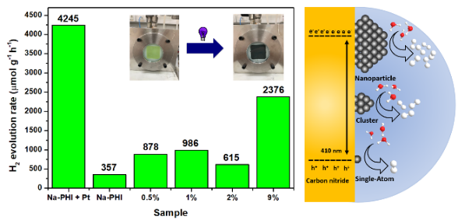
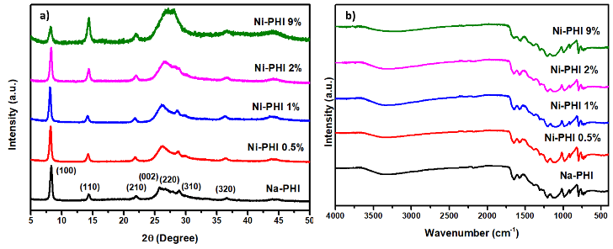
The well-ordered crystalline structure of PHI was verified via X-ray diffraction (Fig. 1a). The diffraction pattern indicates a characteristic layered sheet structure with high heptazine unit organization. (3-4) A discrete signal at 14.4º, marked as (002), corresponds to an intralayer heptazine arrangement spanning 8.2 Å. Signals between 27-30º are attributed to different interlayer spacing reflections, with a primary d-spacing peak at approximately 3.4 Å. Additionally, an intense and narrow signal at 8.3º, related to 10.7 Å spacings, is linked to the (100) plane reflection arising from the structured incorporation of Na ions within the heptazine units. (4)
Figure 1. a) XRD pattern; b) FT-IR spectrum of the photocatalyst.
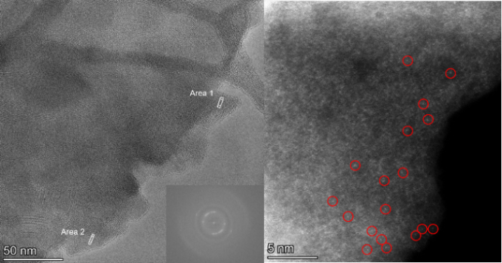
FT-IR analysis illustrates the distinctive framework of PHI, featuring interconnected heteroaromatic units (Fig. 1b). (4) The signal at 800 cm⁻¹ is associated with the heptazine ring's breathing mode. Bands around 1100–1620 cm⁻¹ correspond to stretching and bending vibrations of C-N and C=N bonds within conjugated heterocycles. A peak at 2170 cm⁻¹ indicates asymmetrical stretching of a cyano group, suggesting the potential presence of cyanamide defects. Moreover, a wide band centered around 3100 cm⁻¹ originates from amine groups and adsorbed water.
Figure 2. HR-TEM image of Na-PHI with the respective FFT displayed on the inset and HAADF-STEM of Ni-PHI 0.5% representing the Ni isolated atoms.
TEM microanalysis and HAADF-STEM images, illustrated in Fig. 2, reveal a layered sheet structure displaying two distinct sets of oriented fringes. In agreement with XRD data, the interplanar space within the organized heptazine units (Area 1) measures 10.5 Å, while the spacing between layers (Area 2) is determined at 3.3 Å. HAADF analyses validate the obtention of discrete Ni single-atoms within the photocatalyst for the sample containing 0.5% of the metal.
Figure 3. Comparing photocatalytic H₂ production rates of cocatalysts: Pt vs. Ni at varying loadings. Highlighting enhanced H₂ evolution efficiency with Ni nanoparticles.
The photocatalytic results highlight the effectiveness of Ni metals as catalysts for H₂ production. Notably, while pristine Na-PHI shows modest performance, introducing Ni metals leads to a noticeable increase in the reaction rate. This enhancement reaches a significant threshold of 2376 μmol h⁻¹g⁻¹ in the material with the highest Ni concentration. This emphasizes that metallic clusters outperform isolated sites. Furthermore, the Pt-containing material demonstrates superiority, yet this advantage is balanced by the cost-effective nature of nickel atoms, enhancing the overall cost-effectiveness of the catalytic system.

Conclusions
In conclusion, our study provides compelling evidence for harnessing the potential of PHI-based carbon nitride adorned with nickel sites as a proficient means to obtain green H₂ photocatalysis. By emphasizing the prowess of nickel nanoparticles, we question the prevailing reliance on platinum-based approaches. Indications point to the heightened catalytic activity of Ni nanoparticles in water splitting, surpassing systems with isolated atoms. These pioneering discoveries mark a noteworthy stride in elevating the efficiency and cost-effectiveness of hydrogen production through photocatalysis.

Acknowledgments
The authors are grateful to CNPq (405752/2022-9 and 403064/2021-0), FAPESP (2020/14741-6, 2021/14006-7) and the Max Planck Society.

References
- R. Kothari; R. Sawhney Renew. Sust. Energ. Rev. 2008, 12 (2), 553-563.
- I. Teixeira; M. Antonietti. J. Mater. Chem. 2022, 10 (35), 18156-18161.
- M. da Silva; I. Teixeira. J. Chem. Eng. 2023, 15, 141068.
- Z. Chenç D. Dontsova Adv. Mater. 2017, 29 (32), 1700555.

