Mo/zeolite catalysts for the hydrodeoxygenation of biomass-derived compounds

Gabriel B. Báfero¹, Mateus M.M.R. Duenha¹, Daniela Zanchet^{1,}*
¹ Institute of Chemistry, University of Campinas, UNICAMP, Campinas, SP, 13083-970, Brazil
* Corresponding Author: zanchet@unicamp.br
Resumo/Abstract

RESUMO - A crescente demanda por produtos químicos e combustíveis renováveis tem estimulado a busca por matérias-primas alternativas. Nesse caminho, a biomassa tem despertado interesse da academia e da indústria, sendo a sua valorização a compostos de maior valor agregado ainda um grande desafio. A utilização de catalisadores bifuncionais, como os sistemas metal/zeólita, parece o melhor caminho para a conversão de derivados da biomassa via hidrodesoxigenação (HDO). Tais catalisadores são capazes de mediar muitas das rotas reacionais envolvidas na reação de HDO. Alguns conceitos-chave sobre esses sistemas devem ser levados em consideração, como o balanço e a proximidade entre os sítios ácidos zeolíticos e os sítios metálicos. Alguns óxidos metálicos reduzíveis, como MoO₃, em condições reacionais, podem apresentar sítios hidrogenantes, sendo boas alternativas aos metais convencionalmente empregados. Nesse caminho, o presente trabalho visa avaliar esses conceitos-chave utilizando catalisadores Mo/zeólita frente a reação de HDO de acetona, uma molécula modelo representativa de derivados da biomassa muito útil na sondagem de diferentes funcionalidades catalíticas.

Palavras-chave: catálise, hidrodesoxigenação, zeólita, molibdênio, catalisadores bifuncionais

ABSTRACT - The growing demand for renewable chemicals and fuels has stimulated the search for alternative raw materials. In this way, biomass has gained space in research and industry, however the biomass valorization to compounds with higher added value is still a great challenge. The use of bifunctional catalysts, such as metal/zeolite systems, seems to be the best way to convert biomass derivatives via hydrodeoxygenation (HDO). Such bifunctional systems can mediate many of the reaction pathways involved in the HDO reaction. Some key concepts about these catalysts must be considered, such as the balance and the proximity between the zeolitic acid sites and the metallic sites. Some reducible metal oxides, such as MoO₃, under reaction conditions, can present hydrogenating sites, being good alternatives to the metals conventionally used in these systems. In this way, the present work aims to evaluate these key concepts using MoO₃/zeolite catalysts in the acetone HDO reaction. Acetone is a representative model molecule of biomass derivatives, very useful in probing different catalytic functionalities.

Keywords: catalysis, hydrodeoxygenation, zeolite, molybdenum, bifunctional catalysts

Introduction
In fossil fuel refineries, the basic chemical building blocks that currently serve as platform molecules are normally apolar/low reactivity hydrocarbons, and upgrading these compounds requires the activation of the C–C and C–H bonds. On the other hand, biomass-derived compounds are usually polar, highly reactive, and extensively functionalized oxygenates. Further upgrading involves activation and cleavage of C–O bonds leading to deoxygenated products.
The hydrodeoxygenation reaction (HDO) is one of the main biomass-derived upgrading processes, in which a H₂-rich atmosphere combined with a solid catalyst is used to reduce the high oxygen content by the selective cleavage of C-O bonds, besides saturating aromatics and alkenes (1). The set of reactions usually found in the HDO of biomass-derived compounds may include hydrogenations, hydrogenolyses, direct deoxygenations, dehydrations, isomerizations, decarbonylations, decarboxylations, and carbonyl condensations (2). In this sense, using catalysts that combine different functionalities in a single material seems economically and energetically advantageous.
For reactions requiring acidity and hydrogenation activity, such as HDO, zeolites can be particularly useful for constructing bifunctional materials, once presenting chemical and hydrothermal stability, high surface area, porosity, and intrinsic acidity. Metallic sites can be included through a variety of simple and effective procedures: impregnation, ion exchange, deposition-precipitation, or encapsulation (during synthesis) (3). The optimization of the site-ratio of different catalytic functions is vital to achieve specific products distributions. Synergistic effects are expected if acid sites and hydrogenation functions are put close to each other (4,5). This type of site engineering in metal/zeolite systems is currently being extensively explored.
Therefore, the main objective of this work is to evaluate the bifunctional properties of MoO₃/zeolite catalysts through the HDO reaction of different model molecules, starting with acetone. Acetone is the simpler ketone representative, but still, the acetone HDO reaction network is extensive, leading to different products, according to the nature of the catalytic sites (6). Besides being considered a reducible metal oxide with moderate oxophilicity (7), which facilitates oxygen vacancies generation, MoO₃ can present other functionalities under HDO stream. Previous results showed the formation of oxycarbide phases (MoO_{x}C_{y}), capable of stabilizing Mo⁵⁺ species, which were assigned to efficient hydrogenation activity (8). This way, impregnated zeolite samples with different Mo/acid site ratios will be prepared, seeking to modulate their catalytic contributions.

Experimental
Materials and Methods
The catalysts were prepared following a conventional wet impregnation procedure. Ammonium heptamolybdate tetrahydrate ((NH₄)₆Mo₇O₂₄.4H₂O, Merck) was used as the Mo source, while commercial ZSM-5 zeolite (Si/Al = 140, Zeolyst) and fumed silica (Aerosil 380, Evonik) were employed as the supports. 10 % w/w catalysts were initially prepared and called MoO₃@ZSM-5 and MoO₃@SiO₂. The silica impregnated catalyst as well as a commercial MoO₃ sample (nanopowder, Sigma-Aldrich) were used for comparison purposes.
The crystalline structure of the catalysts and the MoO₃ phase dispersion were initially evaluated by powder X-ray diffraction (XRD), collected in a Bruker D8 Advance Eco diffractometer.

Catalytic Evaluation
Gas-phase acetone HDO reaction was conducted in a plug-flow tubular reactor equipped with a quartz tube (inner diameter of 8.1 mm), with a catalytic bed composed of 50 mg of supported catalysts (or 5 mg of MoO₃) and 150 mg of diluent (Al₂O₃; <100 mesh). Acetone (HPLC Plus Grade, ≥ 99.9%) was introduced into the reactor by using a saturation flask (2.4 mL min⁻¹ of acetone) and He as the carrier gas. H₂ was also fed to the reactor (51 mL min⁻¹; 21 mol H₂:mol acetone), using He for balance achieving a total feed flow of 100 mL min⁻¹. The reactions were conducted isothermally at 400 °C for 3 h. Finally, the reaction products were analyzed by an online gas chromatograph (GC; Agilent Technologies, model 7890A) equipped with an HP-1 column (50 m x 0.32 mm i.d., 0.17 μm). The catalytic activity was evaluated through acetone conversion and products distribution. The main products detected in acetone HDO were propane (C₃A), propene (C₃E), isobutene/isobutane (C₄) and 4-methylpent-3-an-2-one/4-methylpentan-2-one (C₆O).

Results and Discussion
Figure 1 presents the XRD patterns of the commercial MoO₃ sample, as well as the 10% w/w impregnated catalysts. The MoO₃ initial phase matched the orthorhombic crystal structure (ICSD CollCode 166363), essentially composed of Mo⁶⁺ species, forming double lamellae of MoO₆ octahedrons. The MoO₃@SiO₂ catalyst presented a flat diffractogram with a discreet halo between 20 and 30 °2θ, compatible with the silica amorphous nature. In turn, the MoO₃@ZSM-5 catalyst showed a XRD pattern that agrees with ZSM-5 literature standards (9). It is important to highlight that no distinguishable peaks referring to MoO₃ were observed for the impregnated catalysts. This is a first indication that the MoO₃ phase must be well dispersed, without extensive formation of large crystalline aggregates, which would show long-range organization.
Figure 1. XRD patterns of the MoO₃ sample and the 10% w/w impregnated catalysts, MoO₃@SiO₂ and MoO₃@ZSM-5.

When subjected to acetone HDO reaction for 3 h at 400 °C, the catalysts showed similar conversions (around 15-20%), but different product distributions, as shown in Figure 2 and Table 1. The MoO₃ sample presented higher selectivity to C₆O, mediated by acid sites. To a lesser extent, it also converted acetone to C₃E and C₃A, products of deoxygenation and subsequent hydrogenation, respectively. Acetone deoxygenation to C₃E can follow a direct pathway through oxygen vacancies or a two-step pathway, in which it is first hydrogenated to isopropanol that is then dehydrated to C₃E. The distinction between these two mechanisms is difficult to follow experimentally, since MoO₃ presents active sites for both situations under HDO atmosphere (9). The prevalence of C₆O may be related to the small mass of catalyst used for this test, since it was intended to match the amount of MoO₃ in the catalyst bed to the impregnated samples (10% m/m). In this way, the diluent excess would be also contributing to the conversion and products distribution. In preliminary tests using only Al₂O₃ (not shown), it was seen that, under the same reaction conditions, this amount of diluent presents about 18% conversion to C₆O alone.
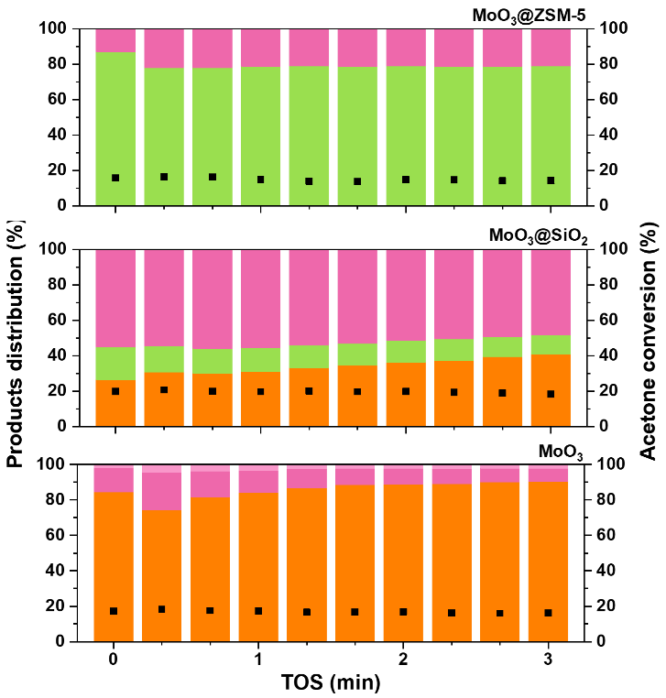
Figure 2. Acetone conversion (black squares) and products distribution (colored bars) of acetone HDO reaction at 400 °C for the MoO₃ and the 10% w/w impregnated catalysts, MoO₃@SiO₂ and MoO₃@ZSM-5. TOS = 3 h.

Table 1. Catalytic data of acetone HDO reaction at 400 °C for the MoO₃ and the 10% w/w impregnated catalysts, MoO₃@SiO₂ and MoO₃@ZSM-5.
 | Products distribution (%)ª
Catalyst | C₃A | C₃E | C₄ | C₆O | DOD (%)^{b}
MoO₃ | 2 | 7 | - | 91 | 9
MoO₃@SiO₂ | - | 48 | 11 | 41 | 59
MoO₃@ZSM-5 | - | 21 | 79 | - | 100
ª after 3h on stream, ^{b} deoxygenation degree
The MoO₃@SiO₂ catalyst showed better results than MoO₃ in terms of products distribution, since it showed a higher deoxygenation degree, 59 against 9%. Chemically, the silica matrix does not present any properties to which these differences could be attributed, however its specific surface area is significantly larger than MoO₃, ~380 versus ~7 m² g⁻¹. The dispersion of the MoO₃ phase certainly enhanced the amount of available active sites, reflected in the larger selectivity to deoxygenated products, especially C₃E.
Finally, the MoO₃@ZSM-5 catalyst showed the ability to deoxygenate all the converted acetone (DOD = 100%), with the predominance of C₄, a different result from that presented by the other MoO₃ catalysts studied, supported or bulk. These C₄ products, isobutene/isobutane, are obtained by the direct action of acidic sites through the condensation of acetone to C₆O, followed by the β-scission of C₆O to isobutene in the presence of water (10). Isobutene can be further hydrogenated to isobutane. Zeolites are recognized by the abundance of acid sites, especially strong Brønsted acid sites, which are distributed along an extensive microporous framework of channels and cavities, presenting high specific surface area (~400 m² g⁻¹ for ZSM-5). In the MoO₃@ZSM-5 system, while the MoO₃ phase probably yielded C₃E, the condensation of acetone to C₆O via acid sites, whether from MoO₃, Al₂O₃ or the zeolite itself, was suppressed by the conversion of C₆O to C₄. As the preference for this reaction pathway was not visualized for the other catalysts, it is plausibly associated with the zeolite matrix and its acid sites.

Conclusions
The ZSM-5 Si/Al ratio equal to 140 and the 10% m/m loading of MoO₃ converge to a Mo/acid site ratio around 7. Little can be said about the proximity and synergy between these functionalities so far, however, the preliminary results obtained showed that the zeolite acid sites were able to deoxygenate acetone condensation products to C₄, while MoO₃ led to the deoxygenation of acetone itself to C₃E. Combined, they presented the best performance among the studied catalysts. Future investigations varying Mo/acid sites ratio and conducting extensive surface characterization look promising.

Acknowledgements
This work was financed by the Conselho Nacional de Desenvolvimento Científico e Tecnológico (CNPq, 830512/1999-3, 140849/2020-3) and the Fundação de Amparo à Pesquisa do Estado de São Paulo (FAPESP, 2018/01258-5).

References
- L. Qu; X. Jiang; Z. Zhang; X.-G. Zhang; G.-Y. Song; H.-L. Wang; Y.-P. Yuan; Y.-L. Chang; Green Chem., 2021, 23, 9348-9376.
- Y. Nakagawa; S. Liu; M. Tamura; K. Tomishige, ChemSusChem., 2015, 8, 1114-1132.
- W. Luo; W. Cao; P.C.A. Bruijnincx; L. Lin; A. Wang; T. Zhang, Green Chem., 2019, 21, 3744-3768.
- N. Batalha, L; Pinard; C. Bouchy; E. Guillon; M. Guisnet, J. Catal., 2013, 307, 122-131.
- W. Song; Y. Liu; E. Barath; C. Zhao; J.A. Lercher, Green Chem., 2015, 17, 1204-1218.
- D. Leite; G.B. Strapasson; D. Zanchet, Mol. Catal., 2022, 530, 112623.
- K.A. Goulas; A.V. Mironenko; G.R. Jenness; T. Mazal; D.G. Vlachos, Nat. Catal., 2019, 2, 269-276.
- G.B. Báfero; G.B. Strapasson; D.S. Leite; D. Zanchet, 2023, submitted.
- International Zeolite Association (IZA), http://www.iza-online.org/, accessed on March 2023.
- J. Sun; R.A.L. Baylon; C. Liu; D. Mei; K.J. Martin; P. Venkitasubramanian; Y. Wang, J. Am. Chem. Soc., 2016, 138(2), 507-517.

