Nickel Single-Atoms Supported on Poly(Heptazine Imides): A Selective Transfer Hydrogenation Photocatalyst Using Water as Proton Source
Luis F.G. Noleto^{1*}; Hamilton A.S. Junior¹; Ivo F. Teixeira¹.
¹Department of Chemistry, Federal University of São Carlos, São Carlos, SP. *fernandoguimaraes621@gmail.com
Abstract

RESUMO - As reações de hidrogenação de alcinos têm grande importância no setor químico industrial e, nesse contexto, há um forte interesse na redução de custos para esses processos. O aproveitamento da luz como fonte de energia e a utilização da água como fonte de prótons surgem como alternativas viáveis, oferecendo redução de custos e menor impacto ambiental. Aqui, poli(heptazina imidas) estabilizadas com Single-Atoms de Ni (Ni-PHI) foram empregadas como catalisadores em reações fotocatalíticas para converter fenilacetileno em estireno. Os resultados dos testes demonstraram que o Ni-PHI-2% alcançou taxas de conversão e seletividade para o estireno de 98,4% e 98,5%, respectivamente. Por fim, foi verificado que os prótons foram doados pela água.
Palavras-chave: Single-Atoms, Poli(imidas de heptazina), Semihidrogenação seletiva, Fenilacetileno, Estireno
ABSTRACT - Hydrogenation reactions of alkynes hold significant importance within the industrial chemical sector, and in connection to this, there is a strong interest in cost reduction for these processes. The harnessing of light as an energy source and the utilization of water as a proton source emerge as viable alternatives, offering cost reduction and an environmentally less aggressive. Here, poly(heptazine imides) stabilized with Ni Single-Atoms (Ni-PHI) were employed as catalysts in photocatalytic reactions to convert phenylacetylene into styrene. The test results demonstrated that Ni-PHI-2% achieved conversion rates and selectivity for styrene of 98.4% and 98.5%, respectively. Lastly, it was verified that the protons were donated by water.
Keywords: Single-Atoms, Poly(heptazine imides), Selective semihydrogenation, Phenylacetylene, Styrene

Introduction
The semi-hydrogenation of phenylacetylene serves as a convenient method to assess the efficacy of hydrogenation catalysts under mild conditions. Typically, to optimize alkene production, it is crucial to maximize the conversion from alkyne to alkene while avoiding complete transformation into alkane [1]. So far, Pd-based catalysts with additives have been widely employed for this reaction, but their low selectivity at high conversion rates poses challenges for subsequent applications [2]. The use of crystalline carbon nitride catalysts, such as poly(heptazine imides) stabilized with low-cost transition metal single atoms like Ni, may offer a promising alternative to enhance these reactions. Furthermore, utilizing water as the primary hydrogen source can lower final costs and minimize greenhouse gas emissions.

Experimental
Synthesis of Na-PHI / Ni-PHI Catalysts and Photocatalytic Tests
The host material (Na-PHI) was synthesized by thermal condensation method, using melamine and NaCl as precursors in a 1:10 ratio [3]. The coordination of Ni²⁺ atoms in the PHI structure was performed by simple cation exchange method [3]. All obtained materials were characterized by X-ray diffraction (XRD), Fourier Transform Infrared (FTIR) and UV-Vis spectroscopy. In addition, the photocatalytic semihydrogenation tests of phenylacetylene to styrene were performed using 20 mg of catalysts, 10 μL of phenylacetylene, 1 mL of water, 1.5 mL of 1,4-dioxane, 750 μL of TEOA, and argon atmosphere (system under agitation and irradiation). The products obtained from the reaction were analysed by GC-FID.

Results and Discussion
XRD patterns for all samples are presented in Fig. 1a. Initially, it is observed that Na-PHI shows a good degree of short-range ordering and consequently, high crystallinity. The diffraction signals centred at 2θ near 8.2º and 14.2º are related to the planes (100) and (110) of the trigonal network, respectively, characteristic of the orientation of the heptazine units in the poly(heptazine imide) [4]. The diffraction signal corresponding to the stacking of the carbon nitride sheets in the (002) plane was located in the 2θ range of 25-30º [5].
Fig. 1b displays the FTIR spectra for both Na-PHI and Ni-PHI samples. The observed broad bands in the range of 3658-2780 cm⁻¹ are attributed to vibrations of the amine groups and water molecules present in the catalysts across all samples [6]. The sharp band at 2182 cm⁻¹ can be assigned to vibrational modes of C≡N bonds in terminal cyanamide groups [7]. The bands observed in the range 1728-1161 cm⁻¹ are attributed to the multiple modes of bond stretching vibration (C–N) [8]. Meanwhile, the bands centred at 1136 and 983 cm⁻¹ are associated with the asymmetric and symmetric stretching of the bonds between the support and the single-atoms metals (M-NC₂) in the metal-heptazine units [4]. Finally, the band at 798 cm⁻¹ is characteristic of the breathing mode of the heptazine ring [6].
The optical properties of the materials were investigated using UV-vis absorption spectra (Fig. 1c). The spectra reveal that Na-PHI exhibits light absorption in the visible region (~470 nm), corresponding to the π → π* electron transition in the conjugated aromatic ring system and indicates that the photocatalyst can be excited by white and blue light [9]. In response to stabilization with Ni single-atoms, a slight red shift was observed, with an absorption edge at 480 nm. The values of the bandgap energy were estimated and assume values of 2.79, 2.80, 2.78, 2.78, and 2.78 eV for Na-PHI, Ni-PHI-0.5%, Ni-PHI-1%, Ni-PHI-2%, and Ni-PHI-4%, respectively (Fig. 1d).
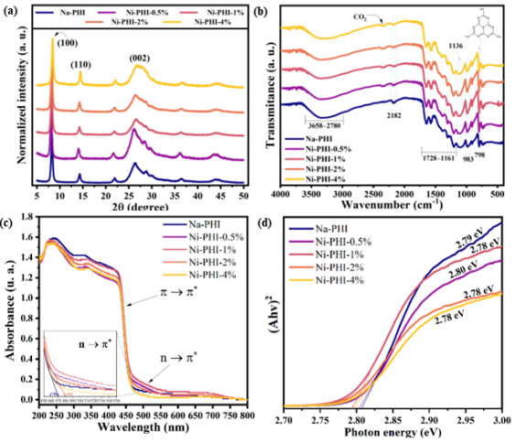
Figure 1. (a) XRD patterns, (b) FTIR spectra, (c) UV-Vis absorption spectra, and (d) bandgap energy for Na-PHI and Ni-PHI samples.
In order to investigate performance of the synthesized catalysts, phenylacetylene semihydrogenation was selected as a probe reaction. Fig. 2a illustrated the conversions rates of phenylacetylene toward styrene over Na-PHI and Ni-PHI samples, in 24 h of reaction.
The catalysts of Ni-PHI (0.5, 1, 2, and 4%) achieved conversion rates of 85.2, 98.6, 98.4, and 92.4% and selectivity rates of 98.7, 98.8, 98.5, and 97.6%, respectively. In contrast, Na-PHI reached only 0.2% conversion and 21.9% selectivity, under the same reaction conditions. The effect of reaction time was evaluated under the same previous conditions (20 mg of Ni-PHI-2% and 65 ºC). The test results demonstrate that conversion rates increase from 0 to ~99% with the addition of time from 0 to 24 h, as shown in Fig. 2b. However, it is already possible to obtain very promising results within 12 h of reaction (95.8% conversion), as the rates exhibit fluctuations below 5% with reaction times exceeding 12 h.
Finally, isotope labeling experiments were conducted, in which H₂O was substituted with D₂O (deuterium oxide), to demonstrate that protons originate from water (Fig. 2c). It was observed that when H₂O was used, the m/z values of 78 and 104 were assigned to the fragmentation ion [C₆H₅]⁺ and the molecular ion of styrene, respectively. However, upon replacing H₂O with D₂O, it was found that the signals shifted to 79 and 106, indicating that water was the source of hydrogen rather than any other hydrogen-containing agent (1,4-dioxane, TEOA, edge hydrogen from CN, etc.). Furthermore, it was demonstrated that only two deuterium atoms (m/z = 106) were added to the molecule, instead of three deuterium atoms (m/z = 107).
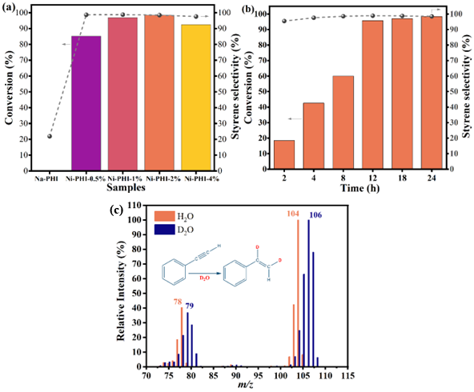
Figure 2. (a) The conversion of phenylacetylene to styrene under Na-PHI and Ni-PHI samples for 24 h. (b) Kinetic curves for the selective semihydrogenation of phenylacetylene using Ni-PHI-2%. (c) Mass spectra of the liquid product from the photocatalytic semihydrogenation of phenylacetylene with D₂O.

Conclusions
Ni-PHI catalysts were prepared and applied in photocatalytic reactions for the semihydrogenation of phenylacetylene. The results indicated that Ni-PHI-2% exhibited the highest conversion rates and selectivity for styrene, at 98.4% and 98.5%, respectively. Furthermore, it was confirmed that the protons used in the reaction are donated by water molecules.

Acknowledgements
CNPq, FAPESP, PPGQ-UFSCar, and LabIvo research group.

References
1. Journal of Catalysis, 2006. 243(1): p. 74-81; 2. Catalysis Today, 2012. 186(1): p. 69-75; 3. Chem. Eng. J., 2023. 460: p. 141068; 4. ACS Appl. Mate. Interfaces 2022. 14(44): p. 49820–49829; 5. Ind. Eng. Chem. Res., 2021. 60(19): p. 7003-7013; 6. Electrochimica Acta, 2021. 390: p. 138831;7. Advanced Materials, 2017. 29(32): p. 1700555; 8. Eng. Env. Sc., 2018. 11(3): p. 566-571; 9. ChemCatChem, 2017. 9(1): p. 167-174;

