*In Situ* Three-Dimensional Imaging of Zeolites During Ethanol Dehydration Reaction by Bragg Coherent Diffractive Imaging

Mariana V. Rodrigues,1 Paloma Vinaches,1 Marlon M. Silva,1,2 Carla Polo,1 Ana F. Suzana,3 Sibele C. Pergher,4 Amélie Rochet,1,2 Florian Meneau1,2*

1Brazilian Synchrotron Light Laboratory (LNLS), Brazilian Center for Research in Energy and Materials (CNPEM), 13083-970 Campinas, SP, Brazil. 2Institute of Chemistry - University of Campinas (Unicamp), CEP, Campinas, SP, Brazil. 3Chemical Sciences and Engineering Division, Argonne National Laboratory, Lemont, IL 60439 4Institute of Chemistry, Federal University of Rio Grande do Norte (UFRN), Laboratório de Peneiras Moleculares (LABPEMOL), 9078-970, Natal, RN, Brazil.

*florian.meneau@lnls.br

Resumo/Abstract

RESUMO - A compreensão dos processos de difusão e adsorção nas zeólitas é muito importante, uma vez que estes materiais são essenciais para muitas reações catalíticas utilizadas na indústria. As zeólitas são aluminossilicatos cristalinos microporosos, compostos por cavidades e microporos. Uma vez que os poros são extremamente pequenos, uma ligeira deformação gerada no cristal induz alterações significativas na forma, conectividade, tamanho dos poros e propriedades químicas da estrutura. Por sua vez, isso afeta grandemente a difusão de moléculas nos poros e, eventualmente, as propriedades catalíticas. A visualização *in situ* resolvida no tempo das regiões ativas durante as reações catalíticas pode fornecer informações cruciais para compreender os fatores mais importantes envolvidos nestes processos, a fim de melhorar a síntese de zeólitas e os métodos pós-sintéticos para aplicações catalíticas. As caracterizações *in situ* convencionais não conseguem obter esta informação porque podem medir apenas uma propriedade média do cristal. A imagem de difração coerente de Bragg (BraggCDI) permite-nos obter a forma de um objeto, os deslocamentos e as deformações no cristal, chamando a atenção para as regiões ativas durante a reação. O nosso objetivo é investigar a desidratação do etanol em zeólitas nanoFAU por BraggCDI.

*Palavras-chave: nanozeólitas, imagem por difração de raios-X coerente, desidratação do etanol, BraggCDI*

ABSTRACT - Understanding the diffusion and adsorption processes in zeolites are very important, since these materials are essential to many catalytic reactions used in industries. Zeolites are crystalline aluminosilicates, composed of cavities and micropores. Since the pores are extremely small, a slight strain generated in the crystal induces significant changes in shape, connectivity, size of the pores and the framework chemical properties. In turn, it greatly affects the diffusion of molecules into the pores and eventually the catalytic properties. Time-resolved *in situ* visualization of the active regions during the catalytic reactions could give crucial information to understand the factors involved in these processes in order to improve zeolite synthesis and post-synthetic methods. Conventional *in situ* characterizations cannot reach this information because they could measure just an average property of the crystal. Bragg Coherent diffraction imaging (BraggCDI) allows us to obtain *in situ* three-dimensional image of an object and the lattice displacements and strains information in the crystal during the reaction. We investigated the ethanol dehydration reaction in nanoFAU (Faujasite) zeolites by BraggCDI.

*Keywords: nanozeolites, coherent X-ray diffraction imaging, ethanol dehydration, BraggCDI*

## Introduction

Zeolites are crystalline materials, whose structure is formed by connected Si and Al tetrahedral, building cavities in form of channels and/or cages. These characteristics provide high specific areas, molecular sieves features and high acidity responsible by their great potential applications in catalytic processes and selectivity. (1) The micropores present in the zeolites are extremely small, the diffusion rates of molecules within the pores are affected by the number of cations, defects, and residues within the pores. These irregular spaces are where molecules adsorb easily and this causes an inhomogeneous distribution on the zeolite surface, affecting the catalytic performance and the intra-crystalline diffusion rates. (2)

In order to maximize the use of zeolites as catalysts and to design and synthesize materials with improved performances, time-resolved *in situ* 3D imaging of the zeolite crystals during the chemical process is crucial. (3)

In this study, we employed operando BraggCDI (Bragg Coherent Diffractive Imaging) at the Advanced Photon Source (USA) to image in 3D a single zeolite crystal during the ethanol dehydration reaction. We could obtain 3D images as function of the reaction steps, and 3D lattice displacements maps of the zeolite nanocrystal. In coherent X-ray diffraction imaging (CDI), phase retrieval algorithms are used to reconstruct and obtain real space images from coherent diffraction patterns. algorithms. In Bragg geometry, BCDI allows obtaining the shape of an object as well as the lattice displacements and strain in the crystal. (4)

Bioethanol dehydration reaction is calling attention due to the use of bioethanol obtained from biomass and the production of diethyl ether (DEE) and ethylene. These later substances are significant chemicals utilized as a gasoline additives, solvents in organic synthesis, or a petrochemical intermediates in the manufacturing of polyethylene. (5) In this study, we applied *in situ* BraggCDI (6-9) during ethanol dehydration to obtain 3D lattice displacement maps of the zeolite during the catalytic process.

## Experimental

*NanoFAU synthesis*

3.1 g of NaOH (Sigma Aldrich, 97%) was dissolved in 7.1 g of deionized water. This dissolution was divided into equal parts (V1 and V2). Beginning with V1, 0.4 g of sodium aluminate (Sigma Aldrich, 53% Al2O3, 41% Na2O) was added and stirred at 100°C up to transparency. In the same way, 0.5 g of silica Aerosil 200 (Sigma Aldrich) was added in V2 and homogenized again to transparency at 100°C. Once both solutions reached room temperature, they were completed with the quantity of deionized water lost with the heating and placed overnight at 5°C. The next day, V2 was slowly dropped on V1 and homogenized for 10 min. The gel was introduced in a Teflon-lined autoclave and heated at 66 °C for 12 h. The catalytic properties of the zeolites were evaluated for ethanol dehydration in a conventional tubular reactor using a saturator and a mass spectrometer (Hidden).

*Bragg CDI measurements*

BraggCDI experiments were performed at the 34-ID-C beamline at the Advanced Photon Source in Argonne National Laboratory, USA. The catalyst powder was dispersed ultrasonically in acetone and then transferred drop by drop onto a Si wafer. The coherent diffraction patterns, (111) Bragg condition, were collected with a Timepix detector, with 55 × 55 μm² pixel sizes, placed 2000 mm away from the sample. The Si wafer was placed in the reactor and was scanned with a 10 keV focused coherent X-ray beam (1000 × 1000 nm²) until an isolated Bragg peak shined on the detector. The 3D diffraction data were acquired as rocking curves with an angular step of 0.1° and 80 frames of 30 s exposure, with 2-5 repetitions. The same nanoparticle was measured under reaction conditions during heating. Ramps of 10 °C/min were used to reach isothermal conditions for the data acquisition at RT, 150 and 250 °C. During the entire thermal treatment, a gas carrier (He) passed through a saturator with ethanol (99%) with a total gas flow of 50 mL·min−1. The gas effluent was simultaneously analyzed by mass spectrometry (Pfeiffer).

## Results and Discussion

Figure 1a shows the scanning electron microscopy (SEM) image of the nanozeolite sample. The crystal exhibited a cubic-type shape and a monodisperse size of around 800 nm. We investigated the dynamics of the crystal lattice deformations taking place during the ethanol dehydration reaction in the nanoporous zeolites by BraggCDI. The central coherent 2D diffraction pattern at the (111) Bragg peak of the zeolite is presented in Fig. 1b.

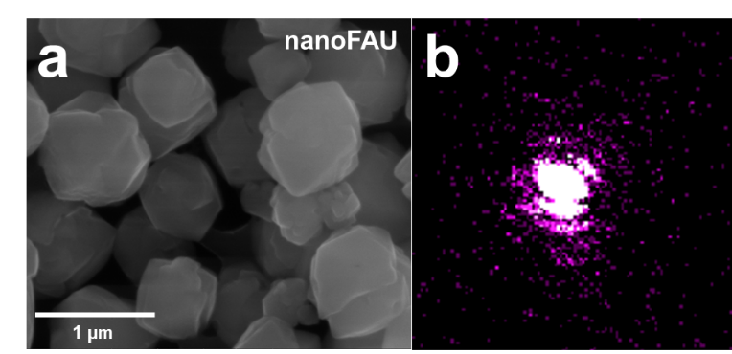

**Figure 1.** **a** Scanning electron microscopy images of the zeolite nanocrystals, showing a cubic shape. **b** 2D diffraction pattern obtained by rocking scans around the (111) Bragg peak of the cube

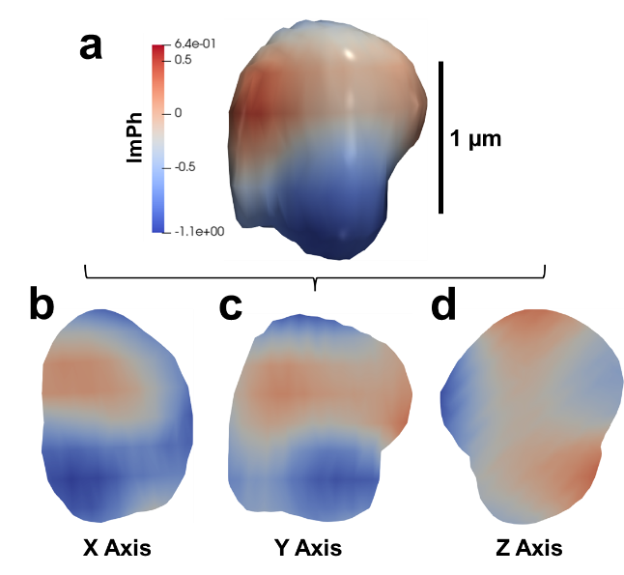

**Figure 2.** **a** Crystal reconstructed by BraggCDI under He flow and cross-sections of the internal displacement along the **b** X axis, **c** Y axis and **d** Z axis.

Figure 2a shows the 3D phase map of the nanocrystal obtained by phase retrieval from the coherent diffraction patterns, under helium flow. Cross-sections through the crystal along the x, y and z axis are presented in Figure 2b, c and d respectively. We can observe from the phase color map that the phase distribution is not homogeneous. This is clearly observed in the 3 different slices showing the phase distribution across the nanocrystal. The phase is directly linked to the lattice displacement where blue zones would correspond to lattice contraction and higher phase values, in red to lattice expansion.

BraggCDI measurements were performed *in situ* during the ethanol dehydration with isothermal steps at 150 °C and 250 °C, during 1 hour each. Data are under analysis and will be presented during the conference.

## Conclusions

The Bragg CDI measurements during ethanol dehydration enabled to obtain 3D lattice displacement maps of a nanozeolite with Faujasite topology. This study demonstrates the feasibility of *in situ* three-dimensional imaging measurements during reactions on zeolites. With new ultra-low emittance synchrotron facilities like Sirius (Brazil), the spatio-temporal resolutions will be improved by several orders of magnitude.

## Acknowledgements

This research was funded by São Paulo Research Funding agency (FAPESP, grant numbers: 2022/13024-4, 2021/06876-1, 2021/11217-7, 2019/01474-2, 2017/23050-4 and 2017/23427-0). We thank Dr Wonsuk Cha for his help during the BraggCDI experiments. LNNano is acknowledged for the access to scanning electron microscopy (SEM). This research used resources of the Advanced Photon Source, a U.S. Department of Energy (DOE) Office of Science user facility operated for the DOE Office of Science by Argonne National Laboratory under Contract No. DE-AC02-06CH11357 (experimente #80424).

## References

1. B. M. Weckhuysen; J. Yu*, Chem. Soc. Rev.* **2015**, *44*, 7022-7024.
2. W. Cha et al. *Nat. Mater.* **2013**, *12*, 729-734.
3. J. Kang et al. *Nat. Comm*. **2020**, *11*, 5901-5909.
4. Pfeifer, M. A. et al. *Nature* **2006**, *442*, 63-66; I. K. Robinson; R. Harder, *Nat. Mater.* **2009**, *8*, 291-298.
5. Z. Wu et al. *Ind. Eng. Chem. Res.* **2020**, *59*, 17300-17306.
6. F Meneau et al. Journal of Physics Condensed Matter**33**, (2021).
7. AR. Passos et al. Nat Commun **11**, (2020).
8. A. Rochet et al. Catal Today **336**, 169–173 (2019).
9. AF. Suzana et al. Nanoscale Adv **1**, 3009–3014 (2019).